A | Post Details
 | Job Title: | Document Author | Function: | Engineering Performance Team
 | Location: | Ramsgate Depot,  Other locations as required. | Unique Post Number:
 | Reports To: | Engineering Performance Manager | Grade: | MG1
B | Purpose of the Job
 | The post holder will work within the Engineering Performance Team to create and manage a catalogue of controlled documentation for activities required for rolling stock Maintenance, Overhaul and Defect Repair within the Engineering Quality Management System (QMS).
C | Principal Accountabilities
C1  C2 | Manage the library of controlled rolling stock maintenance documentation, as a part of the Engineering QMS.  Work collaboratively with key internal and external stakeholders, to develop or improve the content of the documentation associated with rolling stock maintenance.
C3 | Work collaboratively with key internal and external stakeholders to identify and implement innovative media technologies to evolve the suite of rolling stock documentation, in line with the Engineering Systems strategy.
C4 | Support the management of the rolling stock maintenance training and competency material, in line with the document control process.

D |  | Safety Responsibilities
D1 |  | This post is required to undertake SAFETY CRITICAL WORK | Yes |  | No | 
D2 |  | This is a KEY SAFETY POST | Yes |  | No | 
D3 |  | This post requires SECURITY CLEARANCE | Yes |  | No | 
D4 |  | The job requires competence in PERSONAL TRACK SAFETY | Yes |  | No | 
D5 |  | This job has SPECIFIC SAFETY RESPONSIBILITIES (if Yes see section D6 below) | Yes |  | No | 
D6 |  | The post holder has the following specific safety responsibilities:  None
E |  | Decision making Authority
E1 |  | Authority to deliver system/set-up change in accordance with business process.
F |  | Most Challenging and/or Difficult parts of the role
F1  F2  F3  F4  F5  F6  F7 |  | Providing an effective support service to Engineering whilst delivering core requirements of the role  Maintaining perspective to see both the short and long-term business needs – and to balance this in the day to day workload  Gaining participation from other areas of the business, without having direct influence over the priority or objectives of those people, to ensure deliverables are maintained and met.  Be flexible, self-driven and be able to maintain up-to-date understanding and documentation for dynamically changing Engineering environment.  Be able to manage effectively concurrent workstreams whilst maintaining high standards.  Identifying the most appropriate project tools and methodologies to effect delivery  Integrating change projects amongst normal operations within the engineering environment, without detriment to operational performance targets and departmental objectives.
G | Person Specification  Southeastern aims to recruit people not just for jobs but for long term careers. We want good quality, talented people with the right attitude who will stay with us.  For these reasons we look for evidence of Southeastern values and behaviours in all potential staff and our existing staff looking for promotion along with the particular experience/knowledge, skills and behaviours relevant to the position applied for. These are  We care passionately about our people and passengers  - we put ourselves in our passengers’ shoes to do what’s right for them  - we support our colleagues to be, feel and do their best  - we love the places we serve and do our bit for our communities and environment  We aim to be the best  - we move with pace, we’re agile and learn from everything  - we relentlessly strive to be the best  - we are professionals with personalities  We make the difference together  - we are answerable to each other and our passengers  - we trust each other and do what we say we will  - we are stronger together than we are as individuals  We also have identified behaviours required to be successful in leading Southeastern.  The Leading Southeastern framework details how we should be behaving in order to drive up performance to deliver 85 by 18.  Leading Southeastern  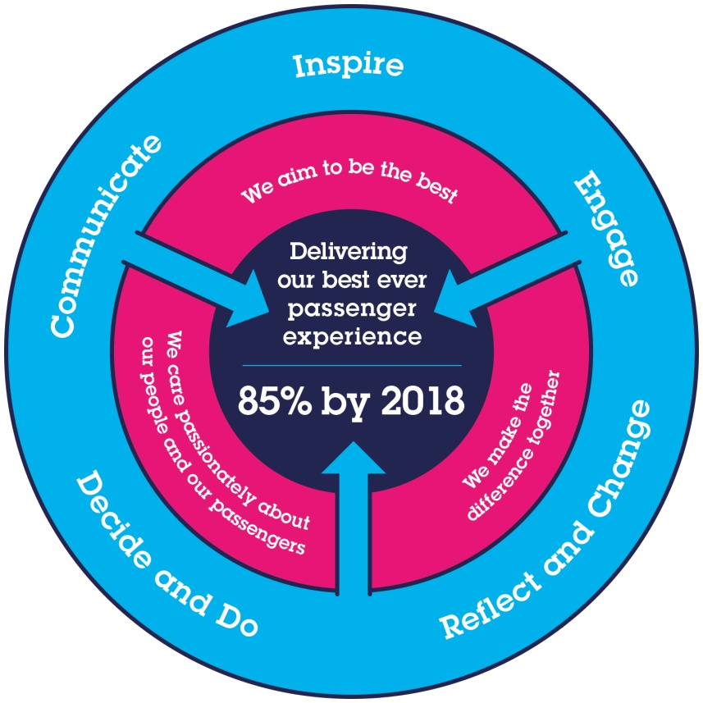  All shortlisted candidates seeking promotion will be assessed against this framework.  The job demands the following blend of experience/knowledge, skills and behaviours (all are essential , unless otherwise shown and will be assessed by application and/ or interview/assessment) :
G1 | Experience, Knowledge & Qualifications  Qualified to level 7 or equivalent in an engineering discipline.  At least 3 years’ experience in an engineering discipline.  Rolling stock experience desirable.  Experience in using standard IT applications.  Experience in using video editing software would be desirable.  Understanding of Web based digital display would be desirable
G2 | Skills (including any specific safety critical competencies)  IT literacy such as would be required to prepare reports, training and presentation materials suitable for large audiences.  An ability to work successfully to deadlines and timescales.  Coaching and influencing skills.  Good communication skills.  Good thinking and problem-solving skills.
G3 | Behaviours  Articulate in written and spoken English  Professional and business focussed outlook.  Attention to detail.  Empathetic and approachable, supportive of colleagues.  Resilient and self-motivated.  Aware of surroundings, naturally inquisitive and questioning.  Business / entrepreneurial acumen.  The ability to research and self-teach.  Enthusiastic to put new ideas forward.  Motivated and a team player with a positive attitude and creative mindset.
G4 | Other  Must have flexibility to work/operate across multiple locations, internal and external to Southeastern

H | Dimensions of role
H1 | Financial – Direct: |  | None
H2 | Financial – Other: |  | None
H3 | Staff Responsibilities – Direct: |  | None
H4 | Staff Responsibilities – Other: |  | None
H5 | Any Other Statistical Data: |  | None
I | Acknowledgement
I1 | Prepared By: | _______________ |  | Date: | ______________
I2 | Approved By (Head of Department): | _______________ |  | Date: | ______________
Page Break
J | Job Description Briefing
 | The post holder has been briefed on and understands the requirements of this Job Description and other related documents:
 | Name of post holder: |  | Signature: |  | Date:
 | Name of briefing manager: |  | Signature: |  | Date:
K | Nominated Deputy for Safety requirements
 | If this is a KEY SAFETY POST (D2 in Safety Details above is YES) at least one nominated deputy must be identified. The Job Holder must ensure that the Nominated Deputy(ies) receives a copy of, and is briefed on this Job Description. If there are more nominated deputies, they should sign further copies of this Job Description.
 | The nominated deputy has been briefed on and understands the requirements of this Job Description and other related documents:
 | Name of nominated deputy: |  | Signature: |  | Date:
 | Name of briefing manager: |  | Signature: |  | Date:

