A | Post Details
 | Job Title: | Railway Enforcement Manager | Function: | Passenger Services
 | Location: |  | Unique Post Number:
 | Reports To: | Railway Enforcement & Intelligence Manager | Grade: | MG1
B | Purpose of the Job
 | To lead and direct a highly effective and motivated team of Railway Enforcement Officers who are dedicated to the reduction of crime, anti-social behaviour and fare evasion. To work in close partnership with other departments and outside agencies, delivering the key objectives of combating ticketless travel, low level crime, disorder, anti-social behaviour and related problems on Southeastern.
C | Principal Accountabilities
C1  C2  C3  C4  C5  C6  C7  C8  C9  C10 | Ensure staff performance is compliant to required standards of the penalty fares scheme, Railway Safety Accreditation Scheme, PTS, legislation, and any other company and role specific standards  Responsible for the effectively management of the Penalty Fare and Railway Safety Accreditation Schemes thereby preventing the loss of these schemes to the Company which would have a significant impact on Southeastern’s Railway Enforcement.  Actively monitor staff in the working environment and conduct regular 1:1 reviews on  a periodic basis to ensure continuous improvement and achievement  Develop and implement coaching plans which will improve individuals output to ensure achievement of desired objectives  Conduct interviews and investigations in line with HR procedures  Manage and present the London and Kent Intelligence Briefs and carry out daily briefings as required as a result of tasking requirements and intelligence led requirements.  Lead Special Operations and taskings as directed by the Railway Enforcement & Intelligence Manager  Act as an Authorised person under the RSAS and PF Scheme, and attain any other licences required for the role  Ensure all REO depots comply with all relevant legislation and competencies  Carry out other work as directed by the Railway Enforcement & Intelligence Manager

D | Safety Responsibilities
D1 | This post is required to undertake SAFETY CRITICAL WORK | Yes |  | No
D2 | This is a KEY SAFETY POST or nominated deputy | Yes |  | No
D3 | This post requires SECURITY CLEARANCE (BTP crime check only) | Yes |  | No
D4 | The job requires competence in PERSONAL TRACK SAFETY | Yes |  | No
D5 | This job has SPECIFIC SAFETY RESPONSIBILITIES (if Yes see section D6 below) | Yes |  | No
D6 | The post holder has the following specific safety responsibilities:
 | Investigation of accidents as requested by Safety and Environment:
E | Decision making Authority
E1  E2 | HR Procedures to final stages and appeals  Authorise annual leave and overtime
F | Most Challenging and/or Difficult parts of the role
F1  F2 | Successfully manage a senior workforce to high performance and results  Managing a wide ranging and geographically large department

G | Person Specification

Southeastern aims to recruit people not just for jobs but for long term careers. We want good quality, talented people with the right attitude who will stay with us.

For these reasons we look for evidence of Southeastern values and behaviours in all potential staff and our existing staff looking for promotion along with the particular experience/knowledge, skills and behaviours relevant to the position applied for. These are

We care passionately about our people and passengers
  - we put ourselves in our passengers’ shoes to do what’s right for them
  - we support our colleagues to be, feel and do their best
  - we love the places we serve and do our bit for our communities and environment

We aim to be the best
  - we move with pace, we’re agile and learn from everything
  - we relentlessly strive to be the best
  - we are professionals with personalities

We make the difference together
  - we are answerable to each other and our passengers
  - we trust each other and do what we say we will
  - we are stronger together than we are as individuals

We also have identified behaviours required to be successful in leading Southeastern.

The Leading Southeastern framework details how we should be behaving in order to drive up performance to deliver 85 by 18.

Leading Southeastern

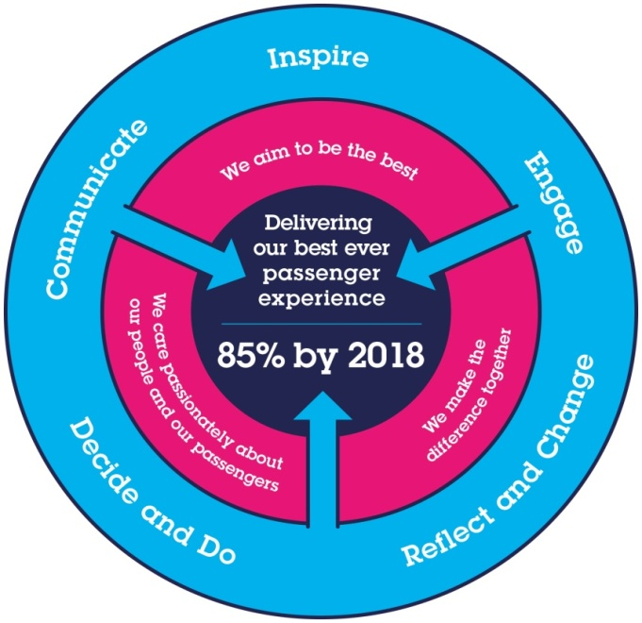

All shortlisted candidates seeking promotion will be assessed against this framework

The job demands the following blend of experience/knowledge, skills and behaviours (all are essential , unless otherwise shown and will be assessed by application and/ or interview/assessment) :
G1 | Experience, Knowledge & Qualifications (including any specific safety training requirements)  Essential:  Good all round standard or education  Previous experience of working as a Team Leader or Manager  Excellent standard of written English, able write reports  Able to demonstrate a high level of confidentiality  Ability to attain relevant qualifications and licences  Ability to understand complex information  Desirable:  Previous office experience and advantage  Computer literate, knowledge of outlook, word and excel
G2 | Skills (including any specific safety critical competencies)  Excellent communication and motivation skills  Excellent organisational skills  Good numerical skills  Excellent communicator at all levels  Good negotiator  Ability to manage staff and produce desired results  Strategic short term and long term planning ability
G3 | Behaviours  Tolerance, understanding, fairness and firmness where required  Honesty and integrity  Responsive to problems and issues and decisive under pressure  Good team leadership and a team player  Respectful of others and their views  Leads by visibility and example
G4 | Other

H | Dimensions of role
H1 | Financial – Direct: |  | None
H2 | Financial – Other: |  | In the absences of more senior direct management, may be required to allocate overtime and rest day working and to provide reports concerning any utilisation of allocated finance
H3 | Staff Responsibilities – Direct: |  | Monitoring personal and team performance  Including conducting 1:1 interviews as required. Carrying out investigations  as may be directed. Monitoring and dealing with sickness or other absence issues
H4 | Staff Responsibilities – Other: |  | None specific
H5 | Any Other Statistical Data: |  | Produce four-weekly activity reports  and analysis of problems or trends for Tasking Meetings as necessary
I | Acknowledgement
I1 | Prepared By: | _______________ |  | Date: | ______________
I2 | Approved By (Head of Department): | _______________ |  | Date: | ______________

J | Job Description Briefing
 | The post holder has been briefed on and understands the requirements of this Job Description and other related documents:
 | Name of post holder: |  | Signature: |  | Date:
 | Name of briefing manager: |  | Signature: |  | Date:
K | Nominated Deputy for Safety requirements
 | If this is a KEY SAFETY POST (D2 in Safety Details above is YES) at least one nominated deputy must be identified. The Job Holder must ensure that the Nominated Deputy(ies) receives a copy of, and is briefed on this Job Description. If there are more nominated deputies, they should sign further copies of this Job Description.
 | The nominated deputy has been briefed on and understands the requirements of this Job Description and other related documents:
 | Name of nominated deputy: |  | Signature: |  | Date:
 | Name of briefing manager: |  | Signature: |  | Date:

