A | Post Details
 | Job Title: | Customer Relations Officer | Function: | Commercial
 | Location: | 4ML | Unique Post Number:
 | Reports To:  Version:02.05.2023 | Customer Relations Team Manager | Grade: | ASG
B | Purpose of the Job
 | The purpose of the Customer Relations Officer is to effectively handle Southeastern’s inbound customer contacts on a day to day basis – via written and verbal communications, ensuring a high level of customer service is delivered to our passengers.
C | Principal Accountabilities
C  C  C  C  C  C  C  C  C  C  C | Provide effective and comprehensive customer service for specified areas of the business, ensuring that all contacts are quickly resolved to the satisfaction of the customer.  Investigate and resolve customer complaints and queries with a range of appropriate personnel within Southeastern, including senior managers and directors to provide an accurate and timely response to customer complaints.  Proactively source information from a range of personnel across Southeastern including senior managers and directors within KPIs.  Providing a point of contact for our outsourced Customer Service team and effectively helping with their enquiries.  Manage the interface between passengers and Southeastern senior managers and directors including assisting in responding to VIP correspondence on their behalf.  Act as the voice of the customer within Southeastern. Raise repetitive issues and trends to drive actions and resolutions.  Compile and create personalised correspondence (email and letter) to a very high standard and quality, satisfying customers first time every time.  Compile complaint data to report on complaint trends and produce periodic quality of service reports.  Ensuring communications from Customer Services are consistent and in line with all our communications channels.  Effective and accurate reporting of accidents on our Network which are reported via our channels.  Assist with the response to a major incident procedure.  Contribute to building and maintaining a knowledge base shared with the contact centre.  Assess the amount of compensation/gestures of goodwill on a case by case basis using guidelines provided.

D | Safety Responsibilities
D1 | This post is required to undertake SAFETY CRITICAL WORK | Yes |  | No
D2 | This is a KEY SAFETY POST | Yes |  | No
D3 | This post requires SECURITY CLEARANCE | Yes |  | No
D4 | The job requires competence in PERSONAL TRACK SAFETY | Yes |  | No
D5 | This job has SPECIFIC SAFETY RESPONSIBILITIES (if Yes see section D6 below) | Yes |  | No
D6 | The post holder has the following specific safety responsibilities:
 | - None
E | Decision making Authority
E1 | Expenditure levels for customer compensation / gestures of goodwill up to agreed level
F | Most Challenging and/or Difficult parts of the role
F1  F2 | Dealing with difficult complex enquiries  Dealing with repeated complaints regarding company policy
G | Person Specification

Southeastern aims to recruit people not just for jobs but for long term careers. We want good quality, talented people with the right attitude who will stay with us.

For these reasons we look for evidence of Southeastern values in all potential staff and our existing staff looking for promotion along with the particular experience/knowledge, skills and behaviours relevant to the position applied for. These are

We care passionately about our people and passengers
  - we put ourselves in our passengers’ shoes to do what’s right for them
  - we support our colleagues to be, feel and do their best
  - we love the places we serve and do our bit for our communities and environment

We aim to be the best
  - we move with pace, we’re agile and learn from everything
  - we relentlessly strive to be the best
  - we are professionals with personalities

We make the difference together
  - we are answerable to each other and our passengers
  - we trust each other and do what we say we will
  - we are stronger together than we are as individuals
We also have identified behaviours required to be successful in leading Southeastern.

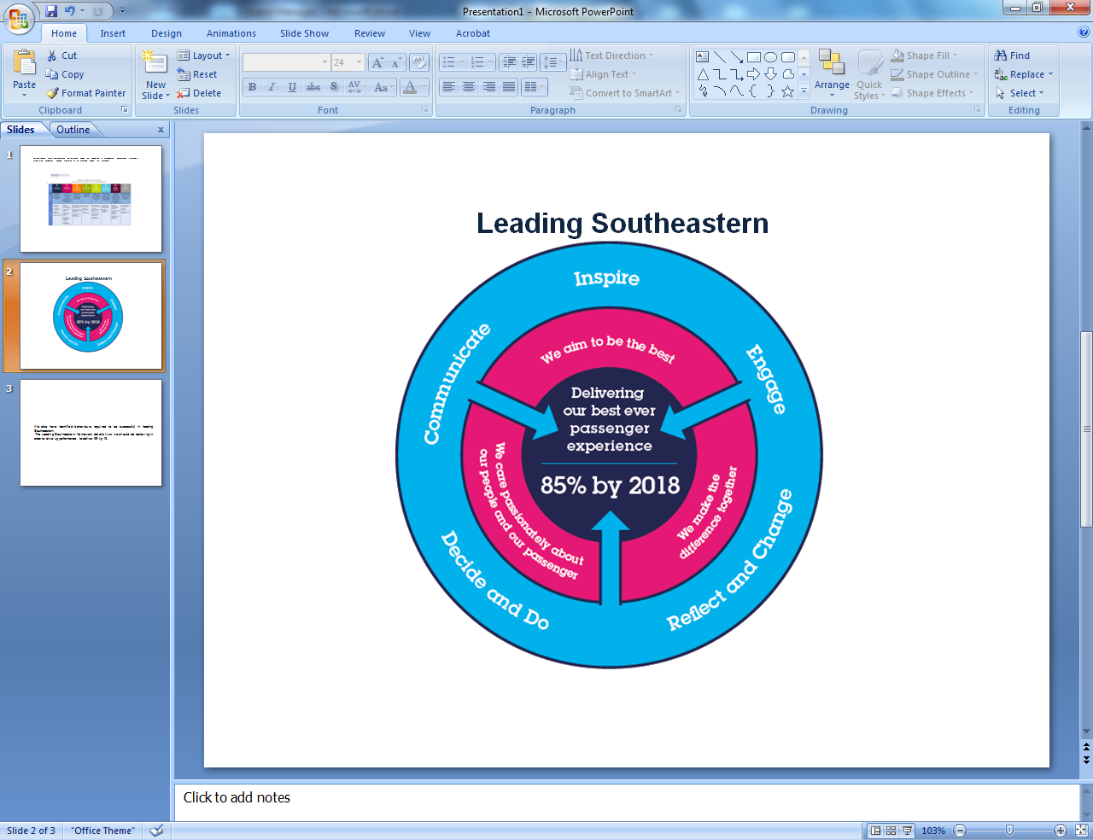
The Leading Southeastern framework details how we should be behaving in order to drive up performance.

All shortlisted candidates seeking promotion will be assessed against this framework.

The job demands the following blend of experience/knowledge, skills and behaviours (all are essential , unless otherwise shown and will be assessed by application and/ or interview/assessment) :

G | Experience, Knowledge & Qualifications – Essential  Customer service experience in a retail environment or similar  Empathetic, friendly, helpful caring manner.  Proven experience of effectively handling customer complaints and customer care skills.  Resilience to pressurised call situations and the ability to stay calm.  Excellent written and verbal communications skills.  Have the ability to identify key people within the organisation to complete complaints effectively.  IT literate e.g. Word, excel, outlook.
G2 | Experience, Knowledge & Qualifications – Desirable  Experience working within the railway industry
G3 | Behaviours and Skills – Essential  Resilience to pressurised situations and the ability to stay calm.  Excellent written and verbal communications skills.  Have the ability to identify key people within the organisation to address and resolve complaints effectively.
G4 | Other

H | Dimensions of role
H1 | Financial – Direct:
H2 | Financial – Other:
H3 | Staff Responsibilities – Direct:
H4 | Staff Responsibilities – Other:
H5 | Any Other Statistical Data:
I | Acknowledgement
I1 | Prepared By: | _______________ |  | Date: | ______________
I2 | Approved By (Head of Department): | _______________ |  | Date: | ______________

J | Job Description Briefing
 | The post holder has been briefed on and understands the requirements of this Job Description and other related documents:
 | Name of post holder: |  | Signature: |  | Date:
 | Name of briefing manager: |  | Signature: |  | Date:
K | Nominated Deputy for Safety requirements
 | If this is a KEY SAFETY POST (D2 in Safety Details above is YES) at least one nominated deputy must be identified. The Job Holder must ensure that the Nominated Deputy(ies) receives a copy of, and is briefed on this Job Description. If there are more nominated deputies, they should sign further copies of this Job Description.
 | The nominated deputy has been briefed on and understands the requirements of this Job Description and other related documents:
 | Name of nominated deputy: |  | Signature: |  | Date:
 | Name of briefing manager: |  | Signature: |  | Date:

