A | Post Details
 | Job Title: | Training Operations Manager | Function: | Human Resources
 | Location: | Kent | Unique Post Number:
 | Reports To: | Head of Training | Grade: | MG2
B | Purpose of the Job
Responsible for the development, management and delivery of the Training Strategy that drives and supports the achievement of the business objectives, values and behaviours.

Develop and deliver training programmes to support the company in building a capable, competent, confident, and empowered workforce.

C | Principal Accountabilities
C1  C2  C3  C4  C5  C6  C7  C8  C9 | Work closely and collaboratively across internal functions, wider HR departments and internal stakeholders.  Drive a culture of inclusivity, collaboration, and improvement  Provide expert advice and guidance to managers on training needs to meet the current and future requirements of the business.  Lead on training in support of key projects and initiatives.  In collaboration with the Training Resource Manager produce a Training Plan, ensuring it is resourced and delivered and kept under regular review.  Ensure adequate record keeping regarding colleague performance.  Explore and exploit opportunities to improve the effectiveness and efficiency of training  Produce periodic reports as required.  Own, review and improve Training policy and process.
D | Safety Responsibilities
D1 | This post is required to undertake SAFETY CRITICAL WORK |  |  |  | Yes |  | No
D2 | This is a KEY SAFETY POST or nominated deputy |  |  |  | Yes |  | No
D3 | The holder of this post is identified as a KEY SAFETY MANAGER |  |  |  | Yes |  | No
D4 | The job requires competence in PERSONAL TRACK SAFETY |  |  |  | Yes |  | No
D5 | This job has SPECIFIC SAFETY RESPONSIBILITIES (if Yes see section D6 below) |  |  |  | Yes |  | No
D6 | The post holder has the following specific safety responsibilities:
 | - None
E | Decision making Authority
E1  E2  E3 | All staff management issues within the team  Interpretation of policies and relevant practices, trends, and data, making recommendations for action  Give recommendations on the selection of external suppliers of training
F | Most Challenging and/or Difficult parts of the role
F1 | Leading the training team through inevitable change that comes with improvement

G | Person Specification

Southeastern aims to recruit people not just for jobs but for long term careers. We want good quality, talented people with the right attitude who will stay with us.

For these reasons we look for evidence of Southeastern values and behaviours in all potential staff and our existing staff looking for promotion along with the particular experience/knowledge, skills and behaviours relevant to the position applied for. These are

We care passionately about our people and passengers
  - we put ourselves in our passengers’ shoes to do what’s right for them
  - we support our colleagues to be, feel and do their best
  - we love the places we serve and do our bit for our communities and environment

We aim to be the best
  - we move with pace, we’re agile and learn from everything
  - we relentlessly strive to be the best
  - we are professionals with personalities

We make the difference together
  - we are answerable to each other and our passengers
  - we trust each other and do what we say we will
  - we are stronger together than we are as individuals

We also have identified behaviours required to be successful in leading Southeastern.

The Leading Southeastern framework details how we should be behaving in order to drive up performance.

All shortlisted candidates seeking promotion will be assessed against this framework.

The job demands the following blend of experience/knowledge, skills and behaviours (all are essential , unless otherwise shown and will be assessed by application and/ or interview/assessment) :

G1 | Experience, Knowledge & Qualifications (including any specific safety training requirements)  Hold or working towards, City & Guilds Vocational/Direct trainer assessor awards;  - V1 or equivalent  - A1 or equivalent  - A2 or equivalent  - L 10 or equivalent  - L11 or equivalent  - L12 or equivalent  - L6 or equivalent
G2 | Skills and Behaviours
 | 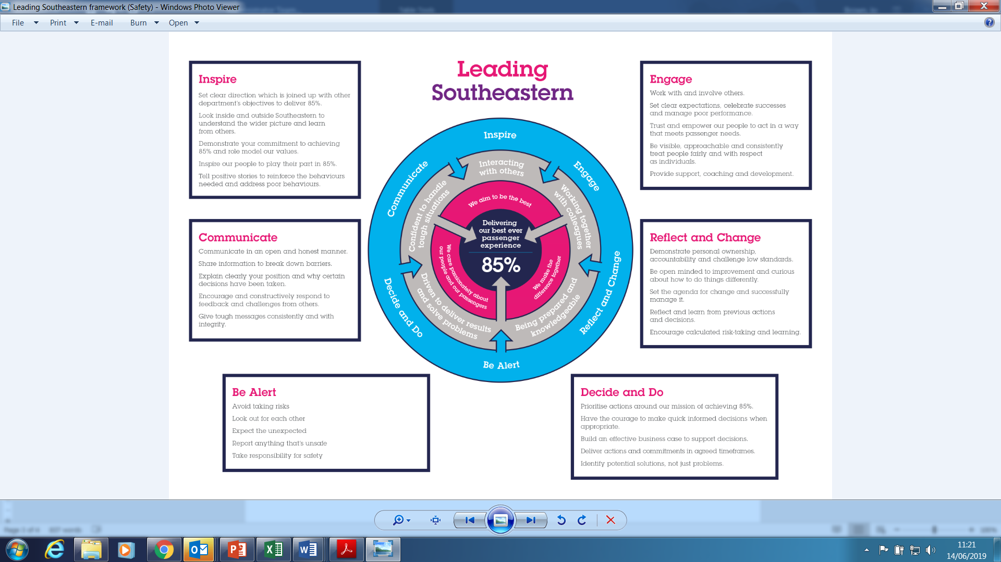

H | Dimensions of role
H1 | Financial – Direct:
H2 | Financial – Other:
H3 | Staff Responsibilities – Direct: 27
H4 | Staff Responsibilities – Other: 9
H5 | Any Other Statistical Data:
I | Acknowledgement
I1 | Prepared By: | _______________ |  | Date: | ______________
I2 | Approved By (Head of Department): | _______________ |  | Date: | ______________

J | Job Description Briefing
 | The post holder has been briefed on and understands the requirements of this Job Description and other related documents:
 | Name of post holder: |  | Signature: |  | Date:
 | Name of briefing manager: |  | Signature: |  | Date:
K | Nominated Deputy for Safety requirements
 | If this is a KEY SAFETY POST (D2 in Safety Details above is YES) at least one nominated deputy must be identified. The Job Holder must ensure that the Nominated Deputy(ies) receives a copy of, and is briefed on this Job Description. If there are more nominated deputies, they should sign further copies of this Job Description.
 | The nominated deputy has been briefed on and understands the requirements of this Job Description and other related documents:
 | Name of nominated deputy: |  | Signature: |  | Date:
 | Name of briefing manager: |  | Signature: |  | Date:

