A | Post Details
 | Job Title: | Product Manager | Function: | Major Programmes
 | Location: | Various | Unique Post Number:
 | Reports To: | Rolling Stock Technical Manager | Grade: | MG1
B | Purpose of the Job  The product manager plays a pivotal role in shaping the end-user experience by ensuring that the passenger perspective is at the forefront of all design and operational decisions for introduction of new fleet. Acting as the 'voice of the customer', this role bridges the gap between external stakeholders, passenger service users, and the interior design and infrastructure teams. The successful candidate will lead initiatives to enhance accessibility, information provision, and engagement with key user groups through a human-centred design approach.  The purpose of the role is to take ownership of customer facing elements, ensuring product(s) deliver maximum value to the end user. The product manager will define the product strategy, gathering and prioritizing business and customer requirements, working closely with cross-functional teams, and ensuring the product(s) meet the end users’ needs, business goals, quality standards throughout its lifecycle.  They will work closely with the New Trains Programme Team, Customer Experience Team, Commercial and Operational Subject Matter Experts as well as liaise with key external consultants and the DfT to inform key programme and product decisions.
C  C1  C2  C3  C4  C5  C6  C7  C8  C9  C10  C11 | Principal Accountabilities  Acting as the ‘Voice of the Southeastern Customer’, the Product Manager will serve as the primary representative for passenger feedback and user experience throughout the project & product lifecycle.  Translate customer needs into actionable requirements for train, service and infrastructure design development teams. Collaborate closely with these teams to align user requirements with technical solutions, operational and maintenance requirements.  Act as the liaison between passenger services user groups and the interior design teams/supplier to ensure customer-centric design outcomes.  Champion improved accessibility across design solutions, including significant involvement in the review, evaluation, and testing of unassisted boarding solutions to ensure design is maximised for effectiveness, safety, and usability. Work with station and infrastructure teams to ensure the end-to-end journey through station and on-board is seamless.  Work with the Information Team on ensuring the product design for information provision is clear, accessible, and inclusive (e.g., signage, announcements, digital displays) and links to the wider business strategy for Information Provision (e.g. websites, apps).  Lead design decisions on the interior layout and ambience of the train, considering the needs of capacity and interior comfort.  Collaborate with external stakeholders with a vested interest in customer solutions to gain stakeholder input into the design. This includes Transport Focus, London Travel Watch, Rail Delivery Group, DFTO, GBRTT and DfT.  Organise stakeholder events, prototype demonstrations, and usability testing sessions to gather feedback and validate solutions.  Own the design and development project plan. Track and manage deliverables to this schedule, tracking risks and costs.  Input into the future fleet strategy, looking at customer proposition options for future rolling stock.  Assist with other project, programme and product tasks as required by the programme.

D | Safety Responsibilities
D1 | This post is required to undertake SAFETY CRITICAL WORK | Yes |  | No | P
D2 | This is a KEY SAFETY POST or nominated deputy | Yes |  | No | P
D3 | The holder of this post is identified as a KEY SAFETY MANAGER | Yes |  | No | P
D4 | The job requires competence in PERSONAL TRACK SAFETY | Yes |  | No | P
D5 | This job has SPECIFIC SAFETY RESPONSIBILITIES (if Yes see section D6 below) | Yes |  | No | P
D6 | The post holder has the following specific safety responsibilities:
E | Decision making Authority
E1 | The post holder will be responsible for ensuring design decisions are approved with the relevant level of authority in each project..
F | Most Challenging and/or Difficult parts of the Job
F1  F2  F3  F4 | Gaining participation from other stakeholders, without having direct influence over the management of those people. Gaining agreement amongst stakeholders with differing views.  Integrating project-based work amongst other competing business priorities, including other projects and day to day business operations, without detriment to operational performance targets and departmental objectives.  Using critical thinking, by being able gathering evidence and ideas from a wide variety of sources, to inform decisions and direction.  Planning and organising multiple competing demands.

G | Person Specification

Southeastern aims to recruit people not just for jobs but for long term careers. We want good quality, talented people with the right attitude who will stay with us.

For these reasons we look for evidence of Southeastern values and behaviours in all potential staff and our existing staff looking for promotion along with the particular experience/knowledge, skills and behaviours relevant to the position applied for. These are

We care passionately about our people and passengers
  - we put ourselves in our passengers’ shoes to do what’s right for them
  - we support our colleagues to be, feel and do their best
  - we love the places we serve and do our bit for our communities and environment

We aim to be the best
  - we move with pace, we’re agile and learn from everything
  - we relentlessly strive to be the best
  - we are professionals with personalities

We make the difference together
  - we are answerable to each other and our passengers
  - we trust each other and do what we say we will
  - we are stronger together than we are as individuals

We also have identified behaviours required to be successful in leading Southeastern.

The Leading Southeastern framework details how we should be behaving in order to drive up performance to deliver 85%.

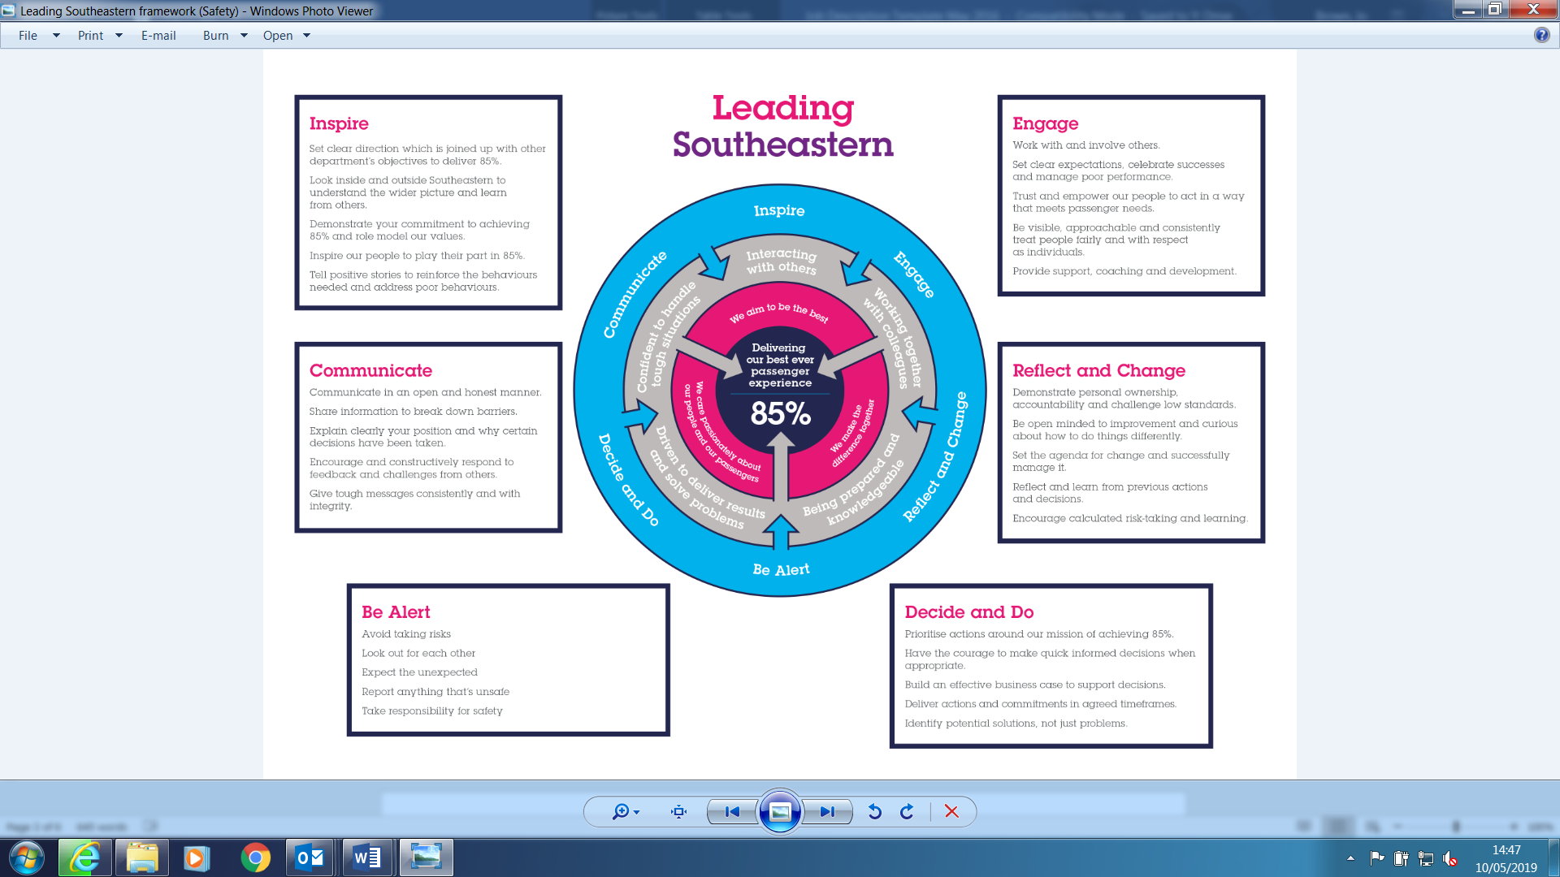

All shortlisted candidates seeking promotion will be assessed against this framework.

The job demands the following blend of experience/knowledge, skills and behaviours (all are essential , unless otherwise shown and will be assessed by application and/ or interview/assessment) :

G1 | Experience, Knowledge & Qualifications (including any specific safety training requirements)  - Formal project or programme qualification or accreditation (PRINCE2, APM foundation or practitioner) and a practical understanding of project management principles, tools and techniques desirable  - Formal product manager qualifications & training  - Demonstratable evidence of previous successful product or project delivery  - Degree educated in relevant subject, or with equivalent experience  - Experience of working in a train operating company, or similar environment
G2 | Skills (including any specific safety critical competencies)  - Critical thinking and problem solving  - Communicating and influencing  - Stakeholder management  - Planning and organising  - Leadership  - Commercial awareness (desirable)  - High standard of written and oral English  - Experience in Microsoft Excel, Word, Powerpoint and Project
G3 | Behaviours  - Proactive – able to pre-empt and drive action forward activities on the project, planning in advance to avoid issues rather than reactive action  - Professional – acting with honesty and integrity, upholding Southeastern values  - Inclusive – able to involve stakeholders at various levels and treat others with respect and courtesy
G4 | Other

H | Dimensions of role
H1 | Financial – Direct: |  |  |  | None
H2 | Financial – Other: |  |  |  | None
H3 | Staff Responsibilities – Direct: |  |  |  | None
H4 | Staff Responsibilities – Other: |  |  |  | Indirectly, organise matrix teams of varying sizes.
H5 | Any Other Statistical Data:
I | Acknowledgement
I1 | Prepared By: |  | _______________ |  |  |  | Date: | ______________
I2 | Approved By (Head of Department): |  | _______________ |  |  |  | Date: | ______________
J | Job Description Briefing
 | The post holder has been briefed on and understands the requirements of this Job Description and other related documents:
 | Name of post holder: |  |  | Signature: |  |  |  |  | Date:
 | Name of briefing manager: |  |  | Signature: |  |  |  |  | Date:
K | Nominated Deputy for Safety requirements
 | If this is a KEY SAFETY POST (D2 in Safety Details above is YES) at least one nominated deputy must be identified. The Job Holder must ensure that the Nominated Deputy(ies) receives a copy of, and is briefed on this Job Description. If there are more nominated deputies, they should sign further copies of this Job Description.
 | The nominated deputy has been briefed on and understands the requirements of this Job Description and other related documents:
 | Name of nominated deputy: |  |  | Signature: |  |  |  |  | Date:
 | Name of briefing manager: |  |  | Signature: |  |  |  |  | Date:

