A | Post Details
 | Job Title: | Learning & Development Partner | Function: | Human Resources
 | Location: | TBC
 | Reports To: | Head of People | Grade: | MG1
B | Purpose of the Job  Work alongside the Head of People, the HR team and wider business stakeholders to champion, promote and embed innovative talent development practices. Working collaboratively across Southeastern to embed talent development approaches that support the business to develop and retain key talent and drive overall business strategy.
C | Principal Accountabilities
C1  C2  C3  C4  C5  C6  C7  C8  C9  C10  C11  C12  C13 | Collaborate with the wider Human Resources team and other key stakeholders to effectively evolve the company's talent management strategy to ensure talent is developed and retained to meet current and future business needs  Develop and oversee the performance management approaches/ review cycles including any redesign or changes required  Responsible for collaborating with functional managers to complete regular and robust talent assessment processes and local succession plans, making this part of the core development programme  Support Go Ahead Group led talent approaches and implement these into the working practices of Southeastern where appropriate  Collaborate with HRBPs and functional leaders to ensure development planning is in place for high potential talent, capability gaps are assessed and learning needs fulfilled  Collaborate with key stakeholders, to develop and deploy improved management onboarding processes  Collaborate with Resourcing to evolve the Employee Value Proposition and to develop our ability to recruit the best talent  Work collaboratively with the Digital Training Manager to design and develop effective management learning resources  Work alongside key stakeholders (and in collaboration with external providers) to ensure leadership and other development programmes are designed and delivered in line with company strategy and accommodate identified organisational capability gaps and accelerate talent development  Facilitate 1-1 and team coaching activity as required, to embed leadership capabilities through effective needs analysis – utilising relevant psychometric tools as required (e.g. 360 feedback, MBTI etc)  Work alongside the HRBP’s and Colleague Experience Manager to support initiatives relating to employee engagement  Be data driven and evaluate the effectiveness of talent processes and programmes and effectively communicate results and findings  Benchmark talent processes and strategies through building networks and looking from the outside in

D | Safety Responsibilities
D1 | This post is required to undertake SAFETY CRITICAL WORK | Yes |  | No
D2 | This is a KEY SAFETY POST | Yes |  | No
D3 | This post requires SECURITY CLEARANCE | Yes |  | No
D4 | The job requires competence in PERSONAL TRACK SAFETY | Yes |  | No
D5 | This job has SPECIFIC SAFETY RESPONSIBILITIES (if Yes see section D6 below) | Yes |  | No
D6 | The post holder has the following specific safety responsibilities:
E | Decision making Authority
E1

F | Most Challenging and/or Difficult parts of the role
F1 | Collaboration across a variety of stakeholders – balancing the understanding and delivery of bespoke needs/ requirements with being consistent in approach from an organisational perspective

G | Person Specification

Southeastern aims to recruit people not just for jobs but for long term careers. We want good quality, talented people with the right attitude who will stay with us.

For these reasons we look for evidence of Southeastern values and behaviours in all potential staff and our existing staff looking for promotion along with the particular experience/knowledge, skills and behaviours relevant to the position applied for. These are

We care passionately about our people and passengers
  - we put ourselves in our passengers’ shoes to do what’s right for them
  - we support our colleagues to be, feel and do their best
  - we love the places we serve and do our bit for our communities and environment

We aim to be the best
  - we move with pace, we’re agile and learn from everything
  - we relentlessly strive to be the best
  - we are professionals with personalities

We make the difference together
  - we are answerable to each other and our passengers
  - we trust each other and do what we say we will
  - we are stronger together than we are as individuals

We also have identified behaviours required to be successful in leading Southeastern.

The Leading Southeastern framework details how we should be behaving in order to drive up performance to deliver 85 by 18.

Leading Southeastern
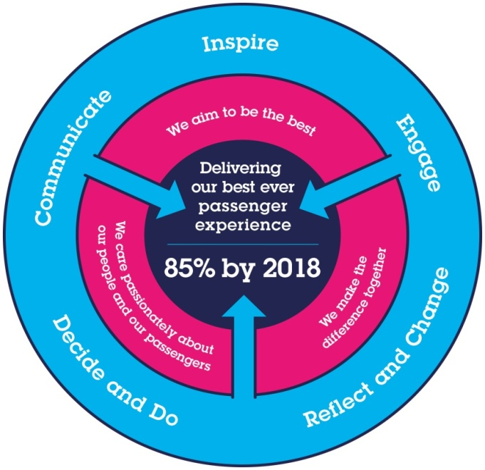

All shortlisted candidates seeking promotion will be assessed against this framework.

The job demands the following blend of experience/knowledge, skills and behaviours (all are essential, unless otherwise shown and will be assessed by application and/ or interview/assessment):

G1 | Experience, Skills & Knowledge
Be a focused and passionate talent professional with the ability to influence and drive results

Be an experienced professional in supporting people through change
Be able to demonstrate previous experience with talent management processes and initiatives such as Graduate programme management and talent assessment processes
Have previous experience in managing performance review processes
Be a team player with the ability to articulate examples of collaborating and partnering with others to achieve tangible results
Be data driven with the skills to match this need
Have proven experience as a coach particularly relating to topics such as performance management
Have experience of assessing capability and critical gaps on an individual and organisational basis
Have previous experience of partnering with stakeholders and using coaching methodology to influence others and reach “value-add” solutions
Be able to work independently and work using initiative
Be enthusiastic and energetic
Ideally have some generalist HR experience to enable bigger picture thinking
Have a passion for learning
Have a positive outlook towards change and working as a team

I | Dimensions of role
I1 | Financial – Direct: |  |  |  | As per budget and DFA
I2 | Financial – Other: |  |  |  | .
I3 | Staff Responsibilities – Direct:
I4 | Staff Responsibilities – Other:
I5 | Any Other Statistical Data:
J | Acknowledgement
J1 | Prepared By: |  |  |  |  |  | Date:
J2 | Approved By (Head of Department): |  |  |  |  |  | Date:
K | Job Description Briefing
 | The post holder has been briefed on and understands the requirements of this Job Description and other related documents:
 | Name of post holder: |  |  | Signature: |  |  |  |  | Date:
 | Name of briefing manager: |  |  | Signature: |  |  |  |  | Date:
L | Nominated Deputy for Safety requirements
 | If this is a KEY SAFETY POST (D2 in Safety Details above is YES) at least one nominated deputy must be identified. The Job Holder must ensure that the Nominated Deputy(ies) receives a copy of, and is briefed on this Job Description. If there are more nominated deputies, they should sign further copies of this Job Description.
 | The nominated deputy has been briefed on and understands the requirements of this Job Description and other related documents:
 | Name of nominated deputy: |  |  | Signature: |  |  |  |  | Date:
 | Name of briefing manager: |  |  | Signature: |  |  |  |  | Date:

