A | Post Details
 | Job Title:  Service Delivery Manager |  | Function:  Engineering
 | Location:  Engineering Depot as specified |  | Unique Post Number:
 | Reports To:  Depot Manager |  | Grade:  MG2
B | Purpose of the Job
To ensure that the depot operational delivery is optimized on a day-to-day basis, meeting the required outputs
Develop teams and individuals into an effective workforce capable of meeting the functional units’ objectives, as specified by the Depot Manager. Whilst developing processes to improve productivity and overall effectiveness.

C | Principal Accountabilities
C1  C2  C3  C4  C5  C6  C7  C8  C9  C10  C11  C12  C13  C14  C15 | Ensure shift production output and service provision targets are met for all rolling stock maintenance activities and wider depot, which includes, train movements, train presentation, and external stakeholders, by the effective deployment of resources and maintenance programming ensuring the customer is at the forefront of the output.  Developing, implementing, and monitoring any required depot KPI’s.  Ensure all teams are managing in accordance with company procedures, making full use of all required engineering systems as required.  Assess, motivate, train, and develop staff to maintain an effective workforce, capable of meeting its objectives. Accountable for shortfalls in staff competency and to ensure development of the training plan to encompass all depot and staff’s requirements to deliver output.  Develop and introduce rosters to meet workload.  Attend depot meetings when on duty that is relevant to the depot output, and ensure that any relevant actions are logged, communicated, and actioned to the wider depot teams.  Work with the wider depot management team(s) and other support functions as directed by the Depot Manager to look for opportunities to further improve depot productivity, output, effectiveness, and safety, ensuring that these are cascaded out over the depot teams,  Liaise with the Planning Delivery Manager for the respective fleet to ensure slot plan and depot delivery are adhered to.  Ensure that any required contractual technical specifications, group standards, systems, and procedures, as defined by the engineering Quality & Safety Management Systems are being complied with.  Deliver changes to working instructions and processes to prevent recurrence and deliver improvement.  Responsible for the management of the day-to-day activities of the depot including liaising with all other stakeholders, ensuring right time delivery is consistently met from the depot.  Responsible for ensuring our cleaning contract is delivering the required results.  Ensure All 24/7 operational support functions are fulfilled to ensure support for KICC and operational services.  Responsible for releasing units into service that does not require Professional Head of Engineering release, in conjunction with business process, as defined in the engineering Quality Management System.  Provide production delivery management support through a 24/7 cover, as agreed.

D | Safety Responsibilities
D1 | This post is required to undertake SAFETY CRITICAL WORK | Yes |  | No | x
D2 | This is a KEY SAFETY POST or nominated deputy | Yes |  | No | x
D3 | The holder of this post is identified as a KEY SAFETY MANAGER | Yes |  | No | x
D4 | The job requires competence in PERSONAL TRACK SAFETY | Yes | x | No
D5 | This job has SPECIFIC SAFETY RESPONSIBILITIES (if Yes see section D6 below) | Yes | x | No
D6 | The post holder has the following specific safety responsibilities:
Carrying out Planned General Inspections of the following locations:
- Ramsgate, Slade Green, and Gillingham

Safety Interface with the following external parties:
- All third-party contractors

Investigation of accidents occurring at the following locations or as requested by Safety & Environment:
- Ramsgate, Slade Green, and Gillingham

E | Decision making Authority
E1

F | Most Challenging and/or Difficult parts of the role
F1  F2  F3  F4 | Ensuring the Depot output is maintained, delivering to the committed targets.  Striving to improve progress and working practices to increase efficiency.  Managing and leading the personal development of a large and diverse team.  Providing support and cover as part of the wider delivery management team.

G | Person Specification

Southeastern aims to recruit people not just for jobs but for long term careers. We want good quality, talented people with the right attitude who will stay with us.

For these reasons we look for evidence of Southeastern values and behaviours in all potential staff and our existing staff looking for promotion along with the particular experience/knowledge, skills and behaviours relevant to the position applied for. These are

We care passionately about our people and passengers
  - we put ourselves in our passengers’ shoes to do what’s right for them
  - we support our colleagues to be, feel and do their best
  - we love the places we serve and do our bit for our communities and environment

We aim to be the best
  - we move with pace, we’re agile and learn from everything
  - we relentlessly strive to be the best
  - we are professionals with personalities

We make the difference together
  - we are answerable to each other and our passengers
  - we trust each other and do what we say we will
  - we are stronger together than we are as individuals

We also have identified behaviours required to be successful in leading Southeastern.

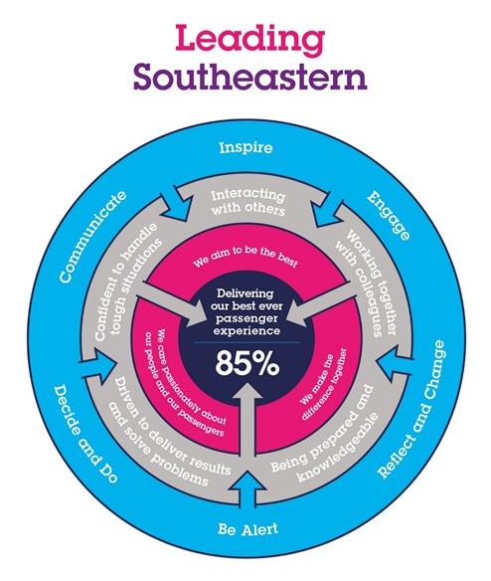

The Leading Southeastern framework details how we should be behaving in order to drive up performance to deliver 85 by 18.

All shortlisted candidates seeking promotion will be assessed against this framework.

The job demands the following blend of experience/knowledge, skills and behaviours (all are essential , unless otherwise shown and will be assessed by application and/ or interview/assessment) :

G1 | Experience, Knowledge & Qualifications (including any specific safety training requirements)  Good track record for managing large teams in different roles.  Good understanding of Engineering rules and Regulations  2 years minimum experience in Managerial or supervisory role  Engineering Qualification (Level 3 or above)  ILM Level 3 (Working towards level 5)  Safety management training – NEBOSH (or Minimum of IOSH and working towards NEBOSH)
G2 | Skills (including any specific safety critical competencies)  Competent in Personal Track Safety.  Releasing units into passenger service.  Influencing Skills
G3 | Behaviours  See above.
G4  G5 | Report Preparation  TBC  Contact with Others

H | Dimensions of role
H1 | Financial – Direct:
H2 | Financial – Other:
H3 | Staff Responsibilities – Direct:
H4 | Staff Responsibilities – Other:
H5 | Any Other Statistical Data:
I | Acknowledgement
I1 | Prepared By: | _______________ |  | Date: | ______________
I2 | Approved By (Head of Department): | _______________ |  | Date: | ______________

J | Job Description Briefing
 | The post holder has been briefed on and understands the requirements of this Job Description and other related documents:
 | Name of post holder: |  | Signature: |  | Date:
 | Name of briefing manager: |  | Signature: |  | Date:
K | Nominated Deputy for Safety requirements
 | If this is a KEY SAFETY POST (D2 in Safety Details above is YES) at least one nominated deputy must be identified. The Job Holder must ensure that the Nominated Deputy(ies) receives a copy of, and is briefed on this Job Description. If there are more nominated deputies, they should sign further copies of this Job Description.
 | The nominated deputy has been briefed on and understands the requirements of this Job Description and other related documents:
 | Name of nominated deputy: |  | Signature: |  | Date:
 | Name of briefing manager: |  | Signature: |  | Date:

