A | Post Details
 | Job Title: | Passenger Services Co-ordinator | Function: | Train Services
 | Location: | Puddle Dock  Kent Integrated Control Centre (KICC) | Unique Post Number:
 | Reports To: | TBC | Grade: | MG1
B | Purpose of the Job
Act as the central co-ordination function for Passenger Services in respect of responding to service disruption, on call mobilisation, chain of care, assisted travel plans, fault reporting, station sickness and passenger focussed input to KICC logs.

Liaise with Passenger Services Managers and Supervisors in real time to facilitate the most appropriate response to differing situations.

Produce a dedicated Passenger Services daily log.

C | Principal Accountabilities
C1  C2  C3  C4  C5  C6  C7  C8  C9 | Provide immediate chain of care response for front line colleagues.  Produce a dedicated Passenger Services log and input into the KICC log from a passenger perspective.  Co-ordination of PS response to service disruption / PIDD - Mobilisation of on-the-ground response to provide best customer support during disruption.  Co-ordinate the on call response to incidents and act as the call out mechanism for 1st line on call managers within PS.  Track station infrastructure / customer-impacting failures. Keep front line colleagues informed of progress relating to resolutions.  Act as the central point for out of hours station sickness calls. Update SharePoint, rosters and local manages accordingly.  Undertake the following activities in support of Southeasterns’ obligations in the Assisted Travel Process:  - Act as a dedicated telephone number for accessibility  - Manage Pre booking of luggage assistance  - Co-ordinate assistance during delays and disruption  - Update on train facilities status  - Organise accessible transport during disruption (i.e. accessible taxi’s etc)  Work with KICC, Depot Managers and on board colleagues to co-ordinate and agree declassification of first class.  Undertake other duties as directed or required.

D | Safety Responsibilities
D1 | This post is required to undertake SAFETY CRITICAL WORK | Yes |  | No
D2 | This is a KEY SAFETY POST | Yes |  | No
D3 | This post requires SECURITY CLEARANCE | Yes |  | No
D4 | The job requires competence in PERSONAL TRACK SAFETY | Yes |  | No
D5 | This job has SPECIFIC SAFETY RESPONSIBILITIES (if Yes see section D6 below) | Yes |  | No
D6 | The post holder has the following specific safety responsibilities:
 | None
E | Decision making Authority
E1  E2  E3  E4 | Prioritising support for Passenger Services during times of disruption  Mobilising Passenger Services On Call  Operational decisions in support of Assisted Travel Process  Co-ordination and agreement of first class de-classification
F | Most Challenging and/or Difficult parts of the role
F1  F2  F3 | Managing information flows in a time sensitive environment during disruption  Responding to customers / colleagues in an empathetic and professional manner  Determining the most appropriate on call response to incidents

G | Person Specification

Southeastern aims to recruit people not just for jobs but for long term careers. We want good quality, talented people with the right attitude who will stay with us.

For these reasons we look for evidence of Southeastern values and behaviours in all potential staff and our existing staff looking for promotion along with the particular experience/knowledge, skills and behaviours relevant to the position applied for. These are

We care passionately about our people and passengers
  - we put ourselves in our passengers’ shoes to do what’s right for them
  - we support our colleagues to be, feel and do their best
  - we love the places we serve and do our bit for our communities and environment

We aim to be the best
  - we move with pace, we’re agile and learn from everything
  - we relentlessly strive to be the best
  - we are professionals with personalities

We make the difference together
  - we are answerable to each other and our passengers
  - we trust each other and do what we say we will
  - we are stronger together than we are as individuals

We also have identified behaviours required to be successful in leading Southeastern.

The Leading Southeastern framework details how we should be behaving in order to drive up performance to deliver 85.

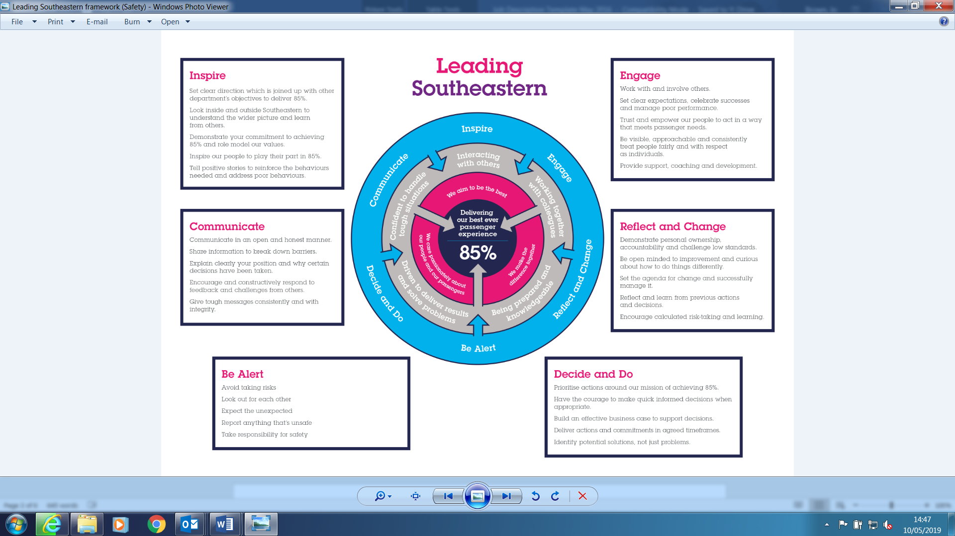

All shortlisted candidates seeking promotion will be assessed against this framework.

The job demands the following blend of experience/knowledge, skills and behaviours (all are essential , unless otherwise shown and will be assessed by application and/ or interview/assessment) :

G1 | Desirable Experience, Knowledge & Qualifications  Knowledge of the relevant geography, including stations and track layouts and services operated by Southeastern.  Good knowledge of generally available and bespoke IT systems.  Good knowledge of relevant operating, rolling stock, engineering, train crew and station procedures  Good general education with passes in English Language and Mathematics operated.
G2 | Skills (including any specific safety critical competencies)  A good command of English language and ability to communicate clearly.  Ability to create own inputs and influence at a number of levels within the KICC.  Excellent communication skills.  Adding value- Exploits opportunities to improve results and add value to the business.  Resilience- Remains calm and self-controlled under pressure. Reacts well to change and stays positive despite setbacks.  Professionalism- Interacts with others in a sensitive and effective way. Respects and works well with others.
G3 | Behaviours  Resilience- Remains calm and self-controlled under pressure. Reacts well to change and stays positive despite setbacks.  Professionalism- Interacts with others in a sensitive and effective way. Respects and works well with others.
G4 | Other

I | Dimensions of role
I1 | Financial – Direct: |  | None
I2 | Financial – Other: |  | None
I3 | Staff Responsibilities – Direct: |  | None
I4 | Staff Responsibilities – Other: |  | None
I5 | Any Other Statistical Data:
J | Acknowledgement
J1 | Prepared By: | Steve Lewis |  | Date: | April 2020
J2 | Approved By (Head of Department): |  |  | Date:

K | Job Description Briefing
 | The post holder has been briefed on and understands the requirements of this Job Description and other related documents:
 | Name of post holder: |  | Signature: |  | Date:
 | Name of briefing manager: |  | Signature: |  | Date:
L | Nominated Deputy for Safety requirements
 | If this is a KEY SAFETY POST (D2 in Safety Details above is YES) at least one nominated deputy must be identified. The Job Holder must ensure that the Nominated Deputy(ies) receives a copy of, and is briefed on this Job Description. If there are more nominated deputies, they should sign further copies of this Job Description.
 | The nominated deputy has been briefed on and understands the requirements of this Job Description and other related documents:
 | Name of nominated deputy: |  | Signature: |  | Date:
 | Name of briefing manager: |  | Signature: |  | Date:

