A | Post Details
 | Job Title: | Stakeholder Engagement Manager | Function: | Communications & Stakeholder
 | Location: | Four More London | Unique Post Number: | U14196
 | Reports To: | Senior Stakeholder Engagement Manager | Grade: | MG1
B | Purpose of the Job
Improve the responsiveness and proactiveness of our stakeholder engagement function, to help enhance stakeholder relationships and their satisfaction with Southeastern.

Represent Southeastern with external stakeholders, attend meetings with key stakeholders and support the delivery of the stakeholder engagement strategy.

Take ownership of stakeholder inquiries and complaints and provide timely, high-quality, and consistent responses.

A core part of the role will to be provide support to the Senior Stakeholder Engagement Manager, and wider team, including briefings and research, and assisting with event organisation.

This role is responsible for running the annual Customer and Communities Improvement Fund (CCIF) – drafting scope and governance of each year’s fund, the application and bid evaluation process and agreeing contracts with successful bidders.

Work with the wider Communications Team to help provide proactive stakeholder communications on key developments on the Southeastern network.

C | Principal Accountabilities
C1  C2  C3  C4  C5  C6  C7  C8  C9  C10  C11 | Support the Senior Stakeholder Engagement Manager with day-to-day stakeholder enquiries, drafting and facilitating responses on behalf of Southeastern  Responsible for reactive correspondence to stakeholder inquiries, liaising with internal colleagues including the Department for Transport in the management of stakeholder correspondence, and managing stakeholder databases  Provide proactive corporate updates to stakeholders, including writing and publishing stakeholder newsletters and other material.  Attend stakeholder meetings as a representative of Southeastern as required (includes evening meetings)  Draft and compile internal briefings for members of the Executive ahead of stakeholder meetings.  Provide political monitoring and intelligence of a high quality to the Executive on issues of interest to the business, to maintain and enhance corporate reputation.  Support the Senior Stakeholder Engagement Manager with the organisation of events, including two Stakeholder Forums each year, including management of logistics and the provision of written briefs, speaking notes and presentations for the Southeastern Executive.  Support the Senior Stakeholder Engagement Manager with research, briefings, and presentations for internal and external use.  Provide data and insight from the stakeholder database for monthly reports and other papers. Use mapping software tools to produce constituency-based maps  Deputise for the Senior Stakeholder Engagement Manager as and when required.  Working with Communications colleagues to deliver 24-hour on-call service for media and stakeholders such as Members of Parliament and Government departments and provide communications advice and support to operational colleagues. Any other duties that may be required.

D | Safety Responsibilities
D1 | This post is required to undertake SAFETY CRITICAL WORK | Yes |  | No | X
D2 | This is a KEY SAFETY POST | Yes |  | No | X
D3 | This post requires SECURITY CLEARANCE | Yes |  | No | X
D4 | The job requires competence in PERSONAL TRACK SAFETY | Yes |  | No | X
D5 | This job has SPECIFIC SAFETY RESPONSIBILITIES (if Yes see section D6 below) | Yes |  | No | X
D6 | The post holder has the following specific safety responsibilities:
Carrying out Planned General Inspections of the following locations:
- [list locations or delete if not applicable]

Acting as Fire Precautions Manager for the following locations:
- [list locations or delete if not applicable]

E | Decision making Authority
E1  E2 | Develop company messages and publicity material in line with business objectives  Manage external suppliers to deliver on time
F | Most Challenging and/or Difficult parts of the role
F1  F2 | Managing priorities and workload - managing a high volume of stakeholder enquiries and requests  Managing reputation in a crisis, responding and reacting quickly to unforeseen issues  Delivering high quality communications and engagement in a demanding, high-pressured environment  Public speaking in confrontational environments

G | Person Specification

Southeastern aims to recruit people not just for jobs but for long term careers. We want good quality, talented people with the right attitude who will stay with us.

For these reasons we look for evidence of Southeastern values in all potential staff and our existing staff looking for promotion along with the particular experience/knowledge, skills and behaviours relevant to the position applied for. These are

Take personal responsibility for our actions

Support our colleagues

Take care of our customers

Work collaboratively with stakeholders

Operate in a socially and environmentally responsible way

We also require more than competent performance against our Leadership & Management Competency Framework.

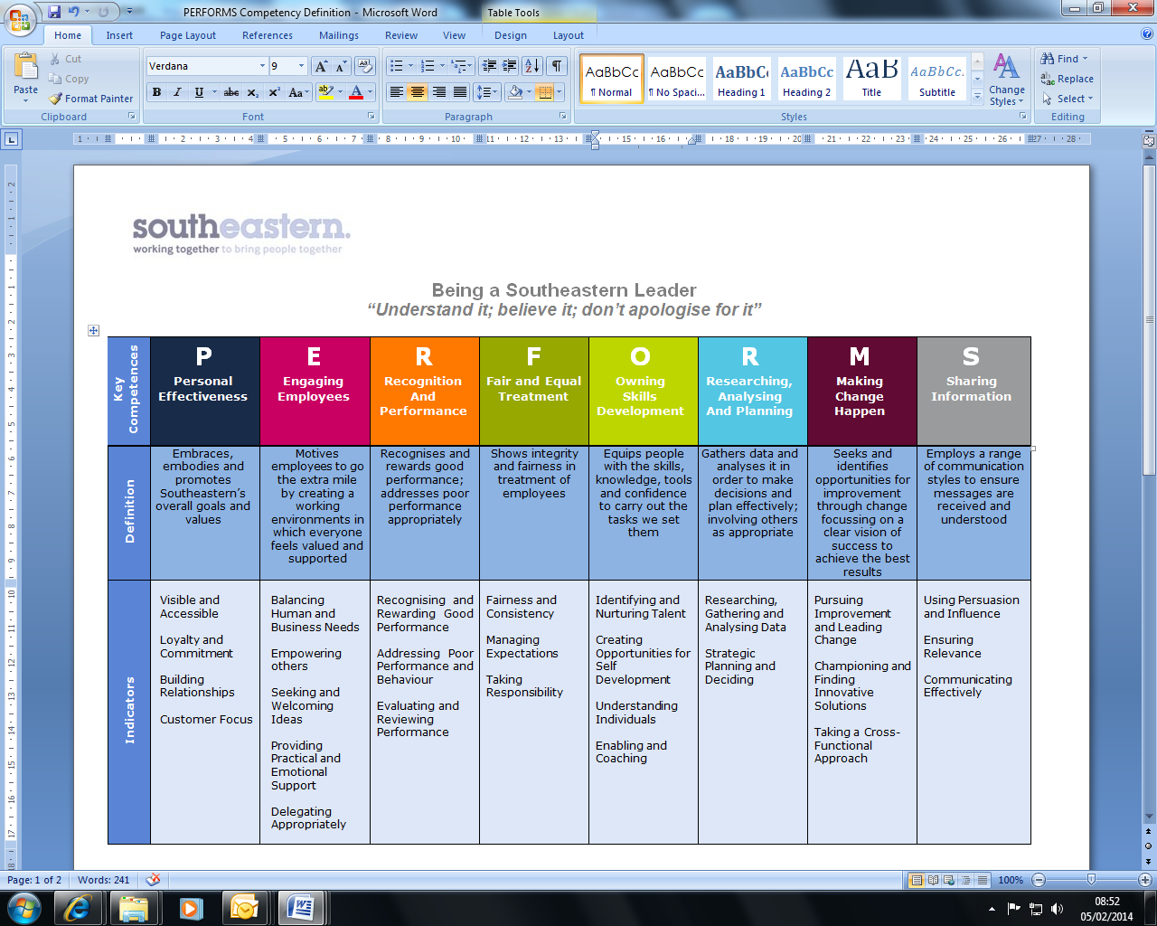
All shortlisted candidates seeking promotion will be assessed against this framework.

The job demands the following blend of experience/knowledge, skills and behaviours (all are essential, unless otherwise shown and will be assessed by application and/ or interview/assessment):

G1 | Experience, Knowledge & Qualifications - Essential  Educated to degree level  Experience in public affairs, government relations, communications or in an equivalent role  Experience in dealing with stakeholder correspondence and handling sensitive/ highly political information  Experience with public speaking and representing a company with external stakeholders  Demonstrated experience working with local communities and representatives to address issues and achieve a positive outcome  Proven ability to present complex material in a simple, understandable way  Experience of planning and delivering events  Experience of managing several projects simultaneously within agreed deadlines.  Experience of running funding programmes  Desirable  Railway knowledge would be ideal  Experience of working in a public affairs or stakeholder engagement role within the rail/ transport sector
G2 | Skills (including any specific safety critical competencies)  - Excellent communication and people skills  - Excellent writing skills  - Good political judgement and intuition  - Thinking and problem solving  - Strategic thinking  - Strong (event) organisational skills
G3 | Behaviours  - Professional  - Diplomatic  - Planning and organising  - Shows empathy  - Team work, sharing and supportive  - Attention to detail  - Ability to work under pressure, adhering to tight deadlines  - Leadership  - Excellent communication and interpersonal skills  - Influencing and negotiating  - Thinking and problem solving  - Taking a broader view  - Professionalism  - Honesty and integrity

I | Dimensions of role
I1 | Financial – Direct:
I2 | Financial – Other:
I3 | Staff Responsibilities –
I4 | Staff Responsibilities – Other:
I5 | Any Other Statistical Data:
J | Acknowledgement
J1 | Prepared By: | Damian Testa |  | Date: | 4 December 2024
J2 | Approved By (Head of Department): | Alison Nolan |  | Date: | 9 December 2024

K | Job Description Briefing
 | The post holder has been briefed on and understands the requirements of this Job Description and other related documents:
 | Name of post holder: |  | Signature: |  | Date:
 | Name of briefing manager: |  | Signature: |  | Date:
L | Nominated Deputy for Safety requirements
 | If this is a KEY SAFETY POST (D2 in Safety Details above is YES) at least one nominated deputy must be identified. The Job Holder must ensure that the Nominated Deputy(ies) receives a copy of, and is briefed on this Job Description. If there are more nominated deputies, they should sign further copies of this Job Description.
 | The nominated deputy has been briefed on and understands the requirements of this Job Description and other related documents:
 | Name of nominated deputy: |  | Signature: |  | Date:
 | Name of briefing manager: |  | Signature: |  | Date:

