A | Post Details
 | Job Title: Junior Asset Manager |  | Function: Managerial
 | Location: London, 4ML |  | Unique Post Number:
 | Reports To: Senior Asset Manager |  | Grade: MG1
B | Purpose of the Job  The purpose of the Junior Asset Manager role is to provide support for Senior Asset Manager in embedding the ISO55001 quality standard processes within Southeastern and to enabling successful execution of long-term station asset management plans. Junior Asset Manager is responsible for facilitating day to day Asset Management operations on behalf of an Asset Management Office supporting 164 Stations locations across London and SE England. A key component of this role is the continued development of our People, Processes, Data and Technology, aligned to our Asset Management System. This is a key role to ensure all asset registers are kept up to date when station assets been upgraded or changed at the stations.
C | Principal Accountabilities
C1  C2  C3  C4  C5  C6  C7  C8 | Provide support for Senior Asset Manager in embedding the ISO55001 quality standard processes within Southeastern and to enabling successful execution of long-term station asset management plans  Facilitate day to day Asset Management operations on behalf of an Asset Management Office supporting 164 Stations locations across London and SE England.  Ensure all asset registers are updated when station assets been upgraded or changed at the stations.  Line Management of Data Analyst role in the Asset Management team.  Enable continuous development of Southeastern People, Processes, Data and Technology, to ensure aligned approach on Asset Management System through efficient collaboration and stakeholder engagement.  Monitor AM activities compliance against ISO55001 Quality Standards and report performance to Senior Asset Manager, including proactively flagging potential non-conformities and development opportunities.  Prepare periodical Asset Management reports consisting of both maintenance and renewal streams. This will include information on required asset upgrades/renewals, asset failure trends, budget and cost, performance against set AM objectives.  Ensure consistent compliance with Asset Management Framework Standards and keep up to date with SFG20 and Network Rail requirements and standards associated with station assets.

D | Safety Responsibilities
D1 | This post is required to undertake SAFETY CRITICAL WORK | Yes |  | No
D2 | This is a KEY SAFETY POST or nominated deputy | Yes |  | No
D3 | The holder of this post is identified as a KEY SAFETY MANAGER | Yes |  | No
D4 | The job requires competence in PERSONAL TRACK SAFETY | Yes |  | No
D5 | This job has SPECIFIC SAFETY RESPONSIBILITIES | Yes |  | No
E | Decision making Authority
E1 | N/A
F | Most Challenging and/or Difficult parts of the role
F1 | Ensuring consistent compliance with Asset Management Framework Standards and keeping up to date with SFG20 and Network Rail requirements and standards associated with station assets.

G | Person Specification

Southeastern aims to recruit people not just for jobs but for long term careers. We want good quality, talented people with the right attitude who will stay with us.

For these reasons we look for evidence of Southeastern values and behaviours in all potential staff and our existing staff looking for promotion along with the particular experience/knowledge, skills and behaviours relevant to the position applied for. These are

We care passionately about our people and passengers
  - we put ourselves in our passengers’ shoes to do what’s right for them
  - we support our colleagues to be, feel and do their best
  - we love the places we serve and do our bit for our communities and environment

We aim to be the best
  - we move with pace, we’re agile and learn from everything
  - we relentlessly strive to be the best
  - we are professionals with personalities

We make the difference together
  - we are answerable to each other and our passengers
  - we trust each other and do what we say we will
  - we are stronger together than we are as individuals

We also have identified behaviours required to be successful in leading Southeastern.

The Leading Southeastern framework details how we should be behaving in order to drive up performance to deliver 85%.

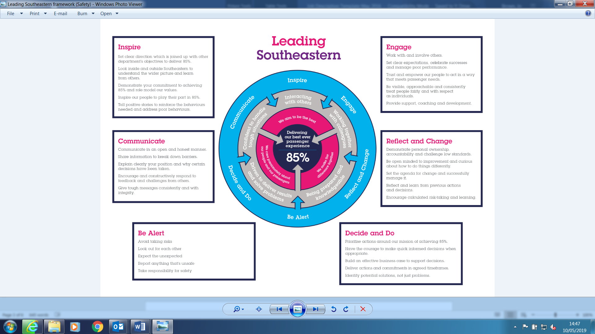

All shortlisted candidates seeking promotion will be assessed against this framework.

The job demands the following blend of experience/knowledge, skills and behaviours (all are essential, unless otherwise shown and will be assessed by application and/ or interview/assessment)

G1 | Experience, Knowledge & Qualifications (including any specific safety training requirements)  - Ideally educated to degree standard, STEM based subjects preferred, but we will consider suitable candidates without a degree if they possess demonstrable experience in an equivalent role  - Possess good interpersonal skills and ability to communicate effectively via all formats including verbal, written, email and presentation to ensure that topics of varying complexity are articulated and understood  - Self-motivated and able to adapt and learn quickly, applying new skills in an efficient way  - Familiar with ISO 55000 Asset Management principles and/or ISO Business Management Systems and their application  - Ability to complete all tasks to a high standard, to budget and on time  - Experience of facilitating technical investigations (e.g., Root Cause Analysis or 5 Whys)  Experience supporting initiatives to demonstrate industry benchmarking, knowledge sharing and continuous improvement
G2 | Skills (including any specific safety critical competencies)  - Proven track record of line management experience, ideally from a retail background  - People focussed with ability to motivate and empower others in order to reach organisational goals.  - Strong interpersonal skills and experienced negotiator.  - Innovative and creative, highly motivated.  - Ability to deal with difficult situations  - Good understanding of commercial awareness and exploits opportunities to add value  - A flexible approach to working and able to adapt to changing demands and conditions.  - Proven success in meeting demanding budgetary and workforce productivity targets.
G3 | Behaviours  - Highly motivated  - Ability to motivate others  - Approachable, engaging and collaborative  - Professional

H | Dimensions of role
H1 | Financial – Direct:
H2 | Financial – Other:
H3 | Staff Responsibilities – Direct:
H4 | Staff Responsibilities – Other:
H5 | Any Other Statistical Data:
I | Acknowledgement
I1 | Prepared By: | _______________ |  | Date: | ______________
I2 | Approved By (Head of Department): | _______________ |  | Date: | ______________

J | Job Description Briefing
 | The post holder has been briefed on and understands the requirements of this Job Description and other related documents:
 | Name of post holder: |  | Signature: |  | Date:
 | Name of briefing manager: |  | Signature: |  | Date:
K | Nominated Deputy for Safety requirements
 | If this is a KEY SAFETY POST (D2 in Safety Details above is YES) at least one nominated deputy must be identified. The Job Holder must ensure that the Nominated Deputy(ies) receives a copy of, and is briefed on this Job Description. If there are more nominated deputies, they should sign further copies of this Job Description.
 | The nominated deputy has been briefed on and understands the requirements of this Job Description and other related documents:
 | Name of nominated deputy: |  | Signature: |  | Date:
 | Name of briefing manager: |  | Signature: |  | Date:

