A | Post Details
 | Job Title: | Performance Analyst | Function: | Train Services
 | Location: | James Forbes House | Unique Post Number:
 | Reports To: | Performance Analysis Manager | Grade: | MG1
B | Purpose of the Job
 | To undertake analysis of prior train running performance to support development of the Performance Strategy and improve the running of trains in the future to meet Schedule 7.1 benchmarks within the Franchise Agreement.
C | Principal Accountabilities
C1  C2  C3  C4  C5  C6  C7  C8  C9  C10 | Undertake analysis of line of route train running to provide recommendations to Accountable Managers regarding areas of concern.  Through excellent analysis influence performance strategy and decision making of Accountable Managers to improve the underlying performance of teams.  Undertake analysis of Performance Strategy actions to validate their success.  Deliver trend analysis graphs of all aspects of Southeastern and Network Rail delivery of input measures.  Undertake analysis of PIE & SPIR action delivery and monitor effect during similar incidents.  Report each period on Schedule 7.1 benchmarks and provide analysis of future performance requirements.  Undertake analysis of seasonal delivery issues to contribute to wider industry forums on behalf of the Head of Performance.  Assist Route Performance Managers with analysis of local issues and timetabling recommendations to support the work of Right Time Railway Groups.  Provide a tracking report, backed by analysis, for each Accountable Manager and their teams of key activities to influence future activity.  Work with the railway analysis community to influence outputs, identify and adopt best practice through the Performance Planning Reform Programme

D | Safety Responsibilities
D1 | This post is required to undertake SAFETY CRITICAL WORK | Yes |  | No
D2 | This is a KEY SAFETY POST or nominated deputy | Yes |  | No
D3 | The holder of this post is identified as a KEY SAFETY MANAGER | Yes |  | No
D4 | The job requires competence in PERSONAL TRACK SAFETY | Yes |  | No
D5 | This job has SPECIFIC SAFETY RESPONSIBILITIES (if Yes see section D6 below) | Yes |  | No
D6 | The post holder has the following specific safety responsibilities:
 | - N/A
E | Decision making Authority
E1 | Analysis requirements
F | Most Challenging and/or Difficult parts of the role
F1  F2 | Building recommendations from analysis undertaken.  Influencing Accountable Managers to take appropriate analysis based decisions.

G | Person Specification

Southeastern aims to recruit people not just for jobs but for long term careers. We want good quality, talented people with the right attitude who will stay with us.

For these reasons we look for evidence of Southeastern values and behaviours in all potential staff and our existing staff looking for promotion along with the particular experience/knowledge, skills and behaviours relevant to the position applied for. These are

We care passionately about our people and passengers
  - we put ourselves in our passengers’ shoes to do what’s right for them
  - we support our colleagues to be, feel and do their best
  - we love the places we serve and do our bit for our communities and environment

We aim to be the best
  - we move with pace, we’re agile and learn from everything
  - we relentlessly strive to be the best
  - we are professionals with personalities

We make the difference together
  - we are answerable to each other and our passengers
  - we trust each other and do what we say we will
  - we are stronger together than we are as individuals

We also have identified behaviours required to be successful in leading Southeastern.

The Leading Southeastern framework details how we should be behaving in order to drive up performance to deliver 85.

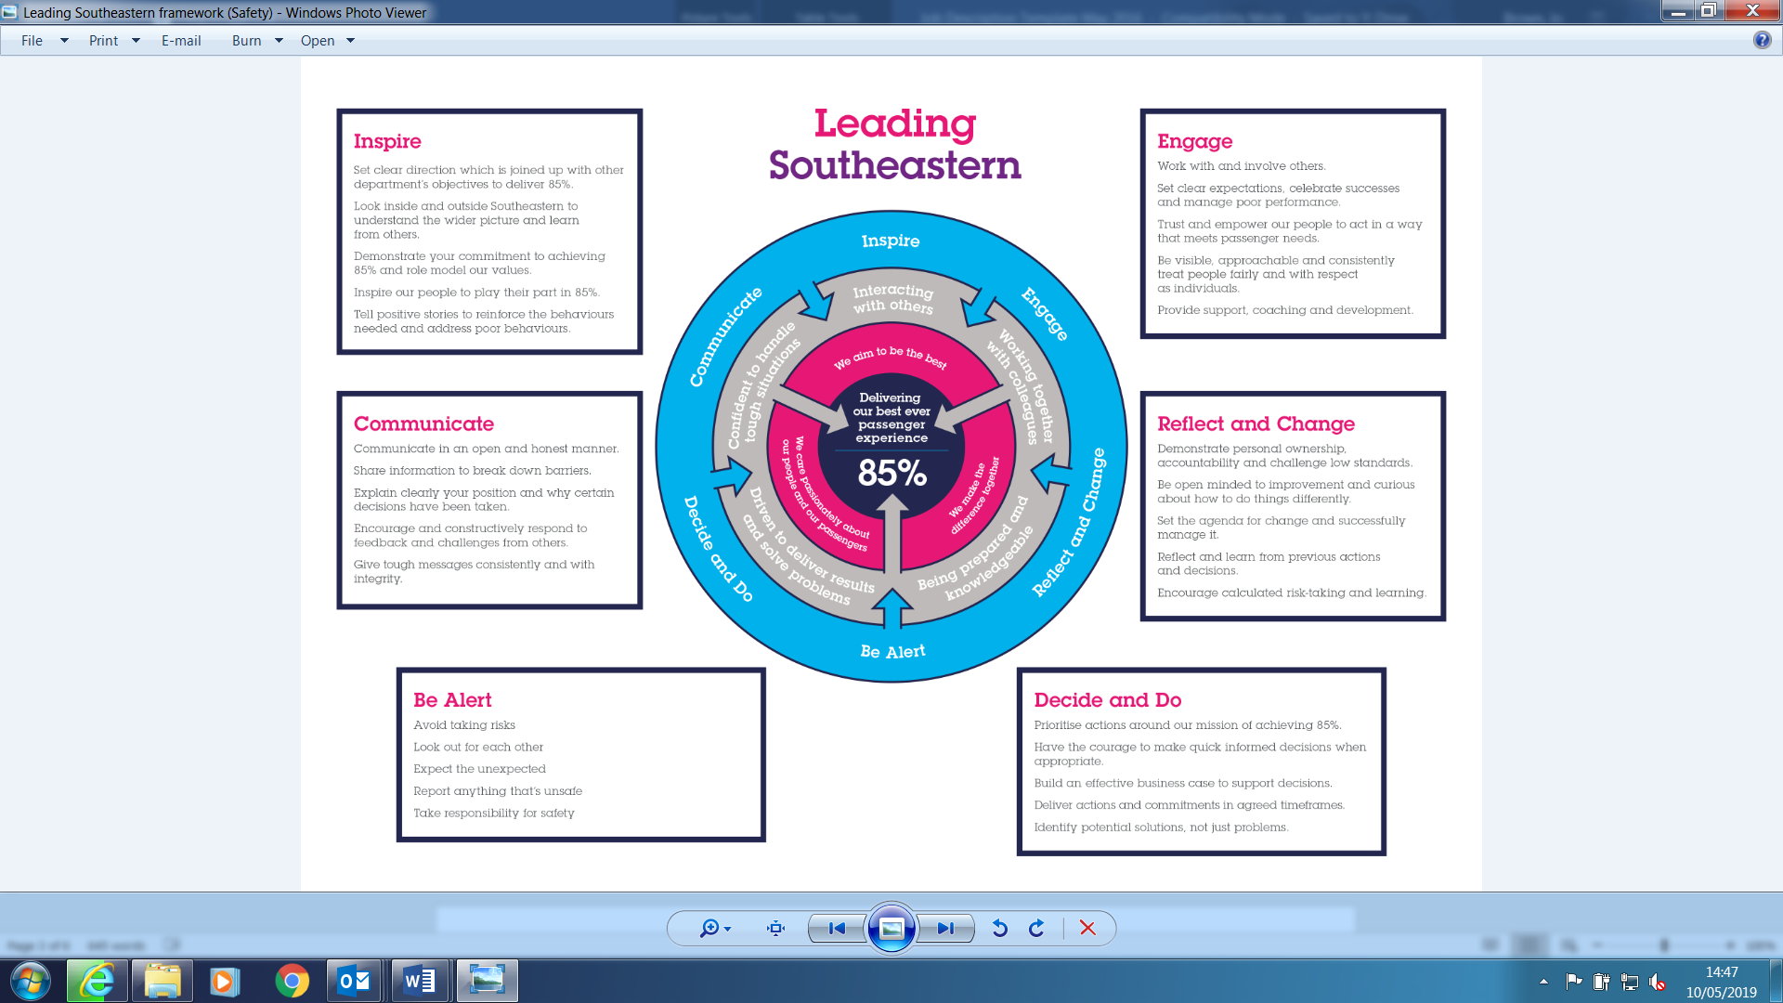

All shortlisted candidates seeking promotion will be assessed against this framework.

The job demands the following blend of experience/knowledge, skills and behaviours (all are essential , unless otherwise shown and will be assessed by application and/ or interview/assessment) :

G1 | Experience, Knowledge & Qualifications (including any specific safety training requirements)  Good education.  Excellent written and oral command of the English Language.  Computer literacy (Excel, Word) and excellent presentation skills.  Ability to present data in a graphical manner.  Ability to prioritise workload.  Ability to be precise and accurate.  Knowledge of BUGLE  Desirable  Knowledge of the rail industry contractual framework.  Knowledge of Southeastern operations.
G2 | Skills (including any specific safety critical competencies)  Good communication skills.  Good interpersonal skills.
G3 | Behaviours
G4 | Other

H | Dimensions of role
H1 | Financial – Direct: |  | Nil
H2 | Financial – Other: |  | £0
H3 | Staff Responsibilities – Direct: |  | Nil
H4 | Staff Responsibilities – Other: |  | Nil
H5 | Any Other Statistical Data: |  | Nil
I | Acknowledgement
I1 | Prepared By: | _______________ |  | Date: | ______________
I2 | Approved By (Head of Department): | _______________ |  | Date: | ______________

J | Job Description Briefing
 | The post holder has been briefed on and understands the requirements of this Job Description and other related documents:
 | Name of post holder: |  | Signature: |  | Date:
 | Name of briefing manager: |  | Signature: |  | Date:
K | Nominated Deputy for Safety requirements
 | If this is a KEY SAFETY POST (D2 in Safety Details above is YES) at least one nominated deputy must be identified. The Job Holder must ensure that the Nominated Deputy(ies) receives a copy of, and is briefed on this Job Description. If there are more nominated deputies, they should sign further copies of this Job Description.
 | The nominated deputy has been briefed on and understands the requirements of this Job Description and other related documents:
 | Name of nominated deputy: |  | Signature: |  | Date:
 | Name of briefing manager: |  | Signature: |  | Date:

