A | Post Details
 | Job Title: | Recruitment & Assessment Officer | Function: | Human Resources
 | Location: | Tonbridge | Unique Post Number:
 | Reports To: | Recruitment Manager | Grade: | MG1
B | Purpose of the Job
Responsible for the delivering of a professional recruitment & selection service to Southeastern, attracting and recruiting competent, confident, customer focussed employees.

Support the HR team in the achievement of Southeastern’s OGTs.

C | Principal Accountabilities
C1  C2  C3  C4  C5  C6  C7  C8  C9  C10  C11  C12 | Recruit and select the best people who reflect our values and will continue to make Southeastern a successful business, taking responsibility for allocated internal and external recruitment campaigns.  Responsible for conducting assessment centres using psychometric tests, interpersonal skills analysis, safety related tests, occupational personality questionnaires and interviews. Interpret and decide on assessment centre results and give meaningful feedback to candidates undergoing testing.  Produce candidate profiles and feedback reports for recruiting managers, ensuring a clear understanding of candidate status. Ensure all internal candidates receive appropriate feedback and that all candidates have a good experience.  Development and delivery of in-house recruitment and selection training, ensuring managers are competent and confident to make selection decisions. Evaluate the success of the workshops and coach managers to enhance their skills where necessary. Participate in recruitment activities i.e. job fairs, recruitment days and seminars as appropriate.  Lead and support Selection Interviews for both internal and external candidates, ensuring that recruiting managers are complying with best practice techniques. Identifying skills gaps with recruiting managers and coaching and making recommendations for improvement as required.  Development, review and enhancement of the use of psychometric tests for selection purposes, making recommendations for use and seeking approval for change  Comply with HR policies and procedures relating to recruitment & selection, including Equality Act, Data Protection Act and Company Data Protection Policy.  Issue contracts of employment, coordinating the arrangements for new entrant induction and ensuring that all new entrant paperwork is completed and correct with particular attention to “right to work in the UK” status.  Produce, develop and enhance the full use of all recruitment advertising methods, ensuring Workmate is used to its full potential.  Working with recruiting managers, develop, review and enhance the structured interviewing templates to ensure they always identify the appropriate competencies and attract the best people for the job.  Act as an internal reviewer for IiP and working closely with the Internal Review Team.  Assist the Recruitment Manager and undertake any projects as required

D | Safety Responsibilities
D1 | This post is required to undertake SAFETY CRITICAL WORK | Yes |  | No
D2 | This is a KEY SAFETY POST or nominated deputy | Yes |  | No
D3 | The holder of this post is identified as a KEY SAFETY MANAGER | Yes |  | No
D4 | The job requires competence in PERSONAL TRACK SAFETY | Yes |  | No
D5 | This job has SPECIFIC SAFETY RESPONSIBILITIES (if Yes see section D6 below) | Yes |  | No
D6 | The post holder has the following specific safety responsibilities:
 | None
E | Decision making Authority
E1  E2  E3 | Interpretation of government legislation and the equality act.  Interpretation of policies and relevant practices, trends and data, making recommendations for action.  Give recommendations on the selection of both internal and external candidates.
F | Most Challenging and/or Difficult parts of the role
F1  F2 | Influencing recruiting managers regarding selection decisions.  Coaching recruiting managers to improve their skills

G | Person Specification

Southeastern aims to recruit people not just for jobs but for long term careers. We want good quality, talented people with the right attitude who will stay with us.

For these reasons we look for evidence of Southeastern values and behaviours in all potential staff and our existing staff looking for promotion along with the particular experience/knowledge, skills and behaviours relevant to the position applied for. These are

Take personal responsibility for our actions

Support our colleagues

Take care of our customers

Work collaboratively with stakeholders

Operate in a socially and environmentally responsible way

We also require more than competent performance against our Leadership & Management Competency Framework.
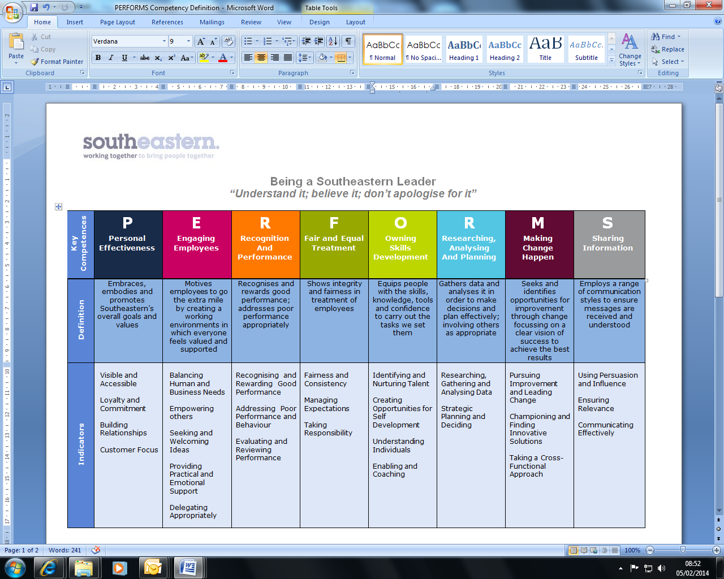
All shortlisted candidates seeking promotion will be assessed against this framework.

The job demands the following blend of experience/knowledge, skills and behaviours (all are essential , unless otherwise shown and will be assessed by application and/ or interview/assessment) :
G1 | Experience, Knowledge & Qualifications (including any specific safety training requirements)  - Must be on the current Register of the British Psychological Society’s Qualifications in Test Use (RQTU)  - Must be certificated to administer and interpret train driver psychometric selection processes, complying with RIS-3751-TOM Train Driver Selection  - Must be able to critically evaluate behaviours and interpersonal skills  - Application of best practice and legislation relating to Recruitment & Assessment techniques  - Application and knowledge of Home Office guidelines for preventing illegal working  - Evidence of a high standard of communication, both written and verbal, with the ability to communicate with all levels of staff, including managers, to explain complex information  - Excellent level of IT proficiency, particularly Microsoft Word, Excel, and Outlook.  - Ability to interpret complex information and make decisions using sound judgment, seeking advice as required.  - Experience of working to tight deadlines and the ability to work well under pressure with little supervision, prioritising appropriately and pro-actively.  - Able to work independently and achieve individual goals, coupled with excellent team working skills and flexibility in approach to work.  - Awareness of the broader impact of potentially sensitive information and the ability to deal with it appropriately and responsibly  A relevant qualification, e.g. Certificate in HR Practices.
G2 | Skills (including any specific safety critical competencies)
G3 | Behaviours
G4 | Other

H | Dimensions of role
H1 | Financial – Direct: |  | none
H2 | Financial – Other: |  | Organisational impact
H3 | Staff Responsibilities – Direct: |  | none
H4 | Staff Responsibilities – Other: |  | Organisational impact
H5 | Any Other Statistical Data:
I | Acknowledgement
I1 | Prepared By: | _Jo Brown______ |  | Date: | _March 2013 __
I2 | Approved By (Head of Department): | _______________ |  | Date: | ______________

J | Job Description Briefing
 | The post holder has been briefed on and understands the requirements of this Job Description and other related documents:
 | Name of post holder: |  | Signature: |  | Date:
 | Name of briefing manager: |  | Signature: |  | Date:
K | Nominated Deputy for Safety requirements
 | If this is a KEY SAFETY POST (D2 in Safety Details above is YES) at least one nominated deputy must be identified. The Job Holder must ensure that the Nominated Deputy(ies) receives a copy of, and is briefed on this Job Description. If there are more nominated deputies, they should sign further copies of this Job Description.
 | The nominated deputy has been briefed on and understands the requirements of this Job Description and other related documents:
 | Name of nominated deputy: |  | Signature: |  | Date:
 | Name of briefing manager: |  | Signature: |  | Date:

