+A | Post Details
 | Job Title: | Executive Governance Manager | Function: | Executive Team
 | Location: | 4ML
 | Reports To: | Chief of Staff | Grade: | MG2
B | Purpose of the Job  You will organise, oversee, and track key business decisions. Manging inputs from multiple people and sources, you will support the achievement of strategic objectives by ensuring there is effective coordination of Committee, Board and Executive management meetings and the related flow of information. You will provide support to the Chief of Staff to ensure that papers, reports, and data is collated and where necessary socialised across departments before meetings.  The postholder is responsible for the delivery of a full secretariat support service to the Executive and SETL Board, deputising for the Chief of Staff at relevant meetings, as necessary.  This will be a pivotal role working across all elements of the business, building strong and trusted relationships with the Executive and Senior Leadership teams.
C | Principal Accountabilities
C1  C2  C3  C4  C5  C6  C7  C8 | To ensure that the corporate governance framework supports high quality, well-informed corporate decision-making, by managing the schedule, agenda, content and logistics for Executive, Board and associated Committee meetings throughout the year, ensuring all relevant content and reports are captured and communicated in an appropriate way.  To be accountable to the Chief of Staff for the smooth and effective operating of the corporate governance framework, in collaboration with the Company Secretary, Executive Directors, DOHL and other colleagues, ensuring that Boards and Committees are properly constituted, have up to date, clear and fit for purpose terms of reference in place.  To be responsible for the provision of a professional secretariat support service to the Board, its assurance Committees and the Executive Leadership team, including maintaining the forward plan; drafting agendas; timely circulation of meeting papers and preparation of packs; taking of accurate minutes; documenting and following up on actions agreed during the course of meetings.  To assist with the preparation of the Annual Governance Statement for inclusion in the Annual Report and Financial Statement, ensuring that each statement is prepared in accordance with requirements and is an accurate reflection of SETL’s position.  To provide advice, guidance and support as required to the Executive , Board, DOHL and Senior Leadership team on matters relating to corporate governance, including the scheduling of meetings, timing and submission of Board and Committee reports in line with relevant Terms of Reference and Service Contract.  To attend specific Executive level meetings to ensure that key actions are captured and followed up by the business as required. Offer own advice and suggestions to influence outcomes as appropriate.  To undertake other administrative tasks and duties in support of the Executive Leadership Team, providing cover, as necessary, for the Chief of Staff and Executive PA team during periods of leave or absence.  To Maintain close working relationships with SETL, DOHL, Network Rail or other TOC colleagues to ensure effective collaboration and the sharing of best practice and/or lessons learned.

D | Safety Responsibilities
D1 | This post is required to undertake SAFETY CRITICAL WORK | Yes |  | No | ü
D2 | This is a KEY SAFETY POST | Yes |  | No | ü
D3 | This post requires SECURITY CLEARANCE | Yes |  | No | ü
D4 | The job requires competence in PERSONAL TRACK SAFETY | Yes |  | No | ü
D5 | This job has SPECIFIC SAFETY RESPONSIBILITIES (if Yes see section D6 below) | Yes |  | No | ü
D6 | The post holder has the following specific safety responsibilities:
E | Decision making Authority
E1

F | Most Challenging and/or Difficult parts of the role
F1  F2  F3  F4 | Understanding the impacts operationally, commercially, and technically of Southeastern governance activities  Keeping the Executive & DOHL board fully briefed on all things governance impacting  Managing stakeholders and interdependencies  Meeting Executive, Board and Committee meeting deadlines.

G | Person Specification

Southeastern aims to recruit people not just for jobs but for long term careers. We want good quality, talented people with the right attitude who will stay with us.

For these reasons we look for evidence of Southeastern values and behaviours in all potential staff and our existing staff looking for promotion along with the particular experience/knowledge, skills and behaviours relevant to the position applied for. These are

We care passionately about our people and passengers
  - we put ourselves in our passengers’ shoes to do what’s right for them
  - we support our colleagues to be, feel and do their best
  - we love the places we serve and do our bit for our communities and environment

We aim to be the best
  - we move with pace, we’re agile and learn from everything
  - we relentlessly strive to be the best
  - we are professionals with personalities

We make the difference together
  - we are answerable to each other and our passengers
  - we trust each other and do what we say we will
  - we are stronger together than we are as individuals

We also have identified behaviours required to be successful in leading Southeastern.

The Leading Southeastern framework details how we should be behaving in order to drive up performance to deliver our best ever passenger experience.

Leading Southeastern
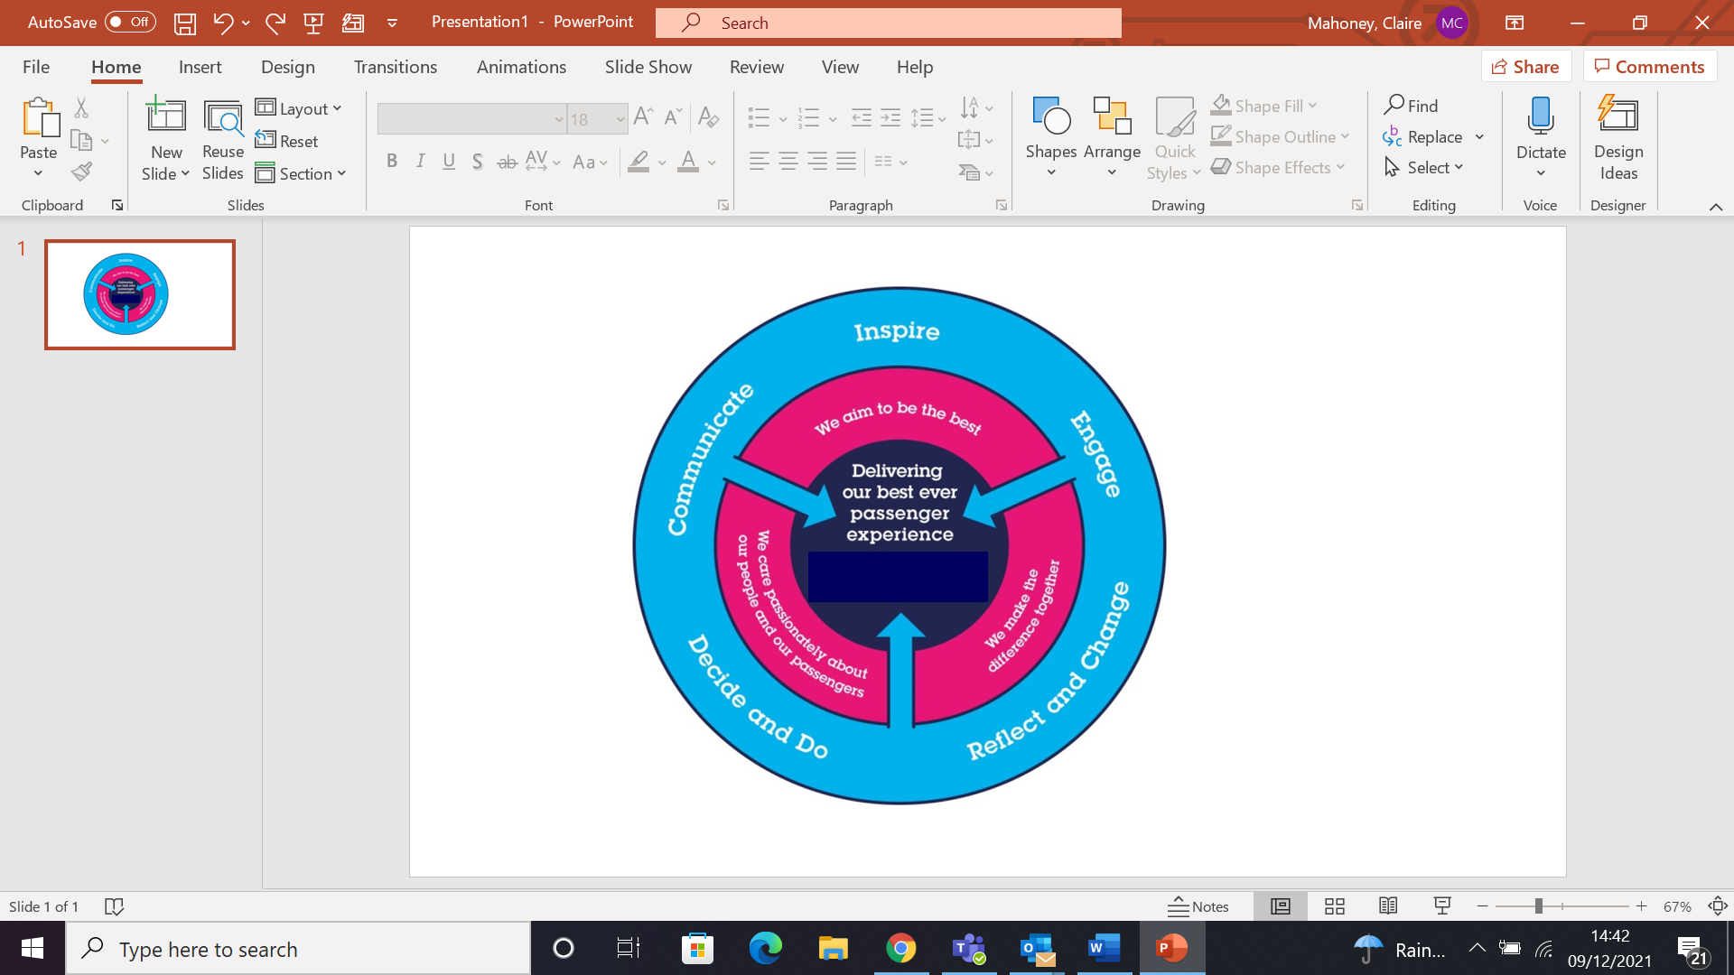

All shortlisted candidates seeking promotion will be assessed against this framework.

The job demands the following blend of experience/knowledge, skills and behaviours (all are essential, unless otherwise shown and will be assessed by application and/ or interview/assessment) :

 | Skills & Knowledge
G1  G2  G3  G4  G5  G6  G7  G9  G10  G11  G12  G13  G14 | Significant experience of working within a corporate governance environment, in a Board Secretary or similar role.  Highly organised with a strong attention to detail and ability to multitask and prioritise with changes in scale, scope, and project deadlines.  Smart, empathetic communicator, skilled in written communication and with the ability to analyse complex information and situations, evaluate issues and recommend an appropriate course of action.  Ability to work on your own initiative, prioritising competing demands and anticipating the needs of Board and Committee Chairs, members and senior colleagues.  Comfortable interacting with executives and senior-level stakeholders, building effective relationships across the business and working within highly technical, specialised disciplines  Ability to engender cooperation from senior colleagues and influence their approach to planning and preparing for key meetings.  Ability to work in a confidential and discrete manner  Excellent time management skills with the ability to think and plan strategically, tactically and creatively over short, medium and long-term timeframes and to reflect this in forward agenda planning  Knowledge of the effective operation of corporate governance to drive business success  Commercial Awareness – understands and applies commercial and financial principles, being able to take a broad based view of issues, events and activities and a perception of their longer-term impact or wider applications.  Leadership – sets direction and encourages commitment to achieve common gaols. Coaches to improve performance.  Communication and team working – expresses oneself clearly, confidently and effectively. Is friendly, approachable and engages others in open, honest and productive conversations. Good listener and supportive of others, helping to promote a team culture. Shares ideas and information.  Thinking and problem-solving – has good analytical skills; analyses issues and breaks them into component parts. Makes systematic and rational judgements based on relevant information.  Preferably previous rail industry or Government experience.

Behaviours
- Influencing – Gains commitment to deliver the desired result, through the use of a range of interpersonal skills, focussing on persuasion, negotiation and selling
- Quality Orientation – Shows awareness of goals and standards, ensuring that quality and productivity standards are met
- Determination and professionalism – dedication and resolve to achieve the programme objectives
- Honesty and Integrity – is transparent and honest and takes full responsibility for actions. Demonstrates confidence and courage and deals effectively with difficult situations
- Flexibility – successfully adapts to changing demands, conditions and scenarios.
- Curious and energetic, with a positive ‘can do' mindset.
I | Dimensions of role
I1 | Financial – Direct: |  |  |  | As per budget and DFA
I2 | Financial – Other:
I3 | Staff Responsibilities – Direct:
I4 | Staff Responsibilities – Other:
I5 | Any Other Statistical Data:
J | Acknowledgement
J1 | Prepared By: Chief of Staff |  |  |  |  |  | Date: | 28/4/23
J2 | Approved By (Head of Department): |  |  |  |  |  | Date:
K | Job Description Briefing
 | The post holder has been briefed on and understands the requirements of this Job Description and other related documents:
 | Name of post holder: |  |  | Signature: |  |  |  |  | Date:
 | Name of briefing manager: |  |  | Signature: |  |  |  |  | Date:
L | Nominated Deputy for Safety requirements
 | If this is a KEY SAFETY POST (D2 in Safety Details above is YES) at least one nominated deputy must be identified. The Job Holder must ensure that the Nominated Deputy(ies) receives a copy of, and is briefed on this Job Description. If there are more nominated deputies, they should sign further copies of this Job Description.
 | The nominated deputy has been briefed on and understands the requirements of this Job Description and other related documents:
 | Name of nominated deputy: |  |  | Signature: |  |  |  |  | Date:
 | Name of briefing manager: |  |  | Signature: |  |  |  |  | Date:

