A | Post Details
 | Job Title: | Driver Apprenticeship Learning Coach | Function: | Human Resources
 | Location: | London / Kent | Unique Post Number:
 | Reports To: | Apprenticeship Manager | Grade: | MG1
B | Purpose of the Job
Provide support and coaching to apprentices, as well as assessing the portfolio of evidence and performance of learners against the skills, knowledge and behaviour criteria laid out in the relevant apprenticeship standard.

Communicating with learners, arranging progress reviews and supporting the completion of e-portfolios.

Work effectively with Functional Skills tutors, Line Managers and the Training Team to ensure learners progress effectively and achieve their qualification.

As a member of the HR team, play a broad role in the delivery of the HR business objectives.

C | Principal Accountabilities
- Work closely with the training team, maintaining an in-depth knowledge of subjects being delivered;
- Supporting and guiding learners in their development, measuring progress in skills, knowledge and behaviours;
- Maintaining effective and efficient administrative systems for recording learners progress towards agreed targets;
- Provide reports on Key Performance Indicators;
- Liaise with the department manager regarding learning targets and additional support for individual learners;
- Support the compilation of evidence including Journey Logs, observations, and professional discussions;
- Review, observe and assess work produced by learners to ensure it is of the appropriate standard.
- Prepare for and attend regular standardisation and review meetings;
- Track, monitor and report mandated ‘off the job’ training time for each learner;
- Take an active role in supporting learners through the gateway and end point assessment process;
- Prepare and support any external assurance visits and audits;
- Attend and/or deliver Apprenticeship Enrolments;
- Act as an independent assessor for the Institute of Rail Operators assisting with End Point Assessments for learners from other Train Operating Companies;
- Actively follow policies e.g. Safeguarding, Data Protection, Equality and Diversity and Health and Safety etc.
- Maintain your occupational competence in line with agreed safety criteria,

D | Safety Responsibilities
D1 | This post is required to undertake SAFETY CRITICAL WORK |  |  |  | Yes |  | No
D2 | This is a KEY SAFETY POST |  |  |  | Yes |  | No
D3 | This post requires SECURITY CLEARANCE |  |  |  | Yes |  | No
D4 | The job requires competence in PERSONAL TRACK SAFETY |  |  |  | Yes |  | No
D5 | This job has SPECIFIC SAFETY RESPONSIBILITIES (if Yes see section D6 below) |  |  |  | Yes |  | No
D6 | The post holder has the following specific safety responsibilities:
E | Decision making Authority
E1
F | Most Challenging and/or Difficult parts of the role
F1  F2  F3 | Time management in order to maintaining occupational competence;  Working to roster teams ensuring effective use of time;  Producing robust review plans to ensure learners are met with, and make progress within the agreed Individual Learning Plan (ILR);

G | Person Specification

Southeastern aims to recruit people not just for jobs but for long term careers. We want good quality, talented people with the right attitude who will stay with us.

For these reasons we look for evidence of Southeastern values and behaviours in all potential staff and our existing staff looking for promotion along with the particular experience/knowledge, skills and behaviours relevant to the position applied for. These are

We care passionately about our people and passengers
  - we put ourselves in our passengers’ shoes to do what’s right for them
  - we support our colleagues to be, feel and do their best
  - we love the places we serve and do our bit for our communities and environment

We aim to be the best
  - we move with pace, we’re agile and learn from everything
  - we relentlessly strive to be the best
  - we are professionals with personalities

We make the difference together
  - we are answerable to each other and our passengers
  - we trust each other and do what we say we will
  - we are stronger together than we are as individuals

We also have identified behaviours required to be successful in leading Southeastern.

The Leading Southeastern framework details how we should be behaving in order to drive up performance.

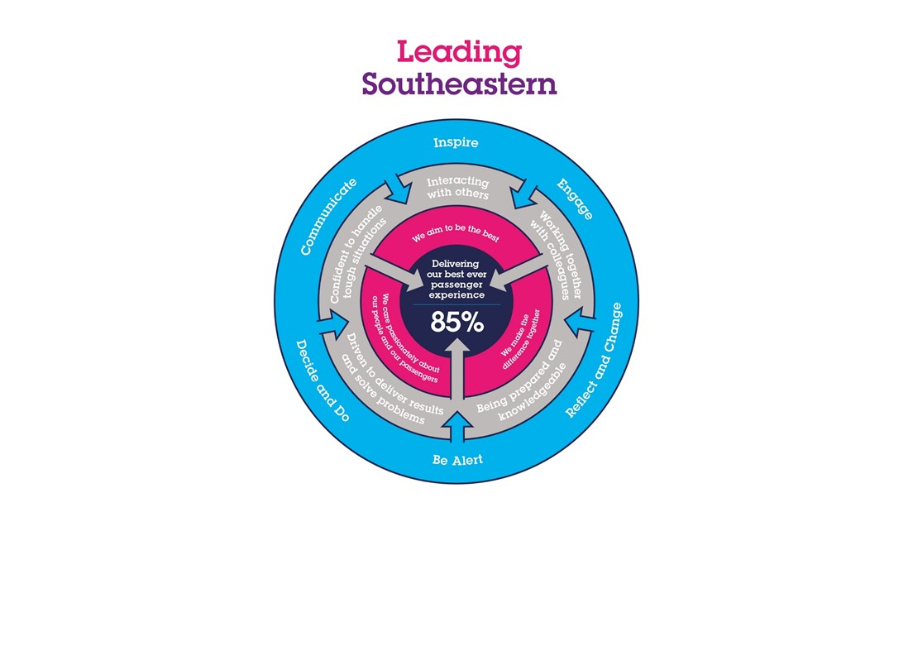

All shortlisted candidates seeking promotion will be assessed against this framework.

The job demands the following blend of experience/knowledge, skills and behaviours (all are essential unless otherwise shown and will be assessed by application and/ or interview/assessment) :

G1 | Experience, Knowledge & Qualifications  - Knowledge of Microsoft Office and IT applications. Experience in producing reports.  - Highly organised and methodical approach to work and able to meet deadlines.  - Able to build positive relationships with learners, key stakeholders, and colleagues;  - Hold relevant occupational competence, with a clear safety record.
G2 | Skills  - Excellent interpersonal and communication skills, both written and oral.  - Shows awareness of goals and standards, ensuring that quality and productivity standards are met.  - Analyses issues and breaks them down into component parts, making systematic and rational judgements based on relevant information.  - Have the initiative to work unsupervised, and undirected.  - Sets up and monitors timescales and plans.  - Proven ability to influence stakeholders and coach learners.

H | Dimensions of role
H1 | Financial – Direct: |  |  |  | Nil
H2 | Financial – Other: |  |  |  | Nil
H3 | Staff Responsibilities – Direct: |  |  |  | Nil
H4 | Staff Responsibilities – Other:
H5 | Any Other Statistical Data:
I | Acknowledgement
I1 | Prepared By: |  |  |  |  |  | Date:
I2 | Approved By (Head of Department): |  |  |  |  |  | Date:
J | Job Description Briefing
 | The post holder has been briefed on and understands the requirements of this Job Description and other related documents:
 | Name of post holder: |  |  | Signature: |  |  |  |  | Date:
 | Name of briefing manager: |  |  | Signature: |  |  |  |  | Date:
K | Nominated Deputy for Safety requirements
 | If this is a KEY SAFETY POST (D2 in Safety Details above is YES) at least one nominated deputy must be identified. The Job Holder must ensure that the Nominated Deputy(ies) receives a copy of and is briefed on this Job Description. If there are more nominated deputies, they should sign further copies of this Job Description.
 | The nominated deputy has been briefed on and understands the requirements of this Job Description and other related documents:
 | Name of nominated deputy: |  |  | Signature: |  |  |  |  | Date:
 | Name of briefing manager: |  |  | Signature: |  |  |  |  | Date:

