A | Post Details
 | Job Title: | Revenue Management Manager | Function: | Commercial
 | Location: | 4 More London | Unique Post Number: | TBC
 | Reports To: | Head of Retail Strategy | Grade: | TBC
B | Purpose of the Job
Effective use of Southeastern’s new Revenue Management System requires a skilled individual to program the system rules and interpret the data that the system provides.

Responsible for the creation and implementation of insight-led strategic development plans to grow and measure income from Southeastern Advance tickets each year.

Ensure Rail Availability and Reservations Service (RARS) and Revenue Management System (RMS) are maintained and optimised for Advance tickets, to deliver revenue targets.

Responsible for analysing Advance fares offering and identifying opportunities across the network, ensuring consistency for customers and stakeholders.

Communication and collaborative working across the business and wider industry to deliver data and insight-led recommendations for future Revenue Management strategies.

Drive optimal income results through effective quota availability strategies and a nuanced and effective approach to train inventory revenue management.

C | Principal Accountabilities
C1  C2  C3  C4  C5  C6  C7  C8  C9  C10  C11 | Lead the team strategy with respect to short/medium-term demand/supply planning to increase revenue and formulate strategy for events or exceptional situations that will drive demand.  Developing yield and journey forecast and targets. Ensuring that any negative variances to targets are effectively addressed.  Responsible for the integrity of the Revenue Management System with specific emphasis on input/seed data and forecast accuracy measurement and improvement.  Interpret key data available from a range of sources to produce recommendations to assist in the making of key business decisions.  Work closely with the Commercial and Finance teams to develop and implement a coherent revenue strategy.  Lead, train, motivate and develop revenue team-members in the Commercial directorate.  Be a key liaison with Marketing/Retail/Digital teams to determine tactical activities and provide commercial expertise in any planning decisions  Ensure booking horizon is maintained, enabling Advance tickets are available for sale as soon as the timetable is published  Provide expert input into the industry development pathway for Revenue Management and Reservations systems with a view to maximising total rail revenue  Undertake project work in relation to fares, retailing and revenue management systems. These include specifying, deploying, and testing new system developments.  Deputise for the Head of Retail Strategy and attend business/industry forums as required.

D | Safety Responsibilities
D1 | This post is required to undertake SAFETY CRITICAL WORK | Yes |  | No
D2 | This is a KEY SAFETY POST | Yes |  | No
D3 | This post requires SECURITY CLEARANCE | Yes |  | No
D4 | The job requires competence in PERSONAL TRACK SAFETY | Yes |  | No
D5 | This job has SPECIFIC SAFETY RESPONSIBILITIES | Yes |  | No
E | Decision making Authority
E1 | Manage the contractual relationship with RMS supplier
F | Most Challenging and/or Difficult parts of the role
F1  F2  F3  F4 | Creating and delivering revenue forecasts  Creation of effective, but complex, business rules to ensure an optimal Revenue Management strategy is developed and implemented for Advance purchase tickets  Managing time between competing priorities, often having to balance the demands of senior internal and external stakeholders (such as DfT, other DOHL TOCs and GBRTT)  Attention to detail under time pressures

G | Person Specification

Southeastern aims to recruit people not just for jobs but for long term careers. We want good quality, talented people with the right attitude who will stay with us.

For these reasons we look for evidence of Southeastern values and behaviours in all potential staff and our existing staff looking for promotion along with the experience/knowledge, skills, and behaviours relevant to the position applied for. These are:

We care passionately about our people and passengers
  - we put ourselves in our passengers’ shoes to do what’s right for them
  - we support our colleagues to be, feel and do their best
  - we love the places we serve and do our bit for our communities and environment

We aim to be the best
  - we move with pace, we’re agile and learn from everything
  - we relentlessly strive to be the best
  - we are professionals with personalities

We make the difference together
  - we are answerable to each other and our passengers
  - we trust each other and do what we say we will
  - we are stronger together than we are as individuals

We also have identified behaviours required to be successful in leading Southeastern.

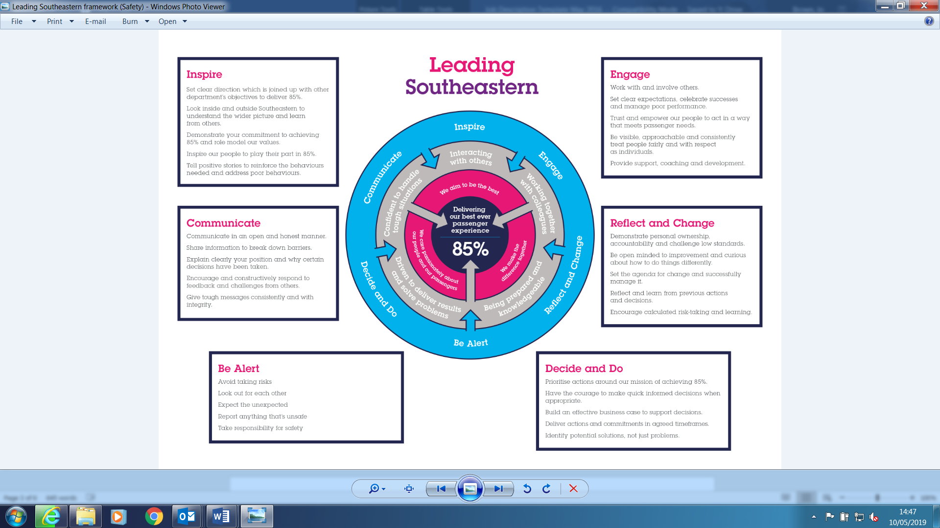

All shortlisted candidates will be assessed against this framework.

The job demands the following blend of experience/knowledge, skills, and behaviours (all are essential , unless otherwise shown and will be assessed by application and/ or interview/assessment):
G1 | Experience, Knowledge & Qualifications  We are looking for a candidate with significant experience in a revenue management post in a highly commercially focused environment is what we are looking for.  Without previous employment experience, a strong capability in a relevant degree (economics, mathematics, statistics, operational research etc) is a must.  Knowledgeable in rail industry (or airline/ferry/coach/car hire) revenue management, fares, and reservations systems.  Highly numerate and IT systems literate.  Able to make strategic revenue impacting decisions, working independently and/or as part of a closeknit team.  Able to build business cases for change.
G2 | Skills (including any specific safety critical competencies)  Knowledge and use of MS Office, including expert-level Excel  Excellent organisational skills  Excellent interpersonal skills  Excellent written and verbal communication skills  Presenting and communicating numerical information in a straightforward and compelling manner to a wide audience  Good problem-solving skills  An influential decision maker  At ease and competent with system-based tools  Proactive approach to learning
G3 | Behaviours  Take personal responsibility for your actions – be transparent and honest. Demonstrate confidence and courage, and deal effectively with difficult situations  Problem Solving – you will identify potential difficulties and causes, generate workable solutions, and make rational judgements.  All colleagues have leadership responsibilities, regardless of their job role. As a leader of our business we expect you to ensure that you engage and inspire our people, are accountable for your actions and business performance, and challenge yourself as an individual to be even better. As a leader you will continually develop and role model leadership skills and our company values.
G4 | Other  Lead interface with departments and senior colleagues across the business, owning group and industry to ensure cohesive and consistent delivery revenue management strategies to optimise revenue growth whilst protecting the business’ reputation  Deputise for the Head of Retail Strategy and attend business/industry forums as may be required from time to time.

I | Dimensions of role
I1 | Financial – Direct: |  |  |  | Direct impact on up to £4m income from Advance tickets sales
I2 | Financial – Other: |  |  |  | Indirect impact on total farebox income
I3 | Staff Responsibilities – Direct: |  |  |  | (currently) 1 x Reservations Administrator & Pricing Assistant
I4 | Staff Responsibilities – Other: |  |  |  | -
I5 | Any Other Statistical Data: |  |  |  | Provide revenue analysis to support initiatives that will help Southeastern achieve and exceed its annual business plan.
J | Acknowledgement
J1 | Prepared By: |  | Simon Byatt |  |  |  | Date: | December 2023
J2 | Approved By (Department): |  | Albert Liddiard |  |  |  | Date: | January 2024
K | Job Description Briefing
 | The post holder has been briefed on and understands the requirements of this Job Description and other related documents:
 | Name of post holder: |  |  | Signature: |  |  |  |  | Date:
 | Name of briefing manager: |  |  | Signature: |  |  |  |  | Date:
L | Nominated Deputy for Safety requirements
 | If this is a KEY SAFETY POST (D2 in Safety Details above is YES) at least one nominated deputy must be identified. The Job Holder must ensure that the Nominated Deputy(ies) receives a copy of and is briefed on this Job Description. If there are more nominated deputies, they should sign further copies of this Job Description.
 | The nominated deputy has been briefed on and understands the requirements of this Job Description and other related documents:
 | Name of nominated deputy: |  |  | Signature: |  |  |  |  | Date:
 | Name of briefing manager: |  |  | Signature: |  |  |  |  | Date:

