A | Post Details
 | Job Title: IT Cyber Security Manager |  | Function: | Engineering, IT and Major Contracts
 | Location:  Four More London |  | Unique Post Number:
 | Reports To:  Head Of IT |  | Grade: MG2
B | Purpose of the Job  The role is responsible for the ongoing cyber security management of the IT systems and services. Leading a team to ensure timely response and remediation of security incidents and potential threats affecting the organisation.  The role will engage and manage the supplier relationships for security related systems, as well as ensuring suppliers are adhering to security requirements, incorporating security reviews of new supply chains.  The role will also lead the major security incident testing routines throughout the year and ensure that it is robust and remains relevant to the changing threat landscape.  The role will also ensure that procedure, process, and standards are created, relevant, and updated when required to ensure they support IT policy. The role will also collaborate with the IT management structure to advise on required policy updates as circumstances and organisational improvements dictate.  This role also performs a significant function in the IT governance requirements, participating in the Design Authority panel, lifecycle Change control of service, software and hardware assets  The role also participates in the Silver command rota requirements of the department, acting as an escalation point for the on-call engineers where impacts of incidents require management involvement and wider organisational or supplier communication and involvement.
C | Principal Accountabilities
C1  C2  C3  C4  C5  C6  C7  C8  C9  C10  C11  C12  C13 | Line management responsibility for the IT Cyber Security team. Set and regularly review KPI’s for the teams and individuals.  Security Incident Management - manage and assist the teams to investigate and implement resolutions in a timely manner  Set and update training paths for the team members, to develop the individuals and ensure ongoing competence for existing and new services supported by the team.  Work with the teams to create and present Security incident reports.  Create and regularly review and update process, procedure and standards  Collaborate with IT management to inform on IT policy amendments where appropriate.  Participate in the IT governance requirements, including the Design Authority Panel and lifecycle Change Management Panel  Supplier engagement and management  Creation of Management reports  Participate in Silver command rota, managing significant technical incidents when required.  Manage document lifecycle requirements within the team, ensuring creation and updates to documentation are completed during installation or upgrades  Lead the Major Security Incident response plan testing, working with the teams to adapt and update them  Undertake any other activity that is commensurate with the role, as requested by the IT Service Delivery manager

D | Safety Responsibilities
D1 | This post is required to undertake SAFETY CRITICAL WORK | Yes |  | No
D2 | This is a KEY SAFETY POST or nominated deputy | Yes |  | No
D3 | The holder of this post is identified as a KEY SAFETY MANAGER | Yes |  | No
D4 | The job requires competence in PERSONAL TRACK SAFETY | Yes |  | No
D5 | This job has SPECIFIC SAFETY RESPONSIBILITIES (if Yes see section D6 below) | Yes |  | No
D6 | The post holder has the following specific safety responsibilities:
Carrying out Planned General Inspections of the following locations:
- None

Acting as Fire Precautions Manager for the following locations:
- None

Safety Interface with the following external parties:
- None

Investigation of accidents occurring at the following locations or as requested by Safety & Environment:
- None

E | Decision making Authority
E1 | As appropriate to ensure the security posture of the organisation is maintained and improved.
F | Most Challenging and/or Difficult parts of the role
F1 | Balancing security options against the operational requirements of the organisation

G | Person Specification

Southeastern aims to recruit people not just for jobs but for long term careers. We want good quality, talented people with the right attitude who will stay with us.

For these reasons we look for evidence of Southeastern values and behaviours in all potential staff and our existing staff looking for promotion along with the particular experience/knowledge, skills and behaviours relevant to the position applied for. These are

We care passionately about our people and passengers
  - we put ourselves in our passengers’ shoes to do what’s right for them
  - we support our colleagues to be, feel and do their best
  - we love the places we serve and do our bit for our communities and environment

We aim to be the best
  - we move with pace, we’re agile and learn from everything
  - we relentlessly strive to be the best
  - we are professionals with personalities

We make the difference together
  - we are answerable to each other and our passengers
  - we trust each other and do what we say we will
  - we are stronger together than we are as individuals

We also have identified behaviours required to be successful in leading Southeastern.

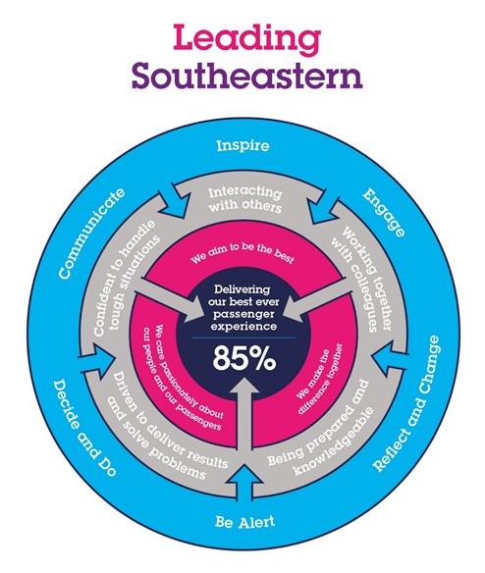

The Leading Southeastern framework details how we should be behaving in order to drive up performance to deliver 85 by 18.

All shortlisted candidates seeking promotion will be assessed against this framework.

The job demands the following blend of experience/knowledge, skills and behaviours (all are essential , unless otherwise shown and will be assessed by application and/ or interview/assessment) :

G1 | Experience, Knowledge & Qualifications (including any specific safety training requirements)  At least 4 years’ experience across multiple functions of InfoSec.  CISSP,  CEH  Experience of Red/blue team scenarios  Security Risk experience.  EDR experience
G2 | Skills (including any specific safety critical competencies)  Driven individual with a ‘CAN DO’ attitude that engenders confidence, respect and support.  Passion, enthusiasm and expertise.  Good written and verbal communication skills  Quality and transparency  Good prioritising skills and the ability to meet targets
G3 | Behaviours  Honesty  Integrity  Reliable
G4 | Other

H | Dimensions of role
H1 | Financial – Direct: DFA up to
H2 | Financial – Other:
H3 | Staff Responsibilities – Direct: Line management of 3 individuals.
H4 | Staff Responsibilities – Other:
H5 | Any Other Statistical Data:
I | Acknowledgement
I1 | Prepared By: | _______________ |  | Date: | ______________
I2 | Approved By (Head of Department): | _______________ |  | Date: | ______________

J | Job Description Briefing
 | The post holder has been briefed on and understands the requirements of this Job Description and other related documents:
 | Name of post holder: |  | Signature: |  | Date:
 | Name of briefing manager: |  | Signature: |  | Date:
K | Nominated Deputy for Safety requirements
 | If this is a KEY SAFETY POST (D2 in Safety Details above is YES) at least one nominated deputy must be identified. The Job Holder must ensure that the Nominated Deputy(ies) receives a copy of, and is briefed on this Job Description. If there are more nominated deputies, they should sign further copies of this Job Description.
 | The nominated deputy has been briefed on and understands the requirements of this Job Description and other related documents:
 | Name of nominated deputy: |  | Signature: |  | Date:
 | Name of briefing manager: |  | Signature: |  | Date:

