A | Post Details
 | Job Title: | Driver Manager | Function: | Train Services
 | Location: |  | Unique Post Number:
 | Reports To: | Local Operations Manager | Grade: | MG2
B | Purpose of the Job
 | To ensure safe reliable train operation in compliance with Railway Group and Company Standards. Line manage drivers to ensure a safe, reliable, punctual train service that customers will buy, at a cost to allow profit.
C | Principal Accountabilities
C1  C2  C3  C4  C5  C6  C7  C8  C9  C10  C11 | Assess and certificate the competence of persons involved in driving and working with trains.  Monitor and enforce the compliance of standards regarding persons engaged in ‘safety critical work,’ so far as driving and train operation is concerned, taking special cognisance of the requirements of the Network Rail Rule Book, Railway Group Standards, Safety Requirements for Train Drivers, and Train Working: Competency and Fitness.  Undertake training of staff in those competencies and standards defined above.  Organise and perform routine supervisory visits to locations, in accordance with company standards, where ‘safety critical work’ activities are being performed.  Attend at the site and investigate the circumstances of accidents and incidents concerning train working.  Undertake On Call and TOLO responsibilities as required.  Manage communication, recruitment, training, development and welfare of staff, in compliance with company procedures (including attendance, capability and conduct).  Deliver or exceed agreed performance indicators.  Responsible for the health and safety of customers, visitors, contractors and staff at depots for which responsible.  Participate in or lead projects as required.  Deliver agreed actions and activities to support the delivery of the Units Performance Improvement Plans

D | Safety Responsibilities
D1 | This post is required to undertake SAFETY CRITICAL WORK | Yes |  | No
D2 | This is a KEY SAFETY POST or nominated deputy | Yes |  | No
D3 | The holder of this post is identified as a KEY SAFETY MANAGER | Yes |  | No
D4 | The job requires competence in PERSONAL TRACK SAFETY | Yes |  | No
D5 | This job has SPECIFIC SAFETY RESPONSIBILITIES (if Yes see section D6 below) | Yes |  | No
D6 | The post holder has the following specific safety responsibilities:
Carrying out Planned General Inspections of the following locations:
- [list locations or delete if not applicable]

Acting as Fire Precautions Manager for the following locations:
- [list locations or delete if not applicable]

Safety Interface with the following external parties:
- [list interfaces or delete if not applicable]

Investigation of accidents occurring at the following locations or as requested by Safety & Environment:
- [list locations or delete if not applicable]

E | Decision making Authority
E1

F | Most Challenging and/or Difficult parts of the Job
F1  F2 | Delivering the required assessment activities within the timescales set  Ensuring that the right balance between compliance driven assessment activities and more general line management actions are delivered.
G | Person Specification:

Southeastern aims to recruit people not just for jobs but for long term careers. We want good quality, talented people with the right attitude who will stay with us.

For these reasons we look for evidence of Southeastern values and behaviours in all potential staff and our existing staff looking for promotion along with the particular experience/knowledge, skills and behaviours relevant to the position applied for. These are

We care passionately about our people and passengers
  - we put ourselves in our passengers’ shoes to do what’s right for them
  - we support our colleagues to be, feel and do their best
  - we love the places we serve and do our bit for our communities and environment

We aim to be the best
  - we move with pace, we’re agile and learn from everything
  - we relentlessly strive to be the best
  - we are professionals with personalities

We make the difference together
  - we are answerable to each other and our passengers
  - we trust each other and do what we say we will
  - we are stronger together than we are as individuals

We also have identified behaviours required to be successful in leading Southeastern.

The Leading Southeastern framework details how we should be behaving in order to drive up performance to deliver 85.

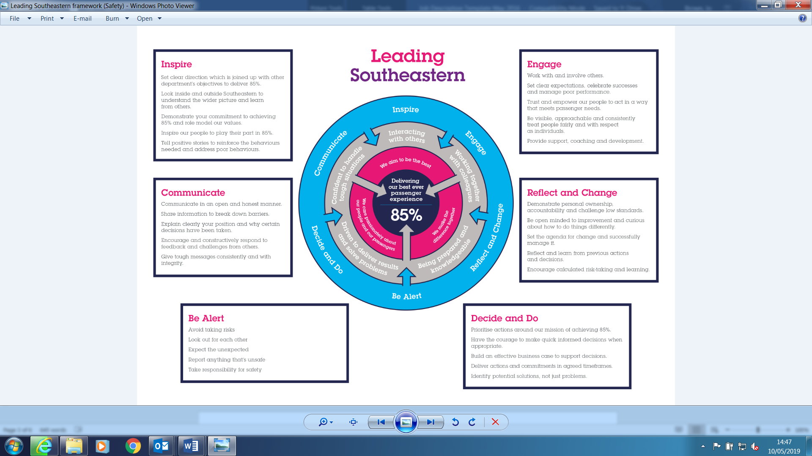

All shortlisted candidates seeking promotion will be assessed against this framework.

The job demands the following blend of experience/knowledge, skills and behaviours (all are essential , unless otherwise shown and will be assessed by application and/ or interview/assessment) :

G1 | Experience, Knowledge & Qualifications – Essential  Licence to drive trains  Thorough knowledge of train driving techniques, rules, instructions and Railway Group and Company Standards. Able to achieve competence in Personal Track Safety (PTS).  Able to investigate accidents and incidents with the objective of identifying basic underlying and root causes, and able to make meaningful recommendations to prevent re-occurrence.  Verbal and written communication skills.  Ability to achieve Vocational Qualification in assessing to required level.  Thorough knowledge of conditions of service applicable to train crew.  Ability to obtain Vocational Qualification in management.
G2 | Experience, Knowledge & Qualifications – Desirable  Previous line management experience  Experience in coaching
G3 | Behaviours and Skills – Essential  Good leadership skills  Excellent communicator  Strong investigatory skills with a good questioning technique  Professionalism  Honesty and integrity- Is transparent and honest and takes full responsibility for actions.  Well organised – able to plan for and achieve deadlines
G4 | Behaviours and Skills – Desirable

H | Dimensions of the Job
H1 | Financial – Direct:
H2 | Financial – Other:
H3 | Staff Responsibilities – Direct:
H4 | Staff Responsibilities – Other:
H5 | Any Other Statistical Data:
I | Acknowledgement
I1 | Prepared By: |  | _______________ |  |  |  | Date: | ______________
I2 | Approved By (Head of Department): |  | _______________ |  |  |  | Date: | ______________
J | Job Description Briefing
 | The post holder has been briefed on and understands the requirements of this Job Description and other related documents:
 | Name of post holder: |  |  | Signature: |  |  |  |  | Date:
 | Name of briefing manager: |  |  | Signature: |  |  |  |  | Date:
K | Nominated Deputy for Safety requirements
 | If this is a KEY SAFETY POST (D2 in Safety Details above is YES) at least one nominated deputy must be identified. The Job Holder must ensure that the Nominated Deputy(ies) receives a copy of, and is briefed on this Job Description. If there are more nominated deputies, they should sign further copies of this Job Description.
 | The nominated deputy has been briefed on and understands the requirements of this Job Description and other related documents:
 | Name of nominated deputy: |  |  | Signature: |  |  |  |  | Date:
 | Name of briefing manager: |  |  | Signature: |  |  |  |  | Date:

