A | Post Details
 | Job Title: | Suicide and Trespass Reduction Manager | Function: | Safeguarding
 | Location: | TBC | Unique Post Number:
 | Reports To: | Safeguarding Manager | Grade: | MG1
B | Purpose of the Job
Southeastern Trains, supported by our stakeholder Network Rail (Kent Route) have created a dedicated role of Suicide & Trespass Reduction Manager for the Kent route. The role will involve, implementing and developing the current and future Joint Suicide Reduction Plan that aligns with the Joint Safeguarding Strategy, influencing the industry to proactively tackle this subject.

The post holder will work for our existing Safeguarding Manager to lead and develop our joint approach to safeguarding across our network. You will assist with delivering a strategy that encompasses our operational response to a range of vulnerable people using or seeking refuge on our network; including those who are suicidal, homeless, impacted by mental health issues, children, young adults and those at risk of being involved in criminal activity due to their vulnerability. The wide-ranging remit of this role will allow you to focus and deliver improvements on a range of interconnected issues and provide strategic alignment between Network Rail and other Train Operating companies, including GB Freightliner who operate on the Kent Network.

You must be highly motivated and enthusiastic, with influencing skills and you will have experience of working collaboratively across a complex structure of internal and external stakeholders. A strong relationship builder and superb influencer, this individual will champion this issue across the business and wider industry.

Please do be aware that due to the nature of this role, and the focus on suicide prevention the successful applicant may required to view upsetting and/or graphic footage of operational incidents and may, on occasion, be required to represent Southeastern at Coroners Court.

C | Principal Accountabilities
C1  C2  C3  C4  C5  C6  C7  C8  C9 | Responsible for the delivery and co-ordination of the Joint Safeguarding Strategy, liaising with central and route-based action owners to track and report on the progress of suicide reduction intervention.  Responsible for delivering the strategic objectives as set out in the Southeastern, Network Rail, British Transport Police Joint 2022/23 Suicide Reduction Plan and focusing attention on the anti-trespass work being undertaken by Southeastern Trains, BTP and Network Rail.  Lead the implementation of initiatives designed to reduce likelihood of trespass and suicides taking place across the Kent route, this will include ownership of Operation Safer for NWR and Southeastern  Liaise with industry groups on suicide prevention and anti-trespass continuing to champion improvements nationally, maintaining the Southeastern and NWR reputation and represent the Safeguarding team for all review meetings where performance has been severely impacted. Supporting the Joint Performance Team with reports and discussion points prior to these reviews and undertake completion of assigned actions, and implement learning recommendations, following the review to mitigated future events.  Responsibility and oversight of the Southeastern and NWR Welfare Officers, ensuring they are efficient and effective resource that is embedded within Southeastern and aligned to all policies, training and equipped with all the required equipment. Deliver end of period reports and yearly reviews to include NWR Southern Route (Kent) Welfare Officers.  Ensuring Southeastern has effective arrangements in place to respond suicide events by being the initial point of contact for suicide reduction matters, involving colleagues at an appropriate level to ensure timely responses to stakeholders, including coroner courts and embedding learning throughout the organisation.  Manage and where appropriate, improve the process for responding to recommendations made in BTP Designing Out Crime Unit (DOCU) reports by ensuring joint site visits are attended that will contribute to these reports.  Oversee Managing Suicide Contacts (MSC) training (and associated) and track progress, ensuring Area and Station Managers are leading and implementing this training for all station colleagues.  Liaise with the NWR and SouthEastern safety teams to ensure that the Kent route have appropriate management arrangements and control plans.
D | Person Specification

Southeastern aims to recruit people not just for jobs but for long term careers. We want good quality, talented people with the right attitude who will stay with us.

For these reasons we look for evidence of Southeastern values and behaviours in all potential staff and our existing staff looking for promotion along with the particular experience/knowledge, skills and behaviours relevant to the position applied for. These are

We care passionately about our people and passengers
  - we put ourselves in our passengers’ shoes to do what’s right for them
  - we support our colleagues to be, feel and do their best
  - we love the places we serve and do our bit for our communities and environment

We aim to be the best
  - we move with pace, we’re agile and learn from everything
  - we relentlessly strive to be the best
  - we are professionals with personalities

We make the difference together
  - we are answerable to each other and our passengers
  - we trust each other and do what we say we will
  - we are stronger together than we are as individuals

We also have identified behaviours required to be successful in leading Southeastern.

The Leading Southeastern framework details how we should be behaving in order to drive up performance to deliver 85%.

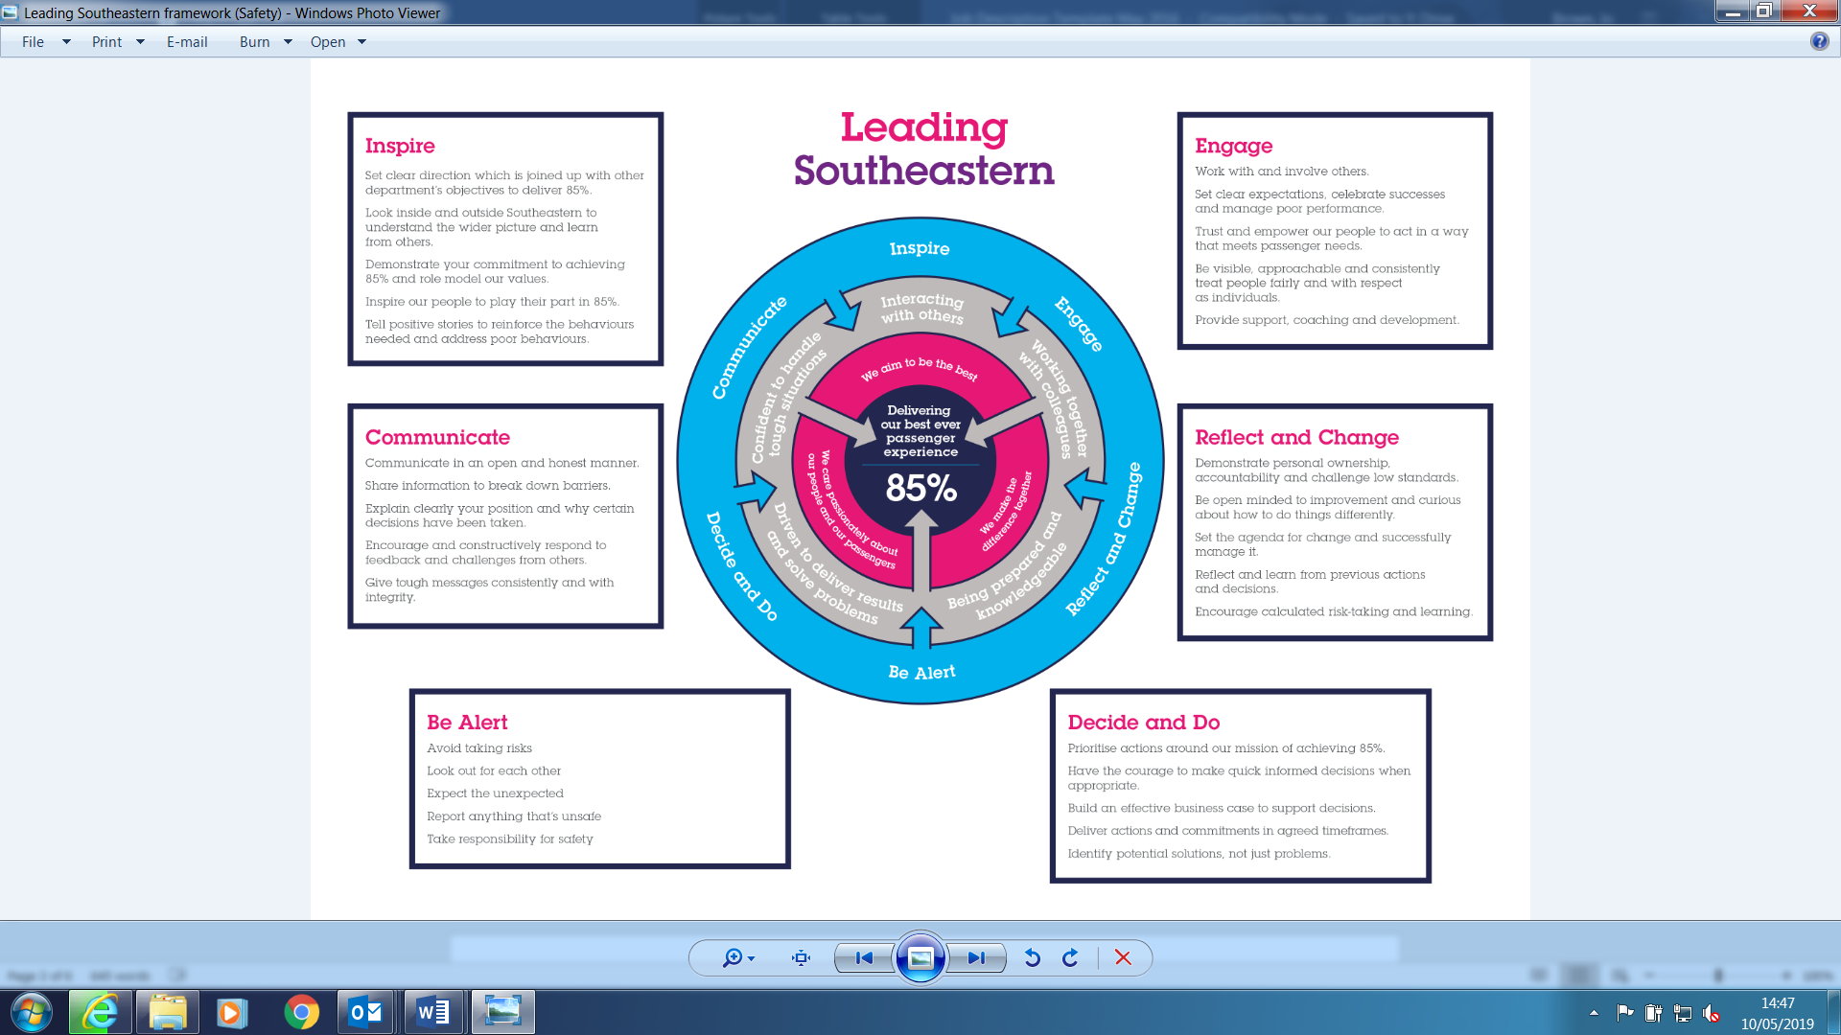

All shortlisted candidates seeking promotion will be assessed against this framework.

The job demands the following blend of experience/knowledge, skills and behaviours (all are essential , unless otherwise shown and will be assessed by application and/ or interview/assessment) :

D1 | Experience, Knowledge & Qualifications (including any specific safety training requirements)  - Experience of working in a business environment requiring a high degree of self-motivation and personal integrity  - Experience of leading or supporting staff through process or business change  - Demonstrable experience of using research and evidence in policy making  - Demonstrable experience of successfully managing complex and/or high-profile projects  - Demonstrable experience of developing partnerships with external organisations to drive change forward

D2 | Skills (including any specific safety critical competencies)  Communication – Expresses oneself confidently and effectively. Is friendly and engages others in open, honest and productive conversations. Confident presentation skills and analytical understating, including excellent written skills with proven ability to research and write accessible, clear reports for a range of audiences.  Leadership – Ability to motivate, empower, negotiate, and influence people at all levels within own team, across the organisation and externally. Deploying influence over those, not in their direct reporting line, to deliver.  Interpersonal Skills – A proven ability to build effective working relationships at all levels internally and externally.  Decision Making – Ability to use initiative and sound judgment, to make informed decisions or recommendations and work under pressure to tight deadlines in a complex political environment.  Persuasiveness – Presents the key points of an argument persuasively and is able to influence decisions.  Collaboration – is able to work collaboratively and productively with a broad range of parties who may have differing needs/ agendas.  Commercial Awareness - Understands and applies commercial and financial principles. Views issues in terms of costs, profits, markets and added value.  IT Skills – Proficient with Microsoft Office (Word, Excel, PowerPoint, Outlook)
D3 | Behaviours  Professionalism – Interacts with others in a sensitive and effective way. Respects and works well with others.  Adding Value – Seeks out opportunities to improve results and add value to the business.  Honesty and integrity – A trustworthy, accountable and reliable individual.  Teamwork – Able to work as part of a small team, within a large department and within external partnerships
E | Decision making Authority
E1  E2 | The ability to robustly make suggestions with internal and external stakeholders and agencies to help with the correct decision to enable positive actions.  To work with analysts by using the data to identify areas of concern and emerging trends to make suggestions to enable a proactive response.
F | Most Challenging and/or Difficult parts of the role
F1  F2  F3 | Perseverance and tenacity to solve challenging problems.  Exposure to potentially distressing or emotive information regarding safeguarding issues  Politically sensitivity when dealing with education establishments, local authorise and the Police Service.

