A | Post Details
 | Job Title: Asset Compliance Manager |  |  | Function: Managerial
 | Location: London, 4ML |  |  | Unique Post Number:
 | Reports To: Head of Estates and Facilities |  |  | Grade: MG2
B | Purpose of the Job
The purpose of the Asset Compliance Manager role is to embed the relevant ISO quality standard processes within Southeastern, act as a champion for change management across the business divisions and enable successful creation and execution of a 40-year long-term station asset management plan to maximise value and manage risk. The Asset Compliance Manager plays a key role in ensuring collaboration with external and internal stakeholder engagement.
Southeastern Asset Management approach forms part of our wider business transformation programme and is designed to deliver our business objectives.
A key component of the Asset Compliance Manager role is continued development of our People, Processes, Data and Technology, aligned to our Asset Management System through efficient stakeholder engagement and collaboration with internal and external parties.
C | Principal Accountabilities
C1  C2  C3  C4  C5  C6  C8  C9  C10  C11  C12  C13  C14  C15 | Leading Southeastern Asset Management Office (Asset Compliance Assistant Manager and Data Analyst) based in London 4 ML Head Office (Hybrid Working).  Leading provision of Asset Management advice and direction for 164 Southeastern stations across SER network.  Asset related service contracts and projects that will deliver asset renewals or enhancements that will come under the scope of this position are valued circa £20m pa. This excludes Network Rail works that will also come into scope.  Managing and influencing multi-level internal and external stakeholder expectations and behaviours including leading change management for implementing mature and functional asset management system  Accountable for Asset Management Strategic planning and efficient stakeholder engagement with key internal and external stakeholders (i.e., Network Rail, Maintenance providers, Senior Contract Managers, Department for Transport, Facilities Project Managers, IT Dept, Commercial & Development, Station Teams and Senior Leaders).  Accountable for strategic alignment of the 40-year Asset management plan within the Network Rail Control Period plans and to ensure planned investments are clearly communicated with Network Rail to avoid duplication or works  Ensure consistent compliance with the ISO55001:2014 Asset Management Standards, SFG20 and Network Rail Standards.  Ensure consistent achievement of asset management objectives and service contract obligations relating to station asset management within timescales.  Review Asset Management policies, processes, strategies, and plans and make recommendations for potential adjustments.  Lead and provide guidance to Asset Management team. Lead the AM team on a multitude of Asset Management activities to drive business performance and influence change across the business.  Develop strategies to increase Return on Investment (ROI) and minimise risk and loss.  Attend the Southeastern Asset Management Steering Group (AMSG) and ensure compliance with the ISO55001 quality standard in reference to Periodic Asset Management Reviews.  Manage risk and opportunity assessment process in AMSG in order to pro-actively escalate, monitor, analyse, and action identified risks and opportunities associated with station assets.  Enable continuous development of Southeastern People, Processes, Data and Technology, to ensure aligned approach on Asset Management System through efficient collaboration and stakeholder engagement.

D | Safety Responsibilities
D1 | This post is required to undertake SAFETY CRITICAL WORK | Yes |  | No
D2 | This is a KEY SAFETY POST or nominated deputy | Yes |  | No
D3 | The holder of this post is identified as a KEY SAFETY MANAGER | Yes |  | No
D4 | The job requires competence in PERSONAL TRACK SAFETY | Yes |  | No
D5 | This job has SPECIFIC SAFETY RESPONSIBILITIES | Yes |  | No
E | Decision making Authority
E1 | Purchase through the Oracle System within budget and Delegated Financial Authority up to a maximum of £5k
F | Most Challenging and/or Difficult parts of the role
F1  F2  F3 | Managing and influencing multi-level internal and external stakeholder expectations and behaviours including change management  Ensure consistent compliance with the ISO55001:2014 Asset Management System Standards as well as compliance with the SFG20 and Network Rail Standards.  Ensure consistent achievement of asset management objectives, service contract obligations and company standards within timescales.

G | Person Specification

Southeastern aims to recruit people not just for jobs but for long term careers. We want good quality, talented people with the right attitude who will stay with us.

For these reasons we look for evidence of Southeastern values and behaviours in all potential staff and our existing staff looking for promotion along with the particular experience/knowledge, skills and behaviours relevant to the position applied for. These are

We care passionately about our people and passengers
  - we put ourselves in our passengers’ shoes to do what’s right for them
  - we support our colleagues to be, feel and do their best
  - we love the places we serve and do our bit for our communities and environment

We aim to be the best
  - we move with pace, we’re agile and learn from everything
  - we relentlessly strive to be the best
  - we are professionals with personalities

We make the difference together
  - we are answerable to each other and our passengers
  - we trust each other and do what we say we will
  - we are stronger together than we are as individuals

We also have identified behaviours required to be successful in leading Southeastern.

The Leading Southeastern framework details how we should be behaving in order to drive up performance to deliver 85%.

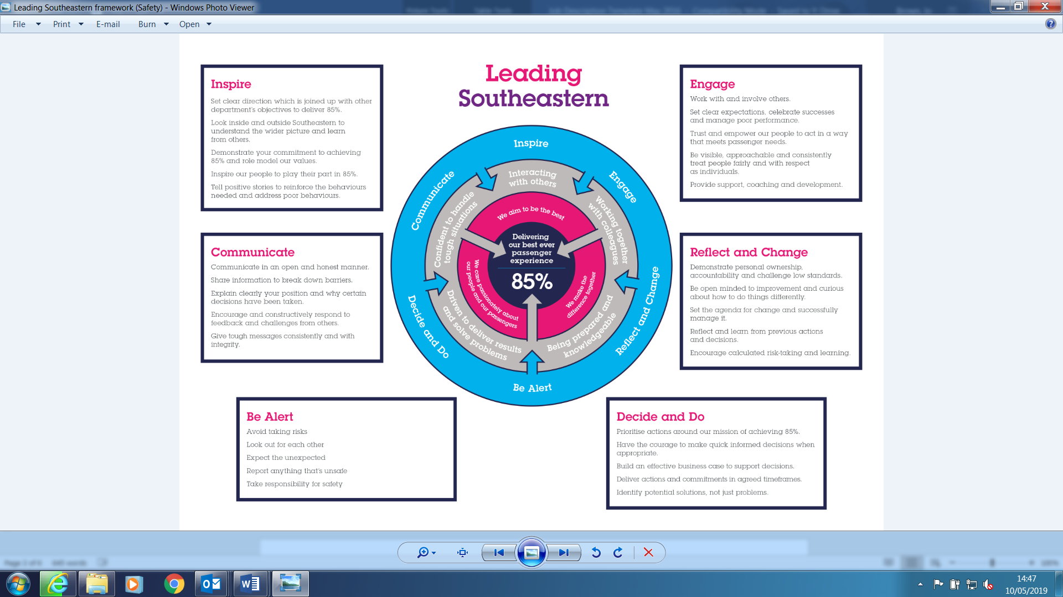

All shortlisted candidates seeking promotion will be assessed against this framework.

The job demands the following blend of experience/knowledge, skills, and behaviours (all are essential, unless otherwise shown and will be assessed by application and/ or interview/assessment):

G1 | Experience, Knowledge & Qualifications (including any specific safety training requirements)  - Ideally, educated to degree standard, Business administration or STEM based subjects such as engineering preferred (suitable candidates without a degree will be considered if they possess demonstrable experience in an equivalent role)  - Asset Management Experience with comprehensive knowledge of operating to ISO 55001 and/or ISO business management systems (e.g., ISO 9001, 14001, 44001, 45001)  - Experience in any of the following roles would be beneficial: Project Management, Asset Management, Facilities Management (SFG 20), Lean 6 Sigma or ISO Audit/Management Systems  - Experience supporting initiatives to demonstrate industry benchmarking, knowledge sharing and continuous improvement  - Experience of leading technical investigations (e.g., Root Cause Analysis or 5 Whys)  - Previous experience of conducting risk and opportunity assessments and analysis.  - Previous experience in developing and mentoring talented people.
G2 | Skills (including any specific safety critical competencies)  - Stations and estates management and good understanding of station assets.  - Project Management skills favourable  - Previous line management experience  - Excellent written and verbal communication skills (incl. presentation skills) and the ability to communicate at all levels, with both internal and external stakeholders.  - Experience of building business cases and demonstrating items that can add value, increase performance, and drive efficiency.
G3 | Behaviours  - Highly self-motivated  - Ability to influence and motivate others  - Approachable, engaging and collaborative  - Organised and process driven

H | Dimensions of role
H1 | Financial – Direct:
H2 | Financial – Other:
H3 | Staff Responsibilities – Direct:
H4 | Staff Responsibilities – Other:
H5 | Any Other Statistical Data:
I | Acknowledgement
I1 | Prepared By: | _______________ |  | Date: | ______________
I2 | Approved By (Head of Department): | _______________ |  | Date: | ______________

J | Job Description Briefing
 | The post holder has been briefed on and understands the requirements of this Job Description and other related documents:
 | Name of post holder: |  | Signature: |  | Date:
 | Name of briefing manager: |  | Signature: |  | Date:
K | Nominated Deputy for Safety requirements
 | If this is a KEY SAFETY POST (D2 in Safety Details above is YES) at least one nominated deputy must be identified. The Job Holder must ensure that the Nominated Deputy(ies) receives a copy of, and is briefed on this Job Description. If there are more nominated deputies, they should sign further copies of this Job Description.
 | The nominated deputy has been briefed on and understands the requirements of this Job Description and other related documents:
 | Name of nominated deputy: |  | Signature: |  | Date:
 | Name of briefing manager: |  | Signature: |  | Date:

