A | Post Details
 | Job Title: IT Project Engineer |  | Function: | IT Department
 | Location:  Four More London |  | Unique Post Number:
 | Reports To: IT Service Manager |  | Grade: FTC - MG1 (1yr)
B | Purpose of the Job  The purpose of the role is to provide technical skills and insight to support the delivery of projects within the organisation.  The role will co-ordinate with the IT Support, Network and Cyber Security teams, gathering and sharing technical information, configuring, testing, undertaking troubleshooting tasks and documenting configurations, to ensure a stable and secure delivery of project objectives. Tasks will range from implementation and changes on desktops, servers, network cabling and switches, station devices e.g. Gateline or ticket system integrations, and Wireless access points.  The role will need to available for a combination of remote and onsite work, across London, Kent and East Sussex, as required by the projects, with the possibility of out of hours and weekend work where required.
C | Principal Accountabilities
C1  C2  C3  C4  C5  C6  C7  C8 | Engage with project team(s) to help scope out the technical requirements, including integration considerations, for the successful delivery of the project  Track and report to projects and IT management on progress of the technical aspects of a project  Facilitate and help gather technical information required to support the delivery of the project.  Undertake technical configurations, testing and troubleshooting as required for the project delivery, liaising with IT teams and 3rd parties subject matter experts as appropriate.  Oversee and manage the actions of 3rd party organisations undertaking work within Southeastern’s IT estate, liaising with IT teams and management to ensure configurations and delivery are performed within the requirements of policy, standards and best practice  Create and update documentation on configurations and integrations of new and changing technologies within the project delivery, enabling a controlled transition of the technical aspects the appropriate IT team(s).  Ensure that the formal change and release management processes are adhered to during the project delivery, working through the IT Change Panel.  Undertake any other activity that is commensurate with the role, as requested by IT management
D | Safety Responsibilities
D1 | This post is required to undertake SAFETY CRITICAL WORK |  |  |  | Yes |  | No
D2 | This is a KEY SAFETY POST or nominated deputy |  |  |  | Yes |  | No
D3 | The holder of this post is identified as a KEY SAFETY MANAGER |  |  |  | Yes |  | No
D4 | The job requires competence in PERSONAL TRACK SAFETY |  |  |  | Yes |  | No
D5 | This job has SPECIFIC SAFETY RESPONSIBILITIES (if Yes see section D6 below) |  |  |  | Yes |  | No
D6 | The post holder has the following specific safety responsibilities:
Carrying out Planned General Inspections of the following locations:
- None

Acting as Fire Precautions Manager for the following locations:
- None

Safety Interface with the following external parties:
- None

Investigation of accidents occurring at the following locations or as requested by Safety & Environment:
- None

E | Decision making Authority
E1 | N/A
F | Most Challenging and/or Difficult parts of the role
F1 | Managing and balancing the expectations of the project and organisation against workload capacity.

G | Person Specification

Southeastern aims to recruit people not just for jobs but for long term careers. We want good quality, talented people with the right attitude who will stay with us.

For these reasons we look for evidence of Southeastern values and behaviours in all potential staff and our existing staff looking for promotion along with the particular experience/knowledge, skills and behaviours relevant to the position applied for. These are

We care passionately about our people and passengers
  - we put ourselves in our passengers’ shoes to do what’s right for them
  - we support our colleagues to be, feel and do their best
  - we love the places we serve and do our bit for our communities and environment

We aim to be the best
  - we move with pace, we’re agile and learn from everything
  - we relentlessly strive to be the best
  - we are professionals with personalities

We make the difference together
  - we are answerable to each other and our passengers
  - we trust each other and do what we say we will
  - we are stronger together than we are as individuals

We also have identified behaviours required to be successful in leading Southeastern.

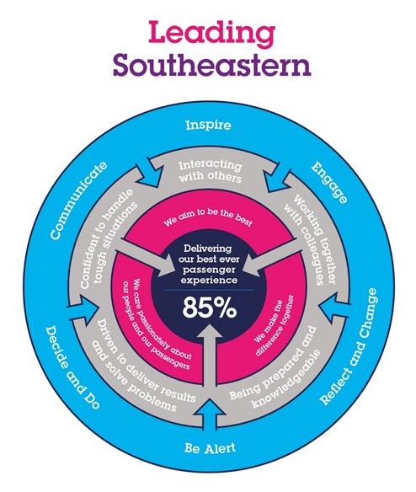

The Leading Southeastern framework details how we should be behaving in order to drive up performance to deliver 85 by 18.

All shortlisted candidates seeking promotion will be assessed against this framework.

The job demands the following blend of experience/knowledge, skills and behaviours (all are essential , unless otherwise shown and will be assessed by application and/ or interview/assessment) :

G1 | Experience, Knowledge & Qualifications (including any specific safety training requirements)  2 years experience working in 3rd line or project delivery/support role (or equivalent)  MCSE, MS-Azure qualification or equivalent (desirable)  Demonstrable understanding of Networking (LAN and WAN)
G2 | Skills (including any specific safety critical competencies)  Driven individual with a ‘CAN DO’ attitude that engenders confidence, respect and support.  Passion, enthusiasm and expertise.  Good written and verbal communication skills  Quality and transparency  Good prioritising skills and the ability to meet targets
G3 | Behaviours  Honesty  Integrity  Reliable
G4 | Other

H | Dimensions of role
H1 | Financial – Direct: None
H2 | Financial – Other: None
H3 | Staff Responsibilities – Direct: None
H4 | Staff Responsibilities – Other: None
H5 | Any Other Statistical Data:
I | Acknowledgement
I1 | Prepared By: | _______________ |  | Date: | ______________
I2 | Approved By (Head of Department): | _______________ |  | Date: | ______________

J | Job Description Briefing
 | The post holder has been briefed on and understands the requirements of this Job Description and other related documents:
 | Name of post holder: |  | Signature: |  | Date:
 | Name of briefing manager: |  | Signature: |  | Date:
K | Nominated Deputy for Safety requirements
 | If this is a KEY SAFETY POST (D2 in Safety Details above is YES) at least one nominated deputy must be identified. The Job Holder must ensure that the Nominated Deputy(ies) receives a copy of, and is briefed on this Job Description. If there are more nominated deputies, they should sign further copies of this Job Description.
 | The nominated deputy has been briefed on and understands the requirements of this Job Description and other related documents:
 | Name of nominated deputy: |  | Signature: |  | Date:
 | Name of briefing manager: |  | Signature: |  | Date:

