A | Post Details
 | Job Title: | Assistant Management Accountant | Function: | Finance
 | Location: | 4 More London | Unique Post Number:
 | Reports To: | Finance Business Partner | Grade: | ASG
B | Purpose of the Job
This is an entry level role, designed to see progression and development in the workplace such as learning and developing management accounting expertise while business partnering non-finance functions and learning the critical principles which enable the finance function to deliver for Southeastern.

The role also entails progression in the government’s level 7 apprentice programme and receiving the chartered institute of management accounts (CIMA) qualification. Once qualified, you will be a designated as Associate Chartered Management Accountant (ACMA) and Chartered Global Management Accountant (CGMA).

C | Principal Accountabilities
Period End
- Proactively challenge periodic figures, prepare financial listings and support Finance Business Partners in their directorate.
- Prepare and submit accounting journals that are compliant with the relevant accounting regulation.
- Work towards tight deadlines to ensure accurate delivery of period end timetable.
Reporting
- Articulate concise commentary outlining the periodic narrative for directorates.
- Produce periodic, timely and accurate reports to finance and non-finance functions.
- Provide detailed variance analysis to budget holders and finance business partnering team.
Forecasting
- Demonstrate strong data processing and analytical skills during the budget upload process.
- Develop financial modelling to support the annual business plan process for Southeastern (contributing to the wider DOHL Group).
- Work collaboratively with finance and non-finance functions to produce an accurate budget and forecast.

Training
- To complete CIMA training, studies and exams for the level 7 apprenticeship programmes within the agreed timescales.
- To attend and complete training for Southeastern.
- To strive for seeking learning opportunities throughout the program.
Business Partnering
- Supporting and working with budget holders to make effective decisions within their budget capability.
- Advise budget holders on risks and opportunities within their directorate.
- To help drive collaborative decision making across directorates through harnessing strong relationships.
Business Planning
- To work closely with the business planning team in ensuring a compliant, accurate and value-added annual business plan is created for Southeastern passengers.
- To support the business case effort across directorates warranting accurate governance is upheld to.
Finance Systems & Processes
- Develop a strong understanding of Southeastern finance systems and share knowledge with finance team members.
- Adopt a continuous improvement attitude to current system usage and drive process improvement.
Ad hoc
- Support the finance business partnering team with ad hoc queries such as periodic transaction listing, business case calculations and purchase order approvals.
- Support the wider finance team in the external audit process.
- Build an understanding and knowledge of services Southeastern delivers to the industry.
- Engage and collaborate with stakeholders outside of Finance, on common projects.

D | Safety Responsibilities
D1 | This post is required to undertake SAFETY CRITICAL WORK |  |  |  | Yes |  | No
D2 | This is a KEY SAFETY POST |  |  |  | Yes |  | No
D3 | This post requires SECURITY CLEARANCE |  |  |  | Yes |  | No
D4 | The job requires competence in PERSONAL TRACK SAFETY |  |  |  | Yes |  | No
D5 | This job has SPECIFIC SAFETY RESPONSIBILITIES (if Yes see section D6 below) |  |  |  | Yes |  | No
D6 | The post holder has the following specific safety responsibilities:
 | - None

E | Decision-making Authority
E1  E2 | Authorised to review and recommend changes to business practices, processes and new projects in discussion with the Finance Business Partners  Authorised to prepare and influence budgets, forecasts and assumptions therein
F | Most Challenging and/or Difficult parts of the role
F1  F2  F3 | Managing to tight deadlines and processing/analysing large amounts of data  Ensuring continuity between the Financial Planning & Analysis and Financial Accounting teams  Understanding the technical aspects of Southeastern financial profile (e.g. passenger income, access charges, rolling stock leases, subsidy, performance regimes as appropriate in the relevant business areas)

G | Person Specification

Southeastern aims to recruit people not just for jobs but for long term careers. We want good quality, talented people with the right attitude who will stay with us.

For these reasons we look for evidence of Southeastern’s ways of working in all potential staff and our existing staff looking for promotion along with the particular experience/knowledge, skills and behaviours relevant to the position applied for. These are

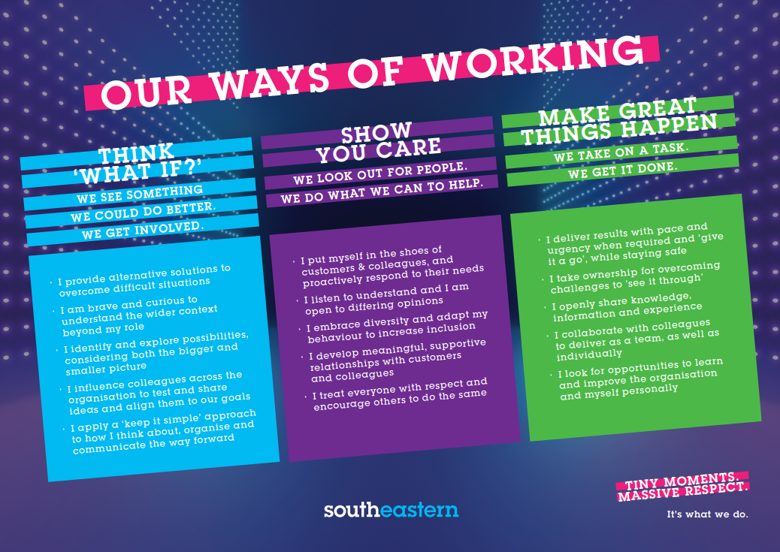

Financial Planning & Analysis Team Charter

The FP&A team are focused on providing quality service and support to their key customers (including management, Directors, DfT, ROSCOs, Network Rail, the Go-Ahead Group and Keolis) and are expected to display the following attributes, striving to continually improve both individual and team performance in each of these four quadrants.

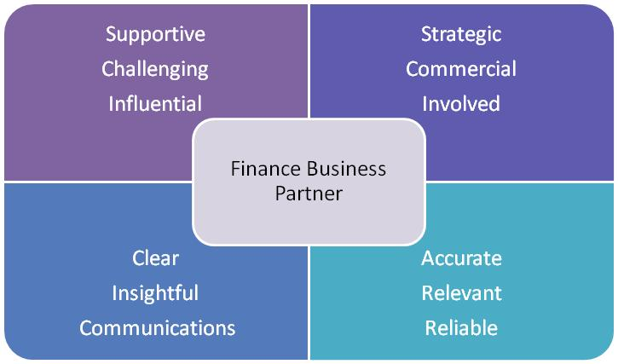

The job demands the following blend of experience/knowledge, skills and behaviours (all are essential, unless otherwise shown and will be assessed by application and/ or interview/assessment):

G1  G2  G3 | Experience, Knowledge & Qualifications  A degree in any discipline, all grades considered  A passion for enhancing people’s lives through public transport and putting the customer at the heart of everything we do  Skills (including any specific safety critical competencies)  Excellent communication and presentation skills  Good oral and written communication skills  The ability to work as part of a team  Excellent analytical and numerical abilities (strong Excel knowledge is essential)  Accuracy and an eye for detail  Behaviours  Willingness to learn and perform in a fast-changing environment  Ability to work efficiently, effectively and collaboratively as part of a team, contributing to a culture of continuous business improvement  Ability to problem solve issues and to identify opportunities for improvement  Ability to communicate clearly and effectively (both written and oral)
G4 | Other
H | Dimensions of role
H1 | Financial – Direct: |  | 0
H2 | Financial – Other: |  | Depending on relevant business areas
H3 | Staff Responsibilities – Direct: |  | 0
H4 | Staff Responsibilities – Other: |  | 0
H5 | Any Other Statistical Data:
I | Acknowledgement
I1 | Prepared By: Alex Walker |  |  | Date: | 26/07/2024
I2 | Approved By (Head of Department): | _Katya Aleksandrovich______________ |  | Date: | 26/07/2024

K | Job Description Briefing
 | The post holder has been briefed on and understands the requirements of this Job Description and other related documents:
 | Name of post holder: |  | Signature: |  | Date:
 | Name of briefing manager: |  | Signature: |  | Date:
L | Nominated Deputy for Safety requirements
 | If this is a KEY SAFETY POST (D2 in Safety Details above is YES) at least one nominated deputy must be identified. The Job Holder must ensure that the Nominated Deputy(ies) receives a copy of, and is briefed on this Job Description. If there are more nominated deputies, they should sign further copies of this Job Description.
 | The nominated deputy has been briefed on and understands the requirements of this Job Description and other related documents:
 | Name of nominated deputy: |  | Signature: |  | Date:
 | Name of briefing manager: |  | Signature: |  | Date:

