A | Post Details
 | Job Title: | Trainer/Assessor TS | Function: | Human Resources
 | Location: | London/Kent | Unique Post Number:
 | Reports To: | Training Delivery Manager TS & Eng | Grade: | MG1
B | Purpose of the Job
Provide an excellent training service that meets the needs of Southeastern, ensuring that all staff are competent to carry out their duties and responsibilities, with a prime focus on customer service.

Ensure that all learning and development needs are identified and implemented to required standards. This should include National Vocational Qualifications and Railway Group Standards and any other applicable legal requirements.

Adopt and display the company values and ensure they are embedded in to all training courses.

C | Principal Accountabilities
C1  C2  C3  C4  C5  C6  C7  C8  C9  C10  C11  C12 | Lead your programmes of training and development and act as a role model to the learners in a way that constantly displays the company values.  Ensure that all courses are delivered in adherence to the training plan, including hours of delivery.  Take responsibly for development, direction and guidance of learners attending the TAD Centres.  Undertake assessments and make decisions and provide feedback to learners.  Assist in the design and review of training course materials and assessment packages.  Ensure that all training materials in areas of responsibility are maintained and validated using TAD procedures.  Take responsibility for maintaining personal competence in areas of expertise and provide the Specification Manager with details of all activities.  Work in accordance with the training schedule and ensure that any deviation from the plan is sanctioned by your team leader or nominated deputy.  Where required be competent in the use of simulators, be able to load scenarios and carry out all observations pertaining to the elements being observed, and rectify/report any faults that arise using the reporting procedures  Accept full responsibility for the discipline of learners under your instruction.  Develop skills in other training areas, as agreed with the Training Delivery Manager, so as to be able to fully support all of the company training requirements.  Work under the direction of the Training Resource Manager to ensure all training allocated is delivered at all training centres or at any other location as required
D | Safety Responsibilities
D1 | This post is required to undertake SAFETY CRITICAL WORK |  |  |  | Yes |  | No
D2 | This is a KEY SAFETY POST or nominated deputy |  |  |  | Yes |  | No
D3 | The holder of this post is identified as a KEY SAFETY MANAGER |  |  |  | Yes |  | No
D4 | The job requires competence in PERSONAL TRACK SAFETY |  |  |  | Yes |  | No
D5 | This job has SPECIFIC SAFETY RESPONSIBILITIES (if Yes see section D6 below) |  |  |  | Yes |  | No
D6 | The post holder has the following specific safety responsibilities:  None
E | Decision making Authority
E1 | Provide line managers with detailed reports when learners fail to meet the required standard and make recommendations as the whether further training should be considered.
F | Most Challenging and/or Difficult parts of the role
F1 | Working to establish the training centres as an integral commercially viable and vital part of the overall business plan for the Southeastern. To be part of a culture change within the organisation from technical training bias to one of continuous improvement and development. To ensure that the function is adding value to the company in improving the customer, technical and competence based error profile.

G | Person Specification

Southeastern aims to recruit people not just for jobs but for long term careers. We want good quality, talented people with the right attitude who will stay with us.

For these reasons we look for evidence of Southeastern values and behaviours in all potential staff and our existing staff looking for promotion along with the particular experience/knowledge, skills and behaviours relevant to the position applied for. These are

We care passionately about our people and passengers
  - we put ourselves in our passengers’ shoes to do what’s right for them
  - we support our colleagues to be, feel and do their best
  - we love the places we serve and do our bit for our communities and environment

We aim to be the best
  - we move with pace, we’re agile and learn from everything
  - we relentlessly strive to be the best
  - we are professionals with personalities

We make the difference together
  - we are answerable to each other and our passengers
  - we trust each other and do what we say we will
  - we are stronger together than we are as individuals

We also have identified behaviours required to be successful in leading Southeastern.

The Leading Southeastern framework details how we should be behaving in order to drive up performance to deliver 85%.

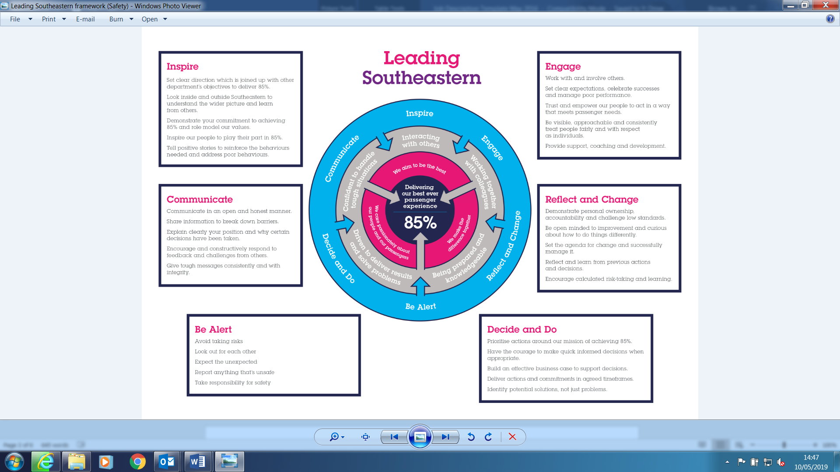

All shortlisted candidates seeking promotion will be assessed against this framework.

The job demands the following blend of experience/knowledge, skills and behaviours (all are essential , unless otherwise shown and will be assessed by application and/ or interview/assessment) :
G1 | Experience, Knowledge & Qualifications  Where required, you shall have passed assessments and undertaken the duties of a train driver and have three years experience of various types of traction where required.  Where required, you shall have passed assessments in areas of expertise and provide the Specification Manager with the required certification  Competent in rules and regulations appertaining to Southeastern.  Hold or working towards, City & Guilds Vocational/Direct trainer assessor awards;  - A1 or equivalent  - A2 or equivalent  - L 10 or equivalent  - L11 or equivalent  - L12 or equivalent  - L6 or equivalent  Excellent inter-personal skills and the ability to communicate at all levels within the organisation.
G2 | Skills (including any specific safety critical competencies)  Customer focused - Finds out expectations of customers and initiates any improvements to deliver a consistently high quality service.
G3 | Behaviours  Honesty and integrity - Is transparent and honest and takes full responsibility for own actions. Demonstrates confidence and courage and deals effectively with difficult decisions.  Persuasive – presents the key points of an argument persuasively. Negotiates and convinces others, changes people’s views and influences decisions.  Communication – Expresses confidently and effectively, questioning others to establish facts and ensure that messages have been understood correctly. Is friendly and approachable and engages others in open and honest productive conversations and listens to other views.
G4 | Other

H | Dimensions of role
H1 | Financial – Direct: |  | Nil
H2 | Financial – Other: |  | Nil
H3 | Staff Responsibilities – Direct: |  | All learners
H4 | Staff Responsibilities – Other: |  | N/A
H5 | Any Other Statistical Data: |  | N/A
I | Acknowledgement
I1 | Prepared By: | _______________ |  | Date: | ______________
I2 | Approved By (Head of Department): | _______________ |  | Date: | ______________

J | Job Description Briefing
 | The post holder has been briefed on and understands the requirements of this Job Description and other related documents:
 | Name of post holder: |  | Signature: |  | Date:
 | Name of briefing manager: |  | Signature: |  | Date:
K | Nominated Deputy for Safety requirements
 | If this is a KEY SAFETY POST (D2 in Safety Details above is YES) at least one nominated deputy must be identified. The Job Holder must ensure that the Nominated Deputy(ies) receives a copy of and is briefed on this Job Description. If there are more nominated deputies, they should sign further copies of this Job Description.
 | The nominated deputy has been briefed on and understands the requirements of this Job Description and other related documents:
 | Name of nominated deputy: |  | Signature: |  | Date:
 | Name of briefing manager: |  | Signature: |  | Date:

