A | Post Details
 | Job Title: | Service Quality Regime Project Manager | Function: | Commercial
 | Location: | 4 More London | Unique Post Number: | FIXED TERM CONTRACT
 | Reports To: | SQR Programme Manager | Grade:
B | Purpose of the Job  Southeastern’s Service Quality Regime (SQR) monitors the service we provide on board of our trains and at our stations, through a mixture of mystery shopping and auditing, which measures key aspects of facilities and customer service. This helps identify areas of opportunity and to improve the overall experience at Southeastern. This role will predominately focus on stations although involvement in onboard SQR projects from a knowledge and contribution perspective will be required.
 | The purpose of the job is to safely lead the delivery of SQR improvement initiatives within the SQR functions Commercial department. The Project Manager will lead simultaneous projects through to completion and get involved in idea generation. Responsibilities include resource planning, allocating tasks and responsibilities, tracking financials, managing the schedule, monitoring and mitigating risks, and keeping stakeholders up to date, to deliver the project successfully.
C  C1  C2  C3  C4  C5  C6  C7  C8  C9  C10  C11  C12  C13 | Principal Accountabilities  Responsible for the timely, cost effective and high quality delivery of SQR projects to support the delivery of SQR benchmarks..  Track and forecast all project costs and timelines, ensuring the project stays on budget and delivers good value. Provide reports to stakeholders and line managers as required.  Identify, monitor and escalate project risks proposing or seeking timely mitigation plans from SME. Hold regular risk reviews with stakeholders and maintaining a project risk register.  Ensure projects are delivered safely and in line with any health, safety, environmental and equality laws and regulation; promoting good safety culture and behaviour amongst all project members.  Develop, own, maintain and track a project schedule, detailing the products, outcomes and decisions that will be delivered by whom and by when, and identifying the critical path, lifecycle phases and milestones.  Identify and manage project stakeholders, promoting good communication and a collaborative working culture. Keep stakeholders up to date through project reports, and develop detailed communication and stakeholder plans where necessary.  Develop and document project scope and requirements alongside internal functions and the DfT.  Assist with the creation of procurement documents alongside the procurement team to ensure infrastructure projects follow Southeastern’s framework.  Manage the project throughout all stages of the lifecycle. Develop a clear delivery strategy, ensuring roles and responsibilities are made clear. Track progress of delivery through metrics and reports.  Track lessons learnt throughout the lifecycle, and incorporate lessons learnt from previous projects throughout key decisions.  Adhere to Southeastern project governance processes as appropriate. Utilise configuration management of key project documentation through change control.  Manage external suppliers to the project, ensuring adherence to good procurement and supplier management processes, and control of contractors on Southeastern sites.  Manage and lead direct and indirect reports as assigned, providing clear direction and managing their development

D | Safety Responsibilities
D1 | This post is required to undertake SAFETY CRITICAL WORK | Yes |  | No | P
D2 | This is a KEY SAFETY POST or nominated deputy | Yes |  | No | P
D3 | The holder of this post is identified as a KEY SAFETY MANAGER | Yes |  | No | P
D4 | The job requires competence in PERSONAL TRACK SAFETY | Yes | P | No
D5 | This job has SPECIFIC SAFETY RESPONSIBILITIES (if Yes see section D6 below) | Yes | P | No
D6 | The post holder has the following specific safety responsibilities:
E | Decision making Authority
E1

F | Most Challenging and/or Difficult parts of the Job
F1  F2  F3  F4 | Gaining participation from other stakeholders, without having direct influence over the management of those people, so as to ensure project deliverables are maintained and met.  Integrating project based work amongst other competing business priorities, including other projects and day to day business operations, without detriment to operational performance targets and departmental objectives.  Using critical thinking, by being able gathering evidence and ideas from a wide variety of sources, in order to inform project decisions and direction.  Planning and organising multiple competing demands.

G | Person Specification

Southeastern aims to recruit people not just for jobs but for long term careers. We want good quality, talented people with the right attitude who will stay with us.

For these reasons we look for evidence of Southeastern values and behaviours in all potential staff and our existing staff looking for promotion along with the particular experience/knowledge, skills and behaviours relevant to the position applied for. These are

We care passionately about our people and passengers
  - we put ourselves in our passengers’ shoes to do what’s right for them
  - we support our colleagues to be, feel and do their best
  - we love the places we serve and do our bit for our communities and environment

We aim to be the best
  - we move with pace, we’re agile and learn from everything
  - we relentlessly strive to be the best
  - we are professionals with personalities

We make the difference together
  - we are answerable to each other and our passengers
  - we trust each other and do what we say we will
  - we are stronger together than we are as individuals

We also have identified behaviours required to be successful in leading Southeastern.

The Leading Southeastern framework details how we should be behaving in order to drive up performance to deliver 85%.

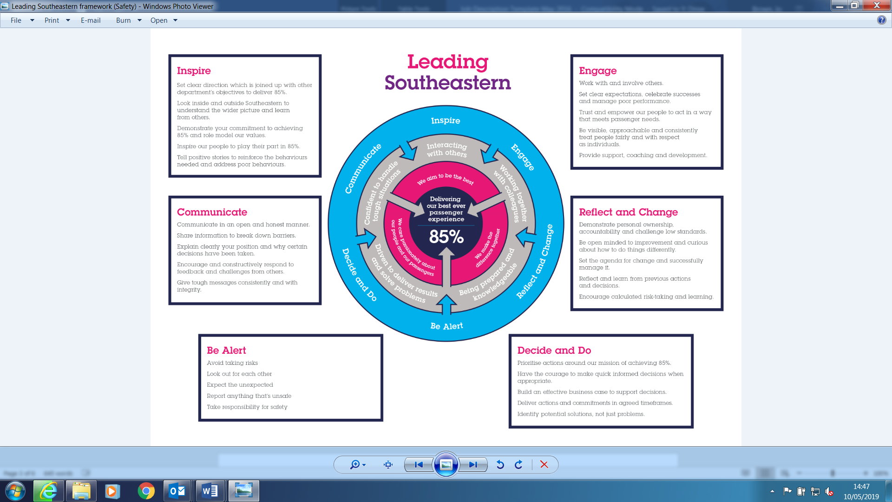

All shortlisted candidates seeking promotion will be assessed against this framework.

The job demands the following blend of experience/knowledge, skills and behaviours (all are essential , unless otherwise shown and will be assessed by application and/ or interview/assessment) :

G1 | Experience, Knowledge & Qualifications (including any specific safety training requirements)  Essential  - Formal project or programme qualification or accreditation (PRINCE2, APM foundation or practitioner) and a practical understanding of project management principles, tools and techniques  - Demonstratable evidence of previous successful project delivery  - Experience of working in a train operating company, or similar environment  - Evidence of working cross functionally in large scale organisations.  - Budget management experience  Desirable  - Degree educated or with equivalent experience  - Inrastructure project management, interfacing with Network Rail and outsourced suppliers  - Audit and customer experience measurement experience
G2 | Skills (including any specific safety critical competencies)  - Critical thinking and problem solving  - Communicating and influencing  - Stakeholder management  - Planning and organising  - Leadership  - Commercial awareness (desirable)  - High standard of written and oral English  - Highly numerate, able to interpret data effectively  - Experience in Microsoft Excel, Word, Powerpoint and Project
G3 | Behaviours  - Proactive – able to pre-empt and drive action forward activities on the project, planning in advance to avoid issues rather than reactive action  - Professional – acting with honesty and integrity, upholding Southeastern values  - Inclusive – able to involve stakeholders at various levels and treat others with respect and courtesy
G4 | Other

H | Dimensions of role
H1 | Financial – Direct: |  |  |  | None
H2 | Financial – Other: |  |  |  | £5m +
I | Acknowledgement
I1 | Prepared By: |  | _______________ |  |  |  | Date: | ______________
I2 | Approved By (Head of Department): |  | _______________ |  |  |  | Date: | ______________
J | Job Description Briefing
 | The post holder has been briefed on and understands the requirements of this Job Description and other related documents:
 | Name of post holder: |  |  | Signature: |  |  |  |  | Date:
 | Name of briefing manager: |  |  | Signature: |  |  |  |  | Date:
K | Nominated Deputy for Safety requirements
 | If this is a KEY SAFETY POST (D2 in Safety Details above is YES) at least one nominated deputy must be identified. The Job Holder must ensure that the Nominated Deputy(ies) receives a copy of, and is briefed on this Job Description. If there are more nominated deputies, they should sign further copies of this Job Description.
 | The nominated deputy has been briefed on and understands the requirements of this Job Description and other related documents:
 | Name of nominated deputy: |  |  | Signature: |  |  |  |  | Date:
 | Name of briefing manager: |  |  | Signature: |  |  |  |  | Date:

