A | Post Details
 | Job Title: | Digital Marketing Manager | Function: | Marketing
 | Location: | 4ML | Unique Post Number:
 | Reports To: | Senior Marketing Campaigns Manager | Grade: | MG1
B | Purpose of the Job  Work with the Head of Marketing and Senior Campaigns Manager to plan and execute highly effective digital marketing strategies aimed at driving ticket sales, app awareness and downloads, customer retention and engagement and ultimately revenue growth.  Collaborate with cross-functional teams, including the Southeastern Digital team, and our media planning agency, to ensure the seamless execution of digital marketing campaigns and thorough analysis of campaign data and analytics.  Oversee digital campaigns across multiple platforms to effectively target relevant customer segments, enhance ticket and product awareness, drive conversions, and boost customer engagement. Leverage customer insights and digital analytics tools, such as GA4 and Branch, to identify growth opportunities.  Formulate and recommend strategic marketing plans that drive revenue growth, and support customer retention and engagement.
C | Principal Accountabilities
C1  C2  C3  C4  C5  C6  C7  C8  C9 | Reporting to the Senior Campaigns Manager (SCM) oversee digital marketing budgets, working with appointed agencies and internal teams. Working with the media agency digital specialists to utilise data-driven insights, finding ways to adjust and optimise campaign performance and budget allocation against key performance indicators (KPIs), such as return on ad spend (ROAS), cost per acquisition (CPA), and conversion rates.  In conjunction with key stakeholders, create and maintain a digital marketing roadmap to enhance growth and development of business objectives. Collaborate with the Digital team and media agency to make strategic recommendations and implement actions for continuous improvement.  Identify opportunities for campaign testing, analysis, and improvement. Share campaign metrics including digital channel engagement rates and revenue attribution.  Work alongside the Digital team, media agency and Insights team and use existing reporting platforms to generate and share comprehensive digital campaign analytics and track key performance metrics.  In collaboration with the media agency, measure effectiveness of digital marketing activities across all channels using platforms such as GA4, Branch and social media platforms. Analyse data and provide actionable insights on key digital marketing KPIs, trends, and metrics. Key metrics include click-through rates (CTR), bounce rates, customer lifetime value (CLV), engagement rates and revenue.  Understand what it takes to achieve digital personalisation at scale, including developing strategies, compliant integration of first-party data, delivering DCO, and working with our creative agencies to develop on-brand assets that drive results.  Identify and continuously seek areas for digital campaign optimization. Keep informed on digital marketing best practices, trends, consumer insights, regulations, compliance and competitor analysis to identify growth opportunities.  Create and manage campaign assets including writing briefs for the creation of assets required for digital marketing campaigns. Manage the process through to the media agency for trafficking.  Perform relevant administrative tasks, utilizing tools and systems, including financial and budget responsibilities. Metrics for success include accurate budget tracking and timely reporting. Undertake any other reasonable duties as requested by your line manager.

D | Safety Responsibilities
D1 | This post is required to undertake SAFETY CRITICAL WORK | Yes |  | No
D2 | This is a KEY SAFETY POST or nominated deputy | Yes |  | No
D3 | The holder of this post is identified as a KEY SAFETY MANAGER | Yes |  | No
D4 | The job requires competence in PERSONAL TRACK SAFETY | Yes |  | No
D5 | This job has SPECIFIC SAFETY RESPONSIBILITIES (if Yes see section D6 below) | Yes |  | No
 | - N/A
E | Decision making Authority
E1 | Taking appropriate action to meet deadlines
F | Most Challenging and/or Difficult parts of the role
F1  F2  F3  F4 | This is a brand-new role at Southeastern and it requires patience and vision to develop and grow the role.  Working with multiple teams and individuals  Managing and delivering on complex projects and campaigns  Translating complex information into briefs and reports

G | Person Specification

Southeastern aims to recruit people not just for jobs but for long term careers. We want good quality, talented people with the right attitude who will stay with us.

For these reasons we look for evidence of Southeastern values and behaviours in all potential staff and our existing staff looking for promotion along with the particular experience/knowledge, skills and behaviours relevant to the position applied for.

These are

We care passionately about our people and passengers
  - we put ourselves in our passengers’ shoes to do what’s right for them
  - we support our colleagues to be, feel and do their best
  - we love the places we serve and do our bit for our communities and environment

We aim to be the best
  - we move with pace, we’re agile and learn from everything
  - we relentlessly strive to be the best
  - we are professionals with personalities

We make the difference together
  - we are answerable to each other and our passengers
  - we trust each other and do what we say we will
  - we are stronger together than we are as individuals

We also have identified behaviours required to be successful in leading Southeastern.

The Leading Southeastern framework details how we should be behaving in order to drive up performance to deliver 85%.

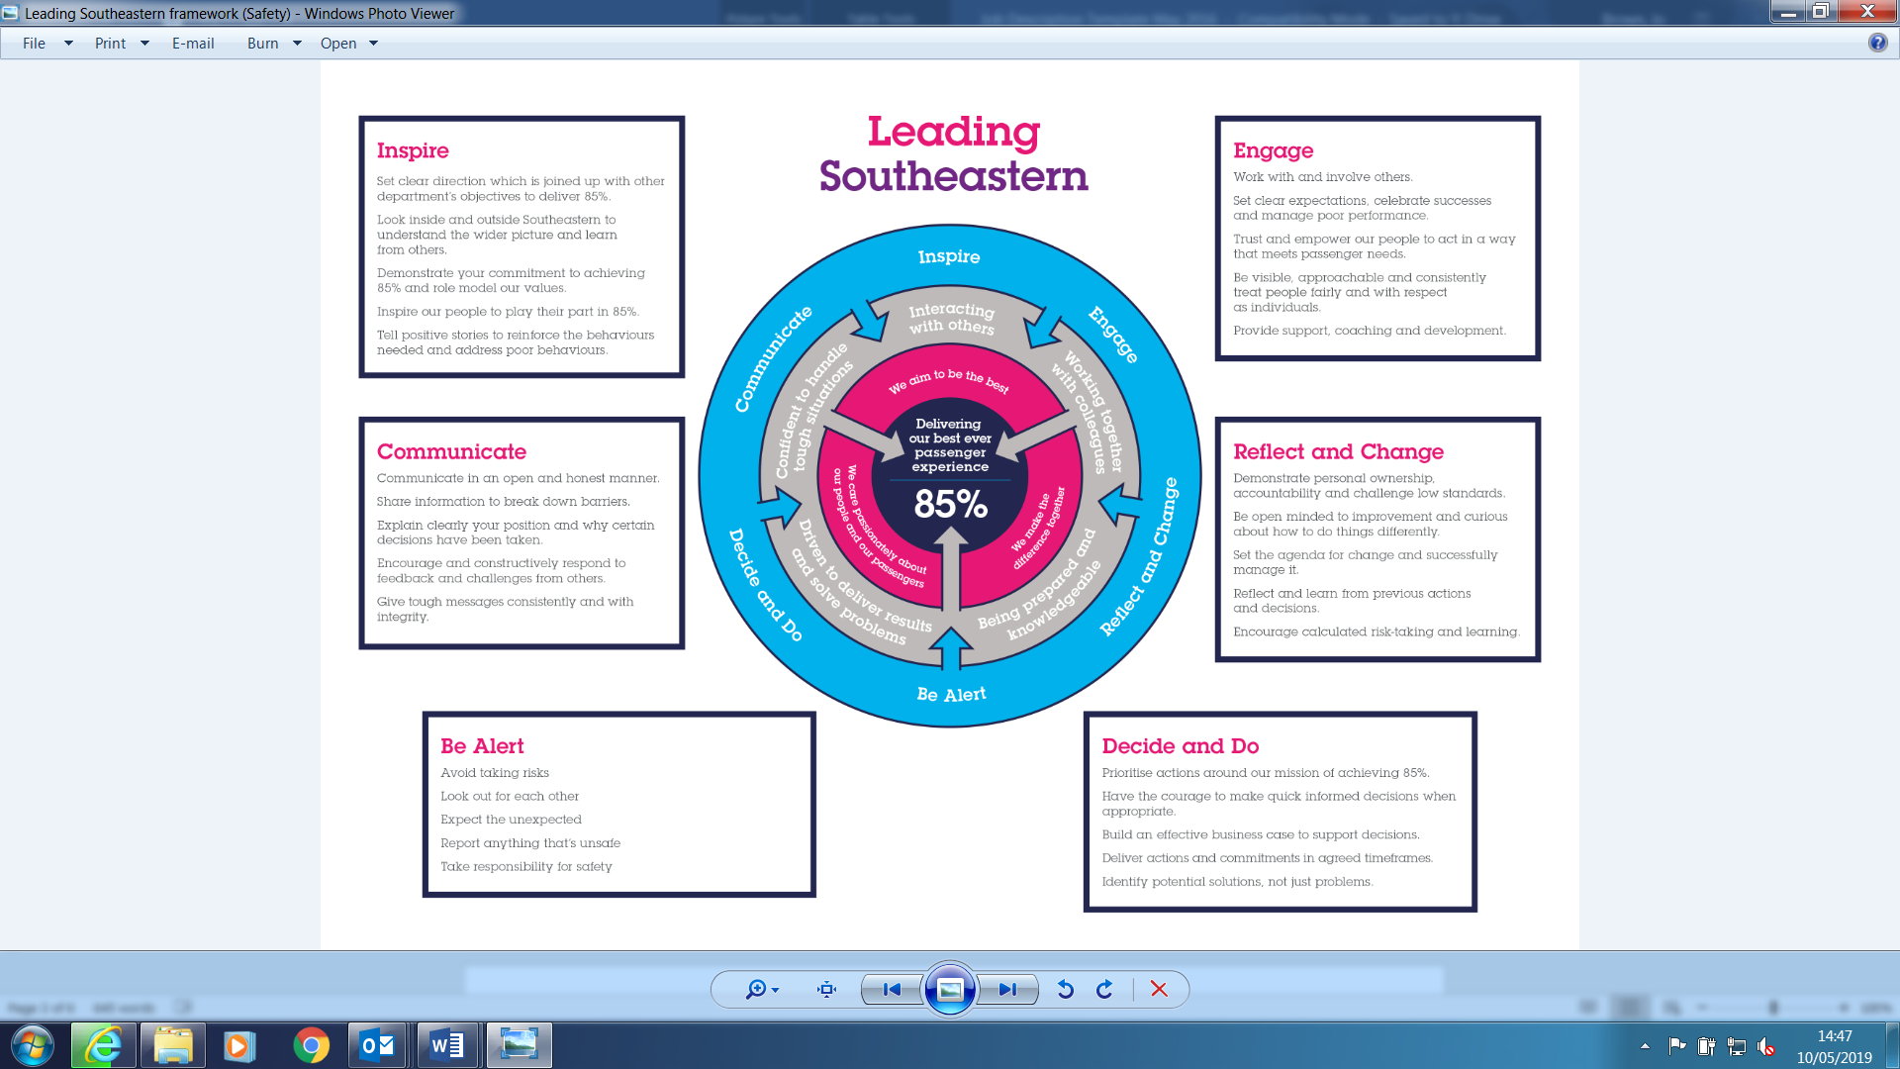

All shortlisted candidates seeking promotion will be assessed against this framework.

The job demands the following blend of experience/knowledge, skills and behaviours (all are essential, unless otherwise shown and will be assessed by application and/ or interview/assessment):

G1 | Experience, Knowledge & Qualifications  Experience:  - Proven experience in managing digital marketing campaigns across multiple platforms, including setting up, monitoring, and optimizing campaigns  - Experience in managing marketing budgets, making data-driven decisions to allocate resources effectively and maximize ROI.  - Demonstrated ability to work collaboratively with cross-functional teams, including design, content, product, plus external agencies.  - Strong project management skills, with the ability to handle multiple projects simultaneously and meet deadlines.  - Experience in performance tracking and reporting on key metrics to measure the effectiveness of digital marketing activities.  - In-depth understanding of digital marketing channels, including SEO, SEM, social media marketing, content marketing, and display advertising.  Knowledge  - Familiarity with current marketing best practices and trends to ensure effective campaign execution.  - Proficiency in using digital analytics tools such as Google Analytics (GA4), a good understanding of Google Tag Manager, MMPs, and other relevant software to track and analyse campaign performance.  - Strong ability to interpret data and generate actionable insights to optimize digital marketing strategies.  - Knowledge of customer behaviour and the ability to leverage customer insights to drive marketing decisions.  Qualifications  - Qualification in digital marketing ideally at degree level  - Certifications from recognized bodies such as the Chartered Institute of Marketing (CIM) will be advantageous such as Certificate or Diploma in Digital Marketing
G2 | Skills (including any specific safety critical competencies)  - Excellent analytical skills with the ability to interpret data and make informed decisions.  - Creative thinker with strong problem-solving skills.  - Ability to work collaboratively in a team environment and manage multiple projects simultaneously.  - Strong communication skills, both written and verbal  - Outstanding attention to detail
G3 | Behaviours – Desirable  - Calm and level-headed  - Excellent listening skills
G4 | Other

H | Dimensions of role
H1 | Financial – Direct: None
H2 | Financial – Other: None
H3 | Staff Responsibilities – Direct: None
H4 | Staff Responsibilities – Other: None
H5 | Any Other Statistical Data: None
I | Acknowledgement
I1 | Prepared By: |  |  | Date:
I2 | Approved By (Head of Department): |  |  | Date:

J | Job Description Briefing
 | The post holder has been briefed on and understands the requirements of this Job Description and other related documents:
 | Name of post holder: |  | Signature: |  | Date:
 | Name of briefing manager: |  | Signature: |  | Date:
K | Nominated Deputy for Safety requirements
 | If this is a KEY SAFETY POST (D2 in Safety Details above is YES) at least one nominated deputy must be identified. The Job Holder must ensure that the Nominated Deputy(ies) receives a copy of, and is briefed on this Job Description. If there are more nominated deputies, they should sign further copies of this Job Description.
 | The nominated deputy has been briefed on and understands the requirements of this Job Description and other related documents:
 | Name of nominated deputy: |  | Signature: |  | Date:
 | Name of briefing manager: |  | Signature: |  | Date:

