A | Post Details
 | Job Title: Data Analyst |  | Function: Asset Management Team Support
 | Location: London, 4ML |  | Unique Post Number:
 | Reports To: Senior Asset Manager |  | Grade: ASG
B | Purpose of the Job  Asset Management Analyst delivers intelligence by transforming data into information, information into insight and insight to inform asset management decision making. Data Analyst works with external and internal data to identify trends to support the provision of Asset Management advice and direction for 164 Stations locations across London and SE England. Our Asset Management approach forms part of our wider business transformation programme designed to deliver our business objectives and to meet our statutory, regulatory requirements.
C | Principal Accountabilities
C1  C2  C3  C4  C5  C6  C7  C8 | Transform data into information in order to provide insight and support asset management decision making.  Apply tools and techniques for data analysis and data visualisation; identify, collect, and migrate data to and from a range of systems, manage, abstract and aggregate data alongside a range of analytical studies on that data, manipulate and link different data sets and summarise and present data and conclusions in the most appropriate format for users  Responsible for developing and producing a wide range of reporting outputs, ensuring accuracy throughout the process.  Responsible for communicating the outputs of reports in an understandable manner.  Responsible for attending bi-weekly facilities team meetings and AMSG (as required) to contribute to the decision-making process on the handling and processing of data.  Responsible for handling a large volume of station asset and project data and identifying trends, risks, and opportunities.  Leading asset trend analysis by providing periodic asset data analysis to contract managers (This includes asset information relating to contracts such as: NG Bailey, CIS, CCTV, TVM, Gate-line, Car Parking machinery, lighting, water, gas and electricity etc.  Responsible for creating, analysing, and updating Asset Management team dashboards and reports.

D | Safety Responsibilities
D1 | This post is required to undertake SAFETY CRITICAL WORK | Yes |  | No
D2 | This is a KEY SAFETY POST or nominated deputy | Yes |  | No
D3 | The holder of this post is identified as a KEY SAFETY MANAGER | Yes |  | No
D4 | The job requires competence in PERSONAL TRACK SAFETY | Yes |  | No
D5 | This job has SPECIFIC SAFETY RESPONSIBILITIES | Yes |  | No
E | Decision making Authority
E1 | N/A
F | Most Challenging and/or Difficult parts of the role
F1 | Turning data from various file types and sources into intelligent information to support decision making.

G | Person Specification

Southeastern aims to recruit people not just for jobs but for long term careers. We want good quality, talented people with the right attitude who will stay with us.

For these reasons we look for evidence of Southeastern values and behaviours in all potential staff and our existing staff looking for promotion along with the particular experience/knowledge, skills and behaviours relevant to the position applied for. These are

We care passionately about our people and passengers
  - we put ourselves in our passengers’ shoes to do what’s right for them
  - we support our colleagues to be, feel and do their best
  - we love the places we serve and do our bit for our communities and environment

We aim to be the best
  - we move with pace, we’re agile and learn from everything
  - we relentlessly strive to be the best
  - we are professionals with personalities

We make the difference together
  - we are answerable to each other and our passengers
  - we trust each other and do what we say we will
  - we are stronger together than we are as individuals

We also have identified behaviours required to be successful in leading Southeastern.

The Leading Southeastern framework details how we should be behaving in order to drive up performance to deliver 85%.

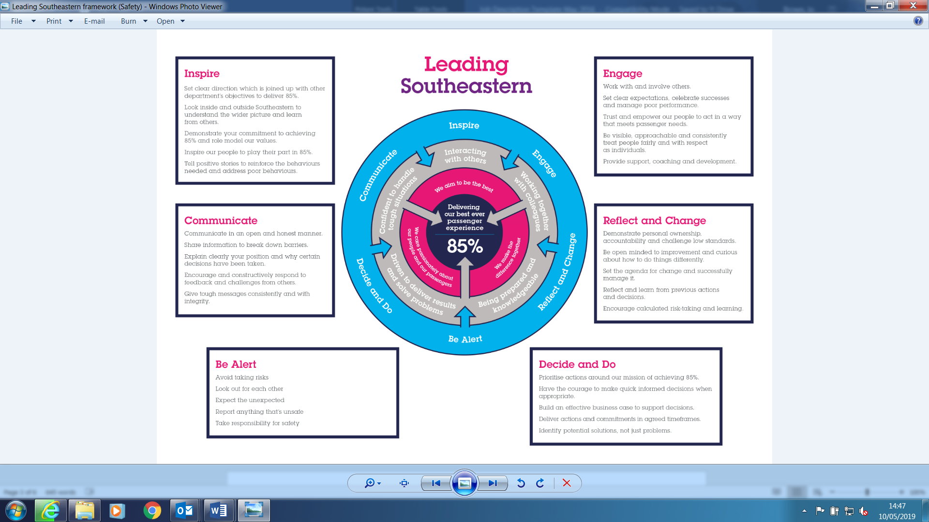

All shortlisted candidates seeking promotion will be assessed against this framework.

The job demands the following blend of experience/knowledge, skills and behaviours (all are essential , unless otherwise shown and will be assessed by application and/ or interview/assessment) :

G1 | Experience, Knowledge & Qualifications (including any specific safety training requirements)  - Educated to a degree level or hold equivalent experience in Social Sciences, Statistics or a related subject.  - Background in data analysis and experience in producing reports and creating graphical representations of data. As such you will be able to evidence proficiency in IT packages such as Microsoft (Excel in particular), Power BI and other data presentation platforms with the ability to learn bespoke packages with ease.
G2 | Skills (including any specific safety critical competencies)  - Excellent communication skills, both written and verbal  - Excellent time management, literacy, and numeracy skills as you will be responsible for coordinating a large volume and variety of project work.  - Ability to analyse large amounts of data quickly and accurately  - Strong communication and presentation skills  - Ability to develop and sustain relationships with key stakeholders and peers  - Ability to manage a challenging workload, whilst working quickly and precisely under pressure.  - Experience within customer insight and marketing functions  - Analytical and problem-solving  - Pragmatic, with the ability to provide sound advice relating to financial crime matters  - Data modelling, data cleansing, and data enrichment  - Data visualisation  - Logical and creative thinking skills
G3 | Behaviours  - Desirable: An interest in data integration and modelling techniques

H | Dimensions of role
H1 | Financial – Direct:
H2 | Financial – Other:
H3 | Staff Responsibilities – Direct:
H4 | Staff Responsibilities – Other:
H5 | Any Other Statistical Data:
I | Acknowledgement
I1 | Prepared By: | _______________ |  | Date: | ______________
I2 | Approved By (Head of Department): | _______________ |  | Date: | ______________

J | Job Description Briefing
 | The post holder has been briefed on and understands the requirements of this Job Description and other related documents:
 | Name of post holder: |  | Signature: |  | Date:
 | Name of briefing manager: |  | Signature: |  | Date:
K | Nominated Deputy for Safety requirements
 | If this is a KEY SAFETY POST (D2 in Safety Details above is YES) at least one nominated deputy must be identified. The Job Holder must ensure that the Nominated Deputy(ies) receives a copy of, and is briefed on this Job Description. If there are more nominated deputies, they should sign further copies of this Job Description.
 | The nominated deputy has been briefed on and understands the requirements of this Job Description and other related documents:
 | Name of nominated deputy: |  | Signature: |  | Date:
 | Name of briefing manager: |  | Signature: |  | Date:

