A |  | Post Details
 |  | Job Title: | Operations Manager | Function: | Train Services
 |  | Location: |  | Unique Post Number:
 |  | Reports To: | Head of Drivers | Grade: | SMG
B |  | Purpose of the Job
 |  | Manage responsible Driver depots and team of Driver Managers at the designated depots to provide a high standard professional management team to deliver a safe, reliable, punctual train service to Southeastern’s customers in a socially responsible environmentally friendly way.
C |  | Principal Accountabilities
C1  C2  C3  C4  C5  C6  C7  C8  C9 | Accountable for delivering the train service to the specified requirements within laid down safety standards for the responsible area.  Accountable for day to day management of operations within the area of control, including:  - Resourcing of train service  - Train driving competency  - Safety of all train movements  - input to train planning process  Accountable for safety and operational procedures for specified sidings, yards and depots within geographical area of control.  Lead, train and develop a cost effective, highly motivated and customer focused workforce to improve efficiency and professionalism. Establish good working practices and relationships with the team.  Accountable for compliance with all regulatory, industry (e.g. Railway Group) and company standards, procedures, processes, contracts and agreements.  Accountable for formal negotiation and consultation with local staff representatives ensuring the company is represented and agreements are made whilst avoiding delays.  Initiate continuous improvement in the maters for which responsible including rosters, train planning ad diagrams.  Accountable for preparation and achievement of budget and submission of investment plans where necessary in partnership with the Business Manager.  Accountable for developing and implementing local improvement plans to deliver the long term company objective to outperform comparable TOC’s.
D |  | Safety Responsibilities
D1 |  | This post is required to undertake SAFETY CRITICAL WORK |  |  |  | Yes |  | No
D2 |  | This is a KEY SAFETY POST or nominated deputy |  |  |  | Yes |  | No
D3 |  | The holder of this post is identified as a KEY SAFETY MANAGER |  |  |  | Yes |  | No
D4 |  | The job requires competence in PERSONAL TRACK SAFETY |  |  |  | Yes |  | No
D5 |  | This job has SPECIFIC SAFETY RESPONSIBILITIES (if Yes see section D6 below) |  |  |  | Yes |  | No
D6 |  | The post holder has the following specific safety responsibilities:
Carrying out Planned General Inspections of the following locations:
- Responsible depots

Acting as Fire Precautions Manager for the following locations:
- Responsible depots where appropriate.

Safety Interface with the following external parties:
- Responsible depots

Investigation of accidents occurring at the following locations or as requested by Safety & Environment:
- Responsible depots

E |  | Decision making Authority
E1  E2  E3 |  | Application of 1999 Procedures to appropriate designated level.  Manage expenditure within Delegated Financial Authorities.  Diagramming or Local Management procedures to optimise costs.
F |  | Most Challenging and/or Difficult parts of the role (these are G in old JD’s)
F1  F2  F3  F4 |  | Delivering continuous improvement in Safety and Performance.  Meeting financial targets.  Delivering a consistent application of procedures and standards to drivers through a diverse management team.  Maintain effective trade union relationships at a local level

G | Person Specification

Southeastern aims to recruit people not just for jobs but for long term careers. We want good quality, talented people with the right attitude who will stay with us.

For these reasons we look for evidence of Southeastern values and behaviours in all potential staff and our existing staff looking for promotion along with the particular experience/knowledge, skills and behaviours relevant to the position applied for. These are

We care passionately about our people and passengers
  - we put ourselves in our passengers’ shoes to do what’s right for them
  - we support our colleagues to be, feel and do their best
  - we love the places we serve and do our bit for our communities and environment

We aim to be the best
  - we move with pace, we’re agile and learn from everything
  - we relentlessly strive to be the best
  - we are professionals with personalities

We make the difference together
  - we are answerable to each other and our passengers
  - we trust each other and do what we say we will
  - we are stronger together than we are as individuals

We also have identified behaviours required to be successful in leading Southeastern.

The Leading Southeastern framework details how we should be behaving in order to drive up performance to deliver 85.

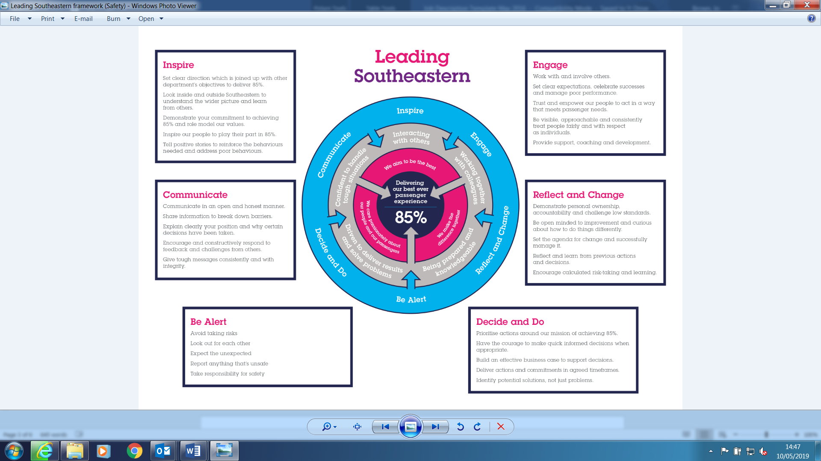

All shortlisted candidates seeking promotion will be assessed against this framework.

The job demands the following blend of experience/knowledge, skills and behaviours (all are essential , unless otherwise shown and will be assessed by application and/ or interview/assessment) :

G1 | Experience, Knowledge & Qualifications (including any specific safety training requirements)  Proven success in meeting demanding budgetary and workforce productivity targets.  Proven track record of line management experience in Railway operations.  Experience of leading and directing a large team.  Ability to interpret financial statement.  Comprehensive knowledge of railway operational standards and railway rules, regulations and instructions, together with experience and understanding of the regulatory framework.
G2 | Skills (including any specific safety critical competencies)  Strong interpersonal skills and experienced negotiator.  Good leadership skills  Strong investigatory skills with a good questioning technique
G3 | Behaviours  Excellent communicator  Professionalism  Honesty and integrity – Is transparent and honest and takes full responsibility for actions  Well organised – able to plan for and achieve deadlines
G4 | Other  Nil

H | Dimensions of role
H1 | Financial – Direct: |  | Costs: Between £6m and £12m depending on Depot Income: Nil
H2 | Financial – Other:
H3 | Staff Responsibilities – Direct: |  | 10
H4 | Staff Responsibilities – Other: |  | 200+
H5 | Any Other Statistical Data: |  | Nil
I | Acknowledgement
I1 | Prepared By: | _______________ |  | Date: | ______________
I2 | Approved By (Head of Department): | _______________ |  | Date: | ______________

J | Job Description Briefing
 | The post holder has been briefed on and understands the requirements of this Job Description and other related documents:
 | Name of post holder: |  | Signature: |  | Date:
 | Name of briefing manager: |  | Signature: |  | Date:
K | Nominated Deputy for Safety requirements
 | If this is a KEY SAFETY POST (D2 in Safety Details above is YES) at least one nominated deputy must be identified. The Job Holder must ensure that the Nominated Deputy(ies) receives a copy of, and is briefed on this Job Description. If there are more nominated deputies, they should sign further copies of this Job Description.
 | The nominated deputy has been briefed on and understands the requirements of this Job Description and other related documents:
 | Name of nominated deputy: |  | Signature: |  | Date:
 | Name of briefing manager: |  | Signature: |  | Date:

