A | Post Details
 | Job Title: IT Compliance, Change & Delivery Manager |  | Function: | Engineering, IT and Major Contracts
 | Location: Four More London |  | Unique Post Number:
 | Reports To: Head Of IT |  | Grade: MG2
B | Purpose of the Job  The role is a key management function, managing the IT compliance, change and delivery requirements of the department.  The IT compliance manager will be responsible for the delivering compliance programmes across various IT platforms. The role will involve coordinating the initial phases of compliance, followed by managing the maturity assessments and the annual attestation process. The role incorporates responsibility for risk management within the technology department, ensuring focus is targeted at higher category issues.  The role is an ambassador and relationship manager for IT delivery and related projects.  The role is also responsible for the Change management cycle within the department. Managing the entire lifecycle change process and IT Project management office, including governance of project delivery to ensure all requirements are met and all stage gates are successfully navigated. Ensuring all the necessary change steps, risk evaluations and impacts have been understood ahead of any change, and any direct or indirect implications to compliance against regulations, directives and standards are not affected, or satisfactorily addressed as part of the change deployment.  The role will also assume line management of additional contracted technical Project Management resources when required, ensuring that they follow the Project delivery requirements ahead of the product or service adoption. The role may also be requested to lead smaller projects workstreams that do not qualify for dedicated additional resource.  The role will also ensure that procedure, process, and standards are relevant, and updated when required to ensure they support IT policy. The role will also collaborate with the IT management structure to advise on required policy updates as circumstances and organisational improvements dictate.  This role also performs a significant function in the IT governance requirements, including participating in the Design Authority panel.  The role will participate in the Silver command rota requirements of the department, acting as an escalation point for the on-call engineers where impacts of incidents require management involvement and wider organisational or supplier communication and involvement.
C | Principal Accountabilities
C1  C2  C3  C4  C5  C6  C7  C8  C9  C10  C11  C12  C13 | Manage the compliance requirements of the department, ensuring system and service audits against the requirements are undertaken and all remedial requirements are tracked and delivered against agreed timeframes.  Manage the Controls and Risk management system on behalf of the department, ensuring new and changing risks are communicated appropriately, and required remedial actions are developed in conjunction with the other IT managers and the wider organisation to reduce or remove the risk index.  Chair the Change Advisory Board with relevant stakeholders, ensuring changes are robust and impact and risk to the organisation is minimal. Maintain a forward schedule of change and communicate with the organisation and 3rd parties as appropriate. Integrate the Change process with the Go-Ahead Group release process  Manage the change pipeline, engaging with departments and directorates to assist and manage inbound changes.  Ensure all projects undertake and receive stage gate approval during their delivery, and ensure their risks are captured within the risk management platform and managed appropriately by their owners, reporting IT programme progress to the Governance Panel and stakeholders  Manage the Cyber and policy training program. Shaping the training packages in conjunction with IT management, as well as holding the relationship with the learning and development department that will deliver the training packages to the organisation via the training platform.  Create, regularly review and update process, procedure and standards  Collaborate with IT management to inform on IT policy amendments where appropriate.  Participate in the IT governance requirements, including the Design Authority Panel  Creation of Management reports  Participate in Silver command rota, managing significant technical incidents when required.  Participate in Major Incident response plan testing, and Business Continuity plan testing requirements, and working with the teams to adapt and update them  Undertake any other activity that is commensurate with the role, as requested by the Head of IT

D | Safety Responsibilities
D1 | This post is required to undertake SAFETY CRITICAL WORK | Yes |  | No
D2 | This is a KEY SAFETY POST or nominated deputy | Yes |  | No
D3 | The holder of this post is identified as a KEY SAFETY MANAGER | Yes |  | No
D4 | The job requires competence in PERSONAL TRACK SAFETY | Yes |  | No
D5 | This job has SPECIFIC SAFETY RESPONSIBILITIES (if Yes see section D6 below) | Yes |  | No
D6 | The post holder has the following specific safety responsibilities:
Carrying out Planned General Inspections of the following locations:
- None

Acting as Fire Precautions Manager for the following locations:
- None

Safety Interface with the following external parties:
- None

Investigation of accidents occurring at the following locations or as requested by Safety & Environment:
- None

E | Decision making Authority
E1  E2 | Change Approvals  Project stage gate progression
F | Most Challenging and/or Difficult parts of the role
F1 | Managing comprehensive change reviews in a busy department

G | Person Specification

Southeastern aims to recruit people not just for jobs but for long term careers. We want good quality, talented people with the right attitude who will stay with us.

For these reasons we look for evidence of Southeastern values and behaviours in all potential staff and our existing staff looking for promotion along with the particular experience/knowledge, skills and behaviours relevant to the position applied for. These are

We care passionately about our people and passengers
  - we put ourselves in our passengers’ shoes to do what’s right for them
  - we support our colleagues to be, feel and do their best
  - we love the places we serve and do our bit for our communities and environment

We aim to be the best
  - we move with pace, we’re agile and learn from everything
  - we relentlessly strive to be the best
  - we are professionals with personalities

We make the difference together
  - we are answerable to each other and our passengers
  - we trust each other and do what we say we will
  - we are stronger together than we are as individuals

We also have identified behaviours required to be successful in leading Southeastern.

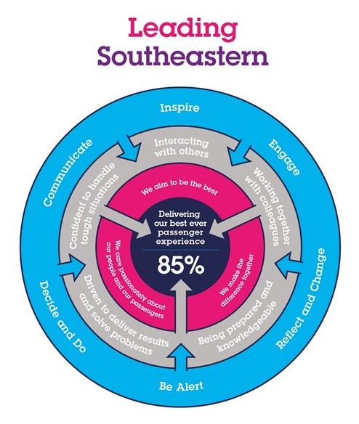

The Leading Southeastern framework details how we should be behaving in order to drive up performance to deliver 85 by 18.

All shortlisted candidates seeking promotion will be assessed against this framework.

The job demands the following blend of experience/knowledge, skills and behaviours (all are essential , unless otherwise shown and will be assessed by application and/ or interview/assessment) :

G1 | Experience, Knowledge & Qualifications (including any specific safety training requirements)  Proven experience as compliance and change manager  In-depth knowledge of the industry’s standards and regulations  Excellent knowledge of reporting procedures and record keeping  A business acumen partnered with a dedication to process and procedure  Methodical and diligent with outstanding planning abilities  An analytical mind able to “see” the complexities of procedures and regulations  ITIL Practitioner (Desirable)  Prince II Practitioner (Desirable)
G2 | Skills (including any specific safety critical competencies)  Methodical and diligent with outstanding planning abilities  Driven individual with a ‘CAN DO’ attitude that engenders confidence, respect and support.  Passion, enthusiasm and expertise.  Good written and verbal communication skills  Quality and transparency  Good prioritising skills and the ability to meet targets
G3 | Behaviours  Honesty  Integrity  Reliable
G4 | Other

H | Dimensions of role
H1 | Financial – Direct:
H2 | Financial – Other:
H3 | Staff Responsibilities – Direct:
H4 | Staff Responsibilities – Other: Contracted Project Managers when required
H5 | Any Other Statistical Data:
I | Acknowledgement
I1 | Prepared By: | _______________ |  | Date: | ______________
I2 | Approved By (Head of Department): | _______________ |  | Date: | ______________

J | Job Description Briefing
 | The post holder has been briefed on and understands the requirements of this Job Description and other related documents:
 | Name of post holder: |  | Signature: |  | Date:
 | Name of briefing manager: |  | Signature: |  | Date:
K | Nominated Deputy for Safety requirements
 | If this is a KEY SAFETY POST (D2 in Safety Details above is YES) at least one nominated deputy must be identified. The Job Holder must ensure that the Nominated Deputy(ies) receives a copy of, and is briefed on this Job Description. If there are more nominated deputies, they should sign further copies of this Job Description.
 | The nominated deputy has been briefed on and understands the requirements of this Job Description and other related documents:
 | Name of nominated deputy: |  | Signature: |  | Date:
 | Name of briefing manager: |  | Signature: |  | Date:

