A | Post Details
 | Job Title: | Project Delivery Manager | Function: | Engineering
 | Location: | 4ML | Unique Post Number:
 | Reports To: | Engineering Programmes Manager | Grade: | MG2
B | Purpose of the Job
Lead the initiation and development of rolling stock projects required by the engineering function and the Southeastern business plan.

Ensuring that development activities are carried out in accordance with the engineering Quality Management System and that developed projects have required approvals and information necessary to ensure effective deployment and implementation.

Provide leadership and direction regarding wider development activities within the engineering function.
C | Principal Accountabilities
C1 | Accountable for consultation and communication within engineering function, other Southeastern departments and stakeholders as appropriate.
C2 | Accountable for securing business case and associated senior management and financial approval.
C3 | Accountable for leadership and direction to the individual project Engineers for the development of rolling stock projects. Particularly accountable for securing adequate resource to ensure that projects are delivered within agreed timescales.
C4 | Accountable for ensuring structured and documented plans for all project development, including adequate stakeholder liaison though progress or steering meeting.
C5 | Accountable for robust financial forecasting and compliance with financial controls. Accountable for progress reporting as required.
C6 | Provide leadership to ensure that sound engineering principles are applied in the development of projects, ensuring a risk-based approach and that projects meet formal approvals required by the Southeastern safety Management System and other regulatory bodies.
C7 | Accountable for liaison and development of engineering projects with the planning and materials team. Ensuring that project development considers

C8  C9 C10  C11 | materials and rolling stock planning in conjunction with the planning team.  Accountable for provision of fully documented and approved Engineering Change documentation and for arranging adequate handover to ensure deployment of projects.  Accountable for tracking and control of project progress using the Q-Pulse tracking system.  Responsible for overseeing the management, deployment and control for engineering trials, prototypes, and tests necessary for the development of change projects.  Accountable for ensuring prototypes, trials, tests are conducted in accordance with the procedures defined in the Quality Management System and also coordinated with the Fleet Engineer responsible for fleet concerned.
D | Decision making Authority
D1 | As directed by the Head of Engineering Services
E | Report Preparation
E1 E2 E3 | Provision of reports for Managing Directors Groups Provision of reports and period end  Provision of financial information as required
F | Contact With Others
F1 F2 F3 F4 F5 F6 F7  F8 | Engineering and other company directors Engineering Senior Managers (Direct Reports)  Fleet Engineers at Slade Green and Ramsgate and their staff Engineering Commercial Manager and Procurement Manager Asset Owners  Network Rail ATOC  Contractors, suppliers

F9 | Customers
G | Most Challenging and/or Difficult parts of the Job
G1 | Coordination of multiple projects, ensuring these are communicated effectively and managed to the agreed plan and milestones are achieved.

H | Person Specification:  Southeastern aims to recruit people not just for jobs but for long term careers. We want good quality, talented people with the right attitude who will stay with us.  For these reasons we look for evidence of Southeastern values and behaviours in all potential staff and our existing staff looking for promotion along with the particular experience/knowledge, skills and behaviours relevant to the position applied for. These are  We care passionately about our people and passengers  - we put ourselves in our passengers’ shoes to do what’s right for them  - we support our colleagues to be, feel and do their best  - we love the places we serve and do our bit for our communities and environment  We aim to be the best  - we move with pace, we’re agile and learn from everything  - we relentlessly strive to be the best  - we are professionals with personalities  We make the difference together  - we are answerable to each other and our passengers  - we trust each other and do what we say we will  - we are stronger together than we are as individuals  We also have identified behaviours required to be successful in leading Southeastern.  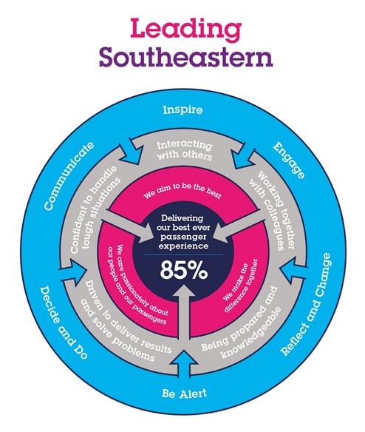  The Leading Southeastern framework details how we should be behaving in order to drive up performance to deliver 85 by 18.  All shortlisted candidates seeking promotion will be assessed against this framework.
H1 | Experience, Knowledge & Qualifications – Essential  Good Education to at least HND Level or equivalent experience. Significant experience in a demanding maintenance environment.  Experience in rolling stock maintenance, materials and production planning. Experience in change management and implementation of change.  High level of commercial experience in the Rail industry.  Experience of project management, particularly project delivery within a demanding environment.  Experience of 6-Sigma and other business process improvement methodologies.
H2 | Experience, Knowledge & Qualifications – Desirable  Engineering Degree, either Mechanical or Electrical based.  Project Management qualification, such as PRINCE2 or equivalent. Recognised management certification.
H3 | Behaviours and Skills – Essential  Excellent communication skills with the ability to communicate at all levels. Leadership skills and the ability to motivate others.  Ability to negotiate with senior level staff. Commercial Awareness  Professionalism  Flexible approach to work and able to adapt to changing priorities
H4 | Behaviours and Skills – Desirable

I | Additional Information
Southeastern franchise requires delivery of committed rolling stock projects to specified timescales. These include: Remote condition monitoring systems, PRM, 375 Relocation of 1st Class seat area. Additional projects in development include On-train Wi-Fi, Half Life Bearing Change, FFCCTV, PIS
J | Dimensions of the Job
J1 | Financial – Direct: |  | £20m
J2 | Financial – Other: |  | None
J3 | Staff Responsibilities – Direct: |  | None
J4 | Staff Responsibilities – Other: |  | Indirect: manage stakeholder groups
J5 | Any Other Statistical Data:
K | Acknowledgement
K1 | Prepared By: | ____ |  |  | Date:
K2 | Head of Department: |  |  |  | Date:
K3 | Compensation & Benefits Manager: |  |  |  | Date:
K4 | Acknowledgement of receipt by Post Holder: |  |  |  | Date:

