A | Post Details
 | Job Title: |  | Engineering Performance Manager | Function: | Engineering
 | Location: |  | Ramsgate | Unique Post Number:
 | Reports To: |  | Fleet Operations Manager | Grade: | MG2
B | Purpose of the Job  Provide leadership for Engineering when concerned with fleet performance. This includes the delivery of engineering objectives and building strong business relationships, both internal and external.  Support the Engineering performance team in the effective discharge of responsibilities; including identifying root cause of incidents, delay attribution management and working with internal stakeholders and external partners to drive business improvements.  Represent Engineering in both Internal and external forums where performance is discussed.  Responsible for delivering an effective Performance Management System, within Engineering the provides an effective governance for Production and the wider business to operate within.  Lead investigation into incidents on the line where engineering performance was a factor.  Act as a Fleet Recovery Engineer.
C | Principal Accountabilities
C1  C2  C3  C4  C5  C6  C7  C8  C9  C10  C11  C12 |  | Lead the development of performance monitoring and investigation for Engineering, ensuring a comprehensive and coherent system is in place that meets the requirements of  Southeastern’s Railway Safety Management System, Legislation, Industry Standards and  business needs.  Drive performance improvement, challenging and supporting functional managers as required.  Identify Key Performance Indicators that relate to performance. And ensure data  acquisition and analysis processes are in place that provide information to Senior Managers and the wider business.  Liaise with the Quality and Standards Manager in regards to identifying root cause of performance issues to ensure appropriate quality control gates are in place to prevent reoccurrence.  Advise the engineering management team on performance assurance, error reduction and human factors issues. Highlight concerns relating to current performance or opportunities for improvement in reports and at management review meetings.  Represent as a key stakeholder, or as required, Engineering at core business forums concerned with performance.  Build strong, sustainable business relationships concerned with performance management, with internal and external stakeholders and industry partners.  Act as lead incident investigator as required, in line with Southeastern Safety Management  System (SMS) and industry best practice.  Act as ‘Competent Person’ for Vehicle Changes, scrutinising proposed changes against  requirements and issuing new Design, Maintenance and Engineering Acceptance Certificates as required  Produce reports relating to the above areas of accountability.  Act as deputy to the Engineering Compliance Manager and undertake other duties as  required.  Carry out Fleet Recovery Engineer duties as part of an on-call roster

D | Safety Responsibilities
D1 | This post is required to undertake SAFETY CRITICAL WORK | Yes | P | No
D2 | This is a KEY SAFETY POST | Yes |  | No | P
D3 | This post requires SECURITY CLEARANCE | Yes |  | No | P
D4 | The job requires competence in PERSONAL TRACK SAFETY | Yes | P | No
D5 | This job has SPECIFIC SAFETY RESPONSIBILITIES (if Yes see section D6 below) | Yes | P | No
D6 | The post holder has the following specific safety responsibilities:
- Competent Person’ for Engineering Change
- Fleet Recovery Engineer

E | Decision making Authority
E1  E2  E3 | Authority to investigate and report on incidents as part of the company SMS.  Authority to approve and certify Vehicle Changes as ‘Assessment Party’  Authority to set team members’ objectives and evaluate performance against these
F | Most Challenging and/or Difficult parts of the role
F1  F2  F3 | Facilitating and supporting delivery of performance requirements, where the  accountability for delivery generally lies with other managers.  Understanding customer requirements and working collaboratively to develop processes that  meet performance, quality, and productivity requirements.  Influencing continual improvements in behaviours and culture which are aligned with wider  engineering and company objectives

G | Person Specification

Southeastern aims to recruit people not just for jobs but for long term careers. We want good quality, talented people with the right attitude who will stay with us.

For these reasons we look for evidence of Southeastern values and behaviours in all potential staff and our existing staff looking for promotion along with the particular experience/knowledge, skills and behaviours relevant to the position applied for. These are

- We care passionately about our people and passengers
- We make the difference together
- We aim to be the best

We also require more than competent performance against our Leadership & Management Competency Framework.

Professional People
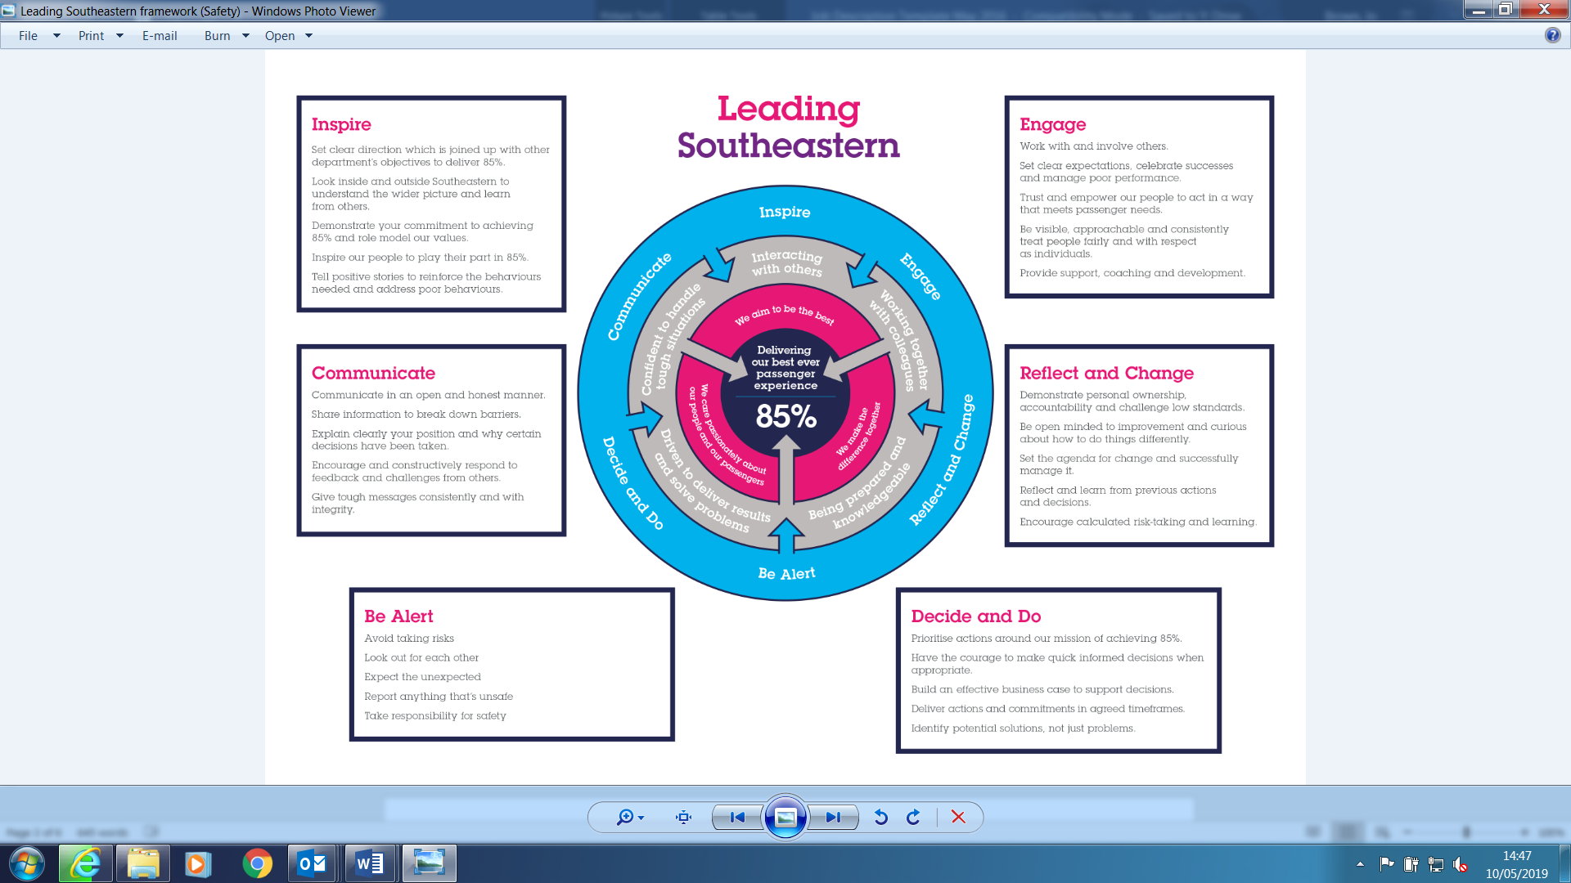
All shortlisted candidates seeking promotion will be assessed against this framework.

The job demands the following blend of experience/knowledge, skills and behaviours (all are essential , unless otherwise shown and will be assessed by application and/ or interview/assessment)

G1 | Experience, Knowledge & Qualifications  10+ years experience in maintenance engineering or asset intensive operational environment  (rail, nuclear, marine, aviation, utilities, process plant, armed forces)  5+ years experience in performance management in above environment  Level 6 qualification in an engineering discipline desirable.  Demonstrable Continued Professional Development (CPD) through membership of  professional institution (such as the IMechE, IET or CQI)  ILM level 5 or prepared to work towards
G2 | Skills (including any specific safety critical competencies)  Excellent management and leadership skill and knowledge demonstrated through above  requirements.  Good communication skills and assertiveness to engage with colleagues; working at all levels  in the organisation.  Good thinking and problem-solving skills  Good planning and organising skills  Strong analytical skills  Excellent computing skills. Understanding of Computerised Maintenance Management  Systems (CMMS) and ability to use Microsoft Office computer applications. Ability to perform  an interrogation and interpretation of rolling stock Remote Conditional Monitoring data, and  then turn into intelligent business information.
G3 | Behaviours  Assertiveness  Professional and business focussed outlook.  Attention to detail.  Aware of surroundings, naturally inquisitive and questioning.
G4 | Other  Membership of IEE or other professional institution.

I | Dimensions of role
I1 | Financial – Direct: |  |  |  | None
I2 | Financial – Other: |  |  |  | As defined by Head of Engineering Compliance
I3 | Staff Responsibilities – Direct: |  |  |  | 4
I4 | Staff Responsibilities – Other: |  |  |  | None
I5 | Any Other Statistical Data: |  |  |  | As directed by Head of Engineering Compliance
J | Acknowledgement
J1 | Prepared By: |  | _______________ |  |  |  | Date: | ______________
J2 | Approved By (Head of Department): |  | _______________ |  |  |  | Date: | ______________
K | Job Description Briefing
 | The post holder has been briefed on and understands the requirements of this Job Description and other related documents:
 | Name of post holder: |  |  | Signature: |  |  |  |  | Date:
 | Name of briefing manager: |  |  | Signature: |  |  |  |  | Date:
L | Nominated Deputy for Safety requirements
 | If this is a KEY SAFETY POST (D2 in Safety Details above is YES) at least one nominated deputy must be identified. The Job Holder must ensure that the Nominated Deputy(ies) receives a copy of, and is briefed on this Job Description. If there are more nominated deputies, they should sign further copies of this Job Description.
 | The nominated deputy has been briefed on and understands the requirements of this Job Description and other related documents:
 | Name of nominated deputy: |  |  | Signature: |  |  |  |  | Date:
 | Name of briefing manager: |  |  | Signature: |  |  |  |  | Date:

