A | Post Details
 | Job Title: | Stores & Services Manager | Function: | Engineering
 | Location: | Slade Green based but as required | Unique Post Number:
 | Reports To: | Materials Manager | Grade: | MG2
B | Purpose of the Job
The management and leadership of the stores at Ramsgate and Slade Green, and the provisioning for and control of materials at all other Engineering locations.

To ensure materials, stores and associated records are kept in compliance of Engineering department, quality and safety standards, as well as ISO 9001 Quality Standards in order to supply an effective stock control service to Engineering.

To manage on-site materials partners such as Hitachi, Wabtec, Unipart and Bombardier, including their facilities on Southeastern property.

To provide supporting services to Engineering such as tool control and calibration, warranty support processes, management of waste and waste management contractors, management of couriers and postal services.

Be the Engineering lead for the Corporate Social Responsibility process and annual report.

Deputise for the Materials Manager as required.

C | Principal Accountabilities
C1  C2  C3  C4  C5  C6  C7  C8  C9  C10  C11  C12  C13  C14  C15  C16  C17 | Responsible for leading and directing the stores teams ensuring that all materials are received, stored and issued in accordance with local procedures ensuring that products are in a serviceable condition when used. This includes Line Side Spares as appropriate. Ensure all stores IT systems and processes are upheld and maintained by all affected staff.  Responsible for the production, implementation and continuous improvement of procedures/work instructions to ensure that the team performs the stores activities in a effective, efficient, professional and consistent manner.  Responsible for reviewing, reporting and monitoring daily performance within the stores that may affect the material supply, including monitoring and reporting on material supply problems either from Unsatisfied Material Demand (UMD) or from abnormal stock holdings.  Ensure stock held is secure (and non stores personnel do not have access to parts directly), safe and accurately recorded and accounted for on an ongoing basis. Particular attention is required to ensure attractive components are stored and managed properly.  Accountable for the financial integrity of the material held and ensuring that stock takes are undertaken in accordance with the agreed procedures.  Maintaining records including daily worksheets and reconciliations and assisting purchasing officer with recommend order processing.  Accountable for keeping all areas where material is stored safe, clean and tidy and ensure that materials are only stored in designated locations.  Day-to-day management, leadership and well-being of your staff, including rostering.  Responsible for the development of your team to ensure that they have all the skills required to professionally undertake their roles in accordance with their job description and the local operating procedures. Managing the team in accordance with the company HR procedures including discipline, attendance, annual leave, etc.  Responsible for the effective management of the return of repairable components within Southeastern and relevant parts supplier, preventing the avoidable loss of components.  Responsible for waste management across Engineering including waste contractors.  Responsible for the control and calibration of appropriate tooling, including the suppliers of quality and calibration services.  Management and control of the material quarantine process across Engineering.  Responsible for providing the required information for warranty management and the execution of warranty management processes such as repairable & warranty failures, rejections, and processing relevant claims.  Responsible for the effective management of other on-site materials partners such as Hitachi, Wabtec, Unipart and Bombardier, including their facilities on Southeastern property.  Provide a transportation management service by providing outsourced and supplier managed logistics, including the provision of courier and postal services across Engineering.  Be the Engineering lead for the Corporate Social Responsibility process and annual report.

D | Safety Responsibilities
D1 | This post is required to undertake SAFETY CRITICAL WORK | Yes |  | No
D2 | This is a KEY SAFETY POST or nominated deputy | Yes |  | No
D3 | The holder of this post is identified as a KEY SAFETY MANAGER | Yes |  | No
D4 | The job requires competence in PERSONAL TRACK SAFETY | Yes |  | No
D5 | This job has SPECIFIC SAFETY RESPONSIBILITIES (if Yes see section D6 below) | Yes |  | No
D6 | The post holder has the following specific safety responsibilities:
 | - None
E | Decision making Authority
E1  E2  E3  E4 | Authorised to make decisions regarding the issue, storage and relevant ordering of materials for use on rolling stock.  Authorised to manage all partners and suppliers for stores and services responsibilities, including the placing of orders.  Authorising Transport and logistics requirements.  Authorising the staff rosters, leave and over time.
F | Most Challenging and/or Difficult parts of the role
F1  F2  F3  F4 | Managing staff in ensuring that all aspects of their duties are consistently carried out in accordance with set policy and procedures.  Controlling stock and stores security  Controlling goods receipt and despatch including the checking of incoming parts to ensure faulty or wrong parts are rejected, and the keeping of accurate stock records.  Managing partners and suppliers in the best interests of Southeastern whilst preserving long term relationships.

G | Person Specification

Southeastern aims to recruit people not just for jobs but for long term careers. We want good quality, talented people with the right attitude who will stay with us.

For these reasons we look for evidence of Southeastern values and behaviours in all potential staff and our existing staff looking for promotion along with the particular experience/knowledge, skills and behaviours relevant to the position applied for. These are

We care passionately about our people and passengers
  - we put ourselves in our passengers’ shoes to do what’s right for them
  - we support our colleagues to be, feel and do their best
  - we love the places we serve and do our bit for our communities and environment

We aim to be the best
  - we move with pace, we’re agile and learn from everything
  - we relentlessly strive to be the best
  - we are professionals with personalities

We make the difference together
  - we are answerable to each other and our passengers
  - we trust each other and do what we say we will
  - we are stronger together than we are as individuals

We also have identified behaviours required to be successful in leading Southeastern.

The Leading Southeastern framework details how we should be behaving in order to drive up performance to deliver 85%.

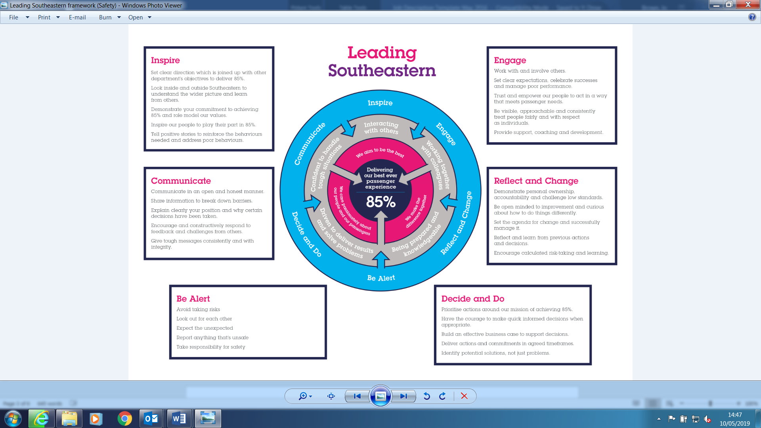

All shortlisted candidates seeking promotion will be assessed against this framework.

The job demands the following blend of experience/knowledge, skills and behaviours (all are essential , unless otherwise shown and will be assessed by application and/ or interview/assessment) :

G1 | Experience, Knowledge & Qualifications (including any specific safety training requirements)  Logistics and materials management experience essential  Understanding of the supply chain process and supply chain management  Understanding of human relations and change management
G2 | Skills (including any specific safety critical competencies)  Great people skills  Ability to work in an assertive environment  Good interpersonal skills, including the ability to develop constructive relationships with suppliers  Good communication skills, including the ability to operate with front line staff  Ability to design new processes and implement change.  Analytical with both hard data and soft data  Self motivated and driven yet be able to achieve results in a team context
G3 | Behaviours  Positive, enthusiastic, optimistic,  Dedicated and confident  Persuasive
G4 | Other

H | Dimensions of role
H1 | Financial – Direct: |  |  |  | Manage approx. £2m of inventory
H2 | Financial – Other:
H3 | Staff Responsibilities – Direct: |  |  |  | 10 Stores staff
H4 | Staff Responsibilities – Other:
H5 | Any Other Statistical Data:
I | Acknowledgement
I1 | Prepared By: |  | _______________ |  |  |  | Date: | ______________
I2 | Approved By (Head of Department): |  | _______________ |  |  |  | Date: | ______________
J | Job Description Briefing
 | The post holder has been briefed on and understands the requirements of this Job Description and other related documents:
 | Name of post holder: |  |  | Signature: |  |  |  |  | Date:
 | Name of briefing manager: |  |  | Signature: |  |  |  |  | Date:
K | Nominated Deputy for Safety requirements
 | If this is a KEY SAFETY POST (D2 in Safety Details above is YES) at least one nominated deputy must be identified. The Job Holder must ensure that the Nominated Deputy(ies) receives a copy of, and is briefed on this Job Description. If there are more nominated deputies, they should sign further copies of this Job Description.
 | The nominated deputy has been briefed on and understands the requirements of this Job Description and other related documents:
 | Name of nominated deputy: |  |  | Signature: |  |  |  |  | Date:
 | Name of briefing manager: |  |  | Signature: |  |  |  |  | Date:

