A | Post Details
 | Job Title: | Lead Competence & Compliance Specialist | Function: | Safety & Environment
 | Location: | 4 More London | Unique Post Number:
 | Reports To: | Occupational Safety Delivery Manager | Grade: | MG1
B | Purpose of the Job
To provide technical health and safety support, guidance, and leadership across all Southeastern functions, supporting operational teams to deliver the requirements of the annual H&S plan, safety culture and overall safety agenda.

Act as a focal point with all levels of management and external parties to ensure that the reporting and recording systems are delivering occupational safety improvement and ensuring that Southeastern achieve and can demonstrate sound occupational safety.

Supporting the Occupational Safety Delivery Manager in ensuring that occupational safety standards, risk assessments and projects are in place in line with industry and regulatory requirements.

Leadership of the Competence & Compliance Specialists delivery and verification.

C | Principal Accountabilities
C1  C2  C3  C4  C5  C6  C7  C8  C9  C10 | Provide safety leadership, support and direction to Leadership teams in relation to Occupational Safety Initiatives  Responsible for the verification and management of SEWIOPS029, SEWIOPS018 & SEWIOPS052  Responsible for leadership of the Competence and Compliance specialist team, managing one to ones, sickness and other HR processes.  Accountable for the development of generic risk assessments, associated safe systems of work and COSHH across all Functions.  Support the development of Southeastern's health and safety management system, policies and standards, including safety communications and support to line managers to deliver an excellent safety culture throughout the company.  Provide regular reports that provide senior managers and executive team with trend analysis that will allow decisions to be taken form an informed perspective.  Develop the process for ensuring that significant incidents and accidents, including significant environmental events, are investigated appropriately and that recommendations are recorded, reviewed and tracked to give assurance the intention has been fulfilled.  Develop the systems and processes to deliver assurances of health safety and environmental performance through development of both leading and lagging (active and reactive) key performance indicators and targets.  Manage the systems for management of change (safety validation process) and document control to ensure that organisational change and documents are validated tracked and issued.  Track and arrange appropriate responses to draft and published changes in legislation, Railway Group Standards, etc. including EU directives and Technical Standards for Interoperability affecting Southeastern's HSMS.

D | Safety Responsibilities
D1 | This post is required to undertake SAFETY CRITICAL WORK | Yes |  | No
D2 | This is a KEY SAFETY POST or nominated deputy | Yes |  | No
D3 | The holder of this post is identified as a KEY SAFETY MANAGER | Yes |  | No
D4 | The job requires competence in PERSONAL TRACK SAFETY | Yes |  | No
D5 | This job has SPECIFIC SAFETY RESPONSIBILITIES (if Yes see section D6 below) | Yes |  | No
D6 | The post holder has the following specific safety responsibilities:
 | Responsible for the verification and management of SEWIOPS029, SEWIOPS018 & SEWIOPS052
E | Decision making Authority
E1 | Authorised to take decisions in relation to assurance systems, report preparation, investigation of accidents and incidents
F | Most Challenging and/or Difficult parts of the role
F1  F2  F3 | Achieving engagement on occupational safety issues and developing an interactive safety culture throughout the business.  Maintaining a focus on safety performance and assurance, ensuring that systems and processes in place are delivering the requisite standards of occupational health.  Working with cross functional teams to challenge and deliver changes in process to focus on passenger and employee experience

G | Person Specification

Southeastern aims to recruit people not just for jobs but for long term careers. We want good quality, talented people with the right attitude who will stay with us.

For these reasons we look for evidence of Southeastern values and behaviours in all potential staff and our existing staff looking for promotion along with the particular experience/knowledge, skills and behaviours relevant to the position applied for. These are

We care passionately about our people and passengers
  - we put ourselves in our passengers’ shoes to do what’s right for them
  - we support our colleagues to be, feel and do their best
  - we love the places we serve and do our bit for our communities and environment

We aim to be the best
  - we move with pace, we’re agile and learn from everything
  - we relentlessly strive to be the best
  - we are professionals with personalities

We make the difference together
  - we are answerable to each other and our passengers
  - we trust each other and do what we say we will
  - we are stronger together than we are as individuals

We also have identified behaviours required to be successful in leading Southeastern.

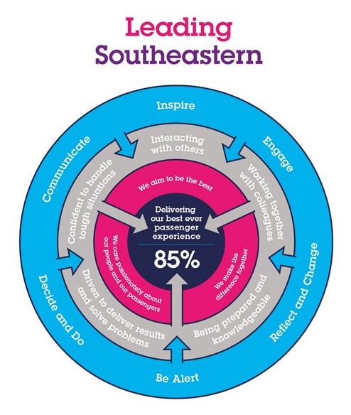

The Leading Southeastern framework details how we should be behaving in order to drive up performance to deliver 85 by 18.

All shortlisted candidates seeking promotion will be assessed against this framework.

The job demands the following blend of experience/knowledge, skills and behaviours (all are essential, unless otherwise shown and will be assessed by application and/ or interview/assessment):

G1 | Experience, Knowledge & Qualifications (including any specific safety training requirements)  Recognised qualification in occupational safety (at least NEBOSH National General Certificate or equivalent) with a practical understanding of the application of those principles within the railway industry.  Recognised qualification in accident/ incident investigation (PPWD, Arthur D Little or equivalent)  Level 4 qualification in internal quality assurance (IQA) required  Professional membership with IOSH or IIRSM
G2 | Skills (including any specific safety critical competencies)  Persuasiveness, ability to present key points of an argument, can negotiate and influence decisions.  Communication expresses oneself confidently and effectively to establish facts and ensure messages have been understood.  Problem solving, analyse information and identify key decision to be made.  Good analytical and investigatory skills.  Excellent attention to detail.
G3 | Behaviours  The ability to work with people and create a team spirit to produce results and gain commitment.  Identify and facilitate innovative ideas and solutions challenging others to think differently.  Excellent leadership skills and ability to motivate others.
G4 | Other

H | Dimensions of role
H1 | Financial – Direct:
H2 | Financial – Other:
H3 | Staff Responsibilities – Direct:
H4 | Staff Responsibilities – Other:
H5 | Any Other Statistical Data:
I | Acknowledgement
I1 | Prepared By: | _______________ |  | Date: | ______________
I2 | Approved By (Head of Department): | _______________ |  | Date: | ______________

J | Job Description Briefing
 | The post holder has been briefed on and understands the requirements of this Job Description and other related documents:
 | Name of post holder: |  | Signature: |  | Date:
 | Name of briefing manager: |  | Signature: |  | Date:
K | Nominated Deputy for Safety requirements
 | If this is a KEY SAFETY POST (D2 in Safety Details above is YES) at least one nominated deputy must be identified. The Job Holder must ensure that the Nominated Deputy(ies) receives a copy of, and is briefed on this Job Description. If there are more nominated deputies, they should sign further copies of this Job Description.
 | The nominated deputy has been briefed on and understands the requirements of this Job Description and other related documents:
 | Name of nominated deputy: |  | Signature: |  | Date:
 | Name of briefing manager: |  | Signature: |  | Date:

