A | Post Details
 | Job Title: | Depot Delivery  Coordinator | Function: | Engineering
 | Location: | Engineering Outstation Depots | Unique Post Number:
 | Reports To: | Depot Manager Outstations | Grade: | SE5
B | Purpose of the Job
This is a wide ranging role, providing first line fault finding for technical defects, and Operational expertise and support as well as team leadership to the outstations engineering shunting teams.

The Operational aspect of the role includes coaching, monitoring and assessment of engineering staff based at outstation locations including competency in DPRP and Isolations. In addition other duties will include monitoring and reporting depot performance, developing and implementation of workflow process improvements, auditing of cleaning activities, and acting as liaison for Depot/Network rail Engineering works. In addition this role may also include depending upon the location, team leadership to a team of between 6 and 14 Engineers/Shunter Drivers, shunter driver duties, Yard Movement Coordinator duties, and day to day supervision of the location.

Key tasks will include leading and motivating a team of staff to ensure that they work together safely and effectively to the required standards and specifications. Co-ordinating the effective deployment of staff to ensure production deadlines and targets are met.

The Technical aspects of the role includes engineering support to the outstations team and first line fault finding, and rectification of minor repairs.

C | Principal Accountabilities
C1  C2  C3  C4  C5  C6  C7  C8  C9  C10  C11  C12  C13  C14  C15  C16  C17  C18  C19  C20 | Responsible for constructing and maintaining train service departure documentation, Identifying and distributing any changes to the depot Berthing / departure plans. Able to interpret Weekly operating notices, Periodical operating notices, Rule book, and local operating instructions to identify any items that may affect operations at the depot  Able to monitor and react to operational train service trends and process management issues.  Required to find innovative ways to continuously improve operational processes and provide right train right time from depot.  Responsible for ensuring vehicles are shunted / driven and prepared for service.  Undertake train and depot cleaning audits as required, liaising with the cleaning contractor ensuring train/depot cleaning activities are to the required standards  Implement seasonal operational programs for the locations, and monitor their progress ensuring compliance with engineering standards and identification of process improvement initiatives.  Day to day site management duties ensuing staff are working safely and that the condition of the site remains compliant with Health and safety requirements, and fire precautions regulations.  Undertake both shunting and driving duties as required  Undertake site inductions  Motivate and lead a team and undertake 1st line managerial control.  Provide technical support to the outstation team, including, troubleshooting and defect rectification for minor repairs, and OTMR download and review.  Prioritise and manage workloads, liaising with other departments as required  Be computer literate and have knowledge of the Engineering Management System (EMS), Genius, P2, TRUST, Train Describer, word, excel.  Accountable for providing technical and operational assistance for accident and incident investigations and reports.  Carry out competency assessments of Team members as requested by the Quality and Safety Department.  Deputise for the Depot Manager Outstations as required, for periods of absence.  Deputise and cross cover for other outstation based DDC for periods of absence  Ensure location output is recorded and reported as required  Undertake other duties as requested or specified by the Depot Manager Outstations.  Undertake delay attribution for outstation locations.

D | Safety Responsibilities
D1 | This post is required to undertake SAFETY CRITICAL WORK | Yes |  | No
D2 | This is a KEY SAFETY POST | Yes |  | No
D3 | This post requires SECURITY CLEARANCE | Yes |  | No
D4 | The job requires competence in PERSONAL TRACK SAFETY | Yes |  | No
D5 | This job has SPECIFIC SAFETY RESPONSIBILITIES (if Yes see section D6 below) | Yes |  | No
D6 | The post holder has the following specific safety responsibilities:
Carrying out Planned General Inspections of the following locations:
- [list locations or delete if not applicable]

Acting as Fire Precautions Manager for the following locations:
- [list locations or delete if not applicable]

E | Decision making Authority
E1 | As defined by the Depot Manager Outstations, but primarily responsible for the day to day performance of the location, supervision of the team, the allocation of work, and safety of the site.
F | Most Challenging and/or Difficult parts of the role
F1  F2  F3  F4 | Ensuring the location output is maintained to the desired productivity level.  Ensuring the location is managed in a safe and productive manner.  Developing and implementation of robust workflow processes improvements  Deputising as Depot Manager Outstations.
G | Report Preparation
G1  G2 | Activity Specific  General reports in Microsoft World, Excel, Access and PowerPoint format, as defined by the Depot Manager Outstations
H | Decision making Authority
H1 | This is a wide ranging role with contacts across the organisation, including Senior and Depot Managers, KICC, Performance section, safety section, Technical Team, Planning Team, Material Team and Warranty Team. Suppliers, contractors and other support and external staff.

I | Person Specification

Southeastern aims to recruit people not just for jobs but for long term careers. We want good quality, talented people with the right attitude who will stay with us.

For these reasons we look for evidence of Southeastern values in all potential staff and our existing staff looking for promotion along with the particular experience/knowledge, skills and behaviours relevant to the position applied for. These are

We care passionately about people
  - we put ourselves in our passengers’ shoes to do what’s right for them
  - we support our colleagues to be, feel and do their best
  - we love the places we serve and do our bit for our communities and environment

We aim to be the best
  - we move with pace, we’re agile and learn from everything
  - we relentlessly strive to be the best
  - we are professionals with personalities

We make the difference together
  - we are answerable to each other and our passengers
  - we trust each other and do what we say we will
  - we are stronger together than we are as individuals

We also have identified behaviours required to be successful in leading Southeastern.

The Leading Southeastern framework details how we should be behaving in order to drive up performance to deliver 85 by 18.

Leading Southeastern

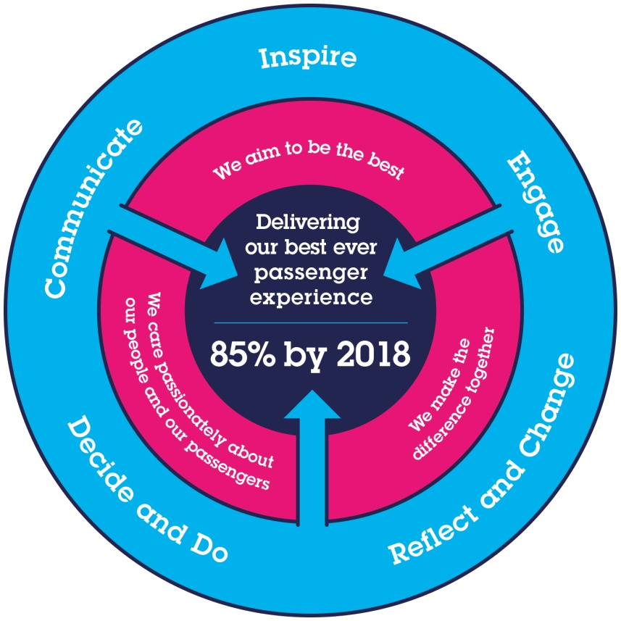
All Shortlisted candidates seeking promotion will be assessed against this framework.

The job demands the following blend of experience/knowledge, skills and behaviours (all are essential , unless otherwise shown and will be assessed by application and/ or interview/assessment) :

J1 | Experience, Knowledge & Qualifications  3 years experience of Railway Operations and or Engineering, Core Management and Leadership training or relevant experience, Intermediate IT skills (Excel, word etc).  Desirable:  Qualifications and certification in an Engineering, shunting or driving discipline, Advanced IT skills (Excel, Word etc), NVQ Level 4 in supervision/team management, quality & safety systems training.
J2 | Skills (including any specific safety critical competencies)
J3 | Behaviours
J4 | Other

K | Dimensions of role
K1 | Financial – Direct: |  |  |  | None
K2 | Financial – Other: |  |  |  | As defined by the Depot Manager Outstations
K3 | Staff Responsibilities – Direct: |  |  |  | None
K4 | Staff Responsibilities – Other: |  |  |  | 5 – 14 Engineering staff
K5 | Any Other Statistical Data: |  |  |  | None
L | Acknowledgement
1 | Prepared By: |  | _______________ |  |  |  | Date: | ______________
L2 | Approved By (Head of Department): |  | _______________ |  |  |  | Date: | ______________
M | Job Description Briefing
 | The post holder has been briefed on and understands the requirements of this Job Description and other related documents:
 | Name of post holder: |  |  | Signature: |  |  |  |  | Date:
 | Name of briefing manager: |  |  | Signature: |  |  |  |  | Date:
N | Nominated Deputy for Safety requirements
 | If this is a KEY SAFETY POST (D2 in Safety Details above is YES) at least one nominated deputy must be identified. The Job Holder must ensure that the Nominated Deputy(ies) receives a copy of, and is briefed on this Job Description. If there are more nominated deputies, they should sign further copies of this Job Description.
 | The nominated deputy has been briefed on and understands the requirements of this Job Description and other related documents:
 | Name of nominated deputy: |  |  | Signature: |  |  |  |  | Date:
 | Name of briefing manager: |  |  | Signature: |  |  |  |  | Date:

