A | Post Details
 | Job Title: | Assistant Management Accountant | Function: | Finance
 | Location: | 4 More London | Unique Post Number:
 | Reports To: | Finance Business Partner | Grade: | ASG
B | Purpose of the Job
 | To undertake month-end reporting activities, to provide accurate, timely and relevant financial information for management reporting and to aid Finance Business Partners and the business in tracking their budgets.
C | Principal Accountabilities
C1  C2  C3  C4  C5  C6  C7  C8 | Responsible for managing period and year end results, producing management analysis to required deadlines, highlighting material variances and trends, their underlying causes and impact on profitability to derive recommendations on strategic action plans.  Ensure financial records are complete and accurate and reflect underlying business activities and objectives.  Liaise closely with the Financial Accounting team to ensure reliability, accuracy and timeliness of financial information and manage relevant accruals and GRNI.  Undertake the CIMA training, study and pass exams.  Gain detailed knowledge of relevant business activities and sales/cost drivers to continually develop clear, concise and relevant financial and management reporting. Follow-up on key items arising each period and track performance.  Build good working relationships with the Finance team, directorate managers and staff.  Proactively identify process improvements within the team and across the business.  Provide adhoc support and analysis to the Finance Business Partners and Financial Planning & Analysis Manager as necessary.
D | Safety Responsibilities
D1 | This post is required to undertake SAFETY CRITICAL WORK |  |  |  | Yes |  | No
D2 | This is a KEY SAFETY POST |  |  |  | Yes |  | No
D3 | This post requires SECURITY CLEARANCE |  |  |  | Yes |  | No
D4 | The job requires competence in PERSONAL TRACK SAFETY |  |  |  | Yes |  | No
D5 | This job has SPECIFIC SAFETY RESPONSIBILITIES (if Yes see section D6 below) |  |  |  | Yes |  | No
D6 | The post holder has the following specific safety responsibilities:
 | - None

E | Decision-making Authority
E1  E2 | Authorised to review and recommend changes to business practices, processes and new projects in discussion with the Finance Business Partners  Authorised to prepare and influence budgets, forecasts and assumptions therein
F | Most Challenging and/or Difficult parts of the role
F1  F2  F3 | Managing to tight deadlines and manipulating large amounts of data  Ensuring continuity between the Financial Planning & Analysis and Financial Accounting teams  Understanding the technical aspects of Southeastern financial profile (e.g. passenger income, access charges, rolling stock leases, subsidy, performance regimes as appropriate in the relevant business areas)

G | Person Specification

Southeastern aims to recruit people not just for jobs but for long term careers. We want good quality, talented people with the right attitude who will stay with us.

For these reasons we look for evidence of Southeastern values and behaviours in all potential staff and our existing staff looking for promotion along with the particular experience/knowledge, skills and behaviours relevant to the position applied for. These are

We care passionately about our people and passengers
  - we put ourselves in our passengers’ shoes to do what’s right for them
  - we support our colleagues to be, feel and do their best
  - we love the places we serve and do our bit for our communities and environment

We aim to be the best
  - we move with pace, we’re agile and learn from everything
  - we relentlessly strive to be the best
  - we are professionals with personalities

We make the difference together
  - we are answerable to each other and our passengers
  - we trust each other and do what we say we will
  - we are stronger together than we are as individuals

We also have identified behaviours required to be successful in leading Southeastern.

The Leading Southeastern framework details how we should be behaving in order to drive up performance to deliver 85%.

All shortlisted candidates seeking promotion will be assessed against this framework.

Financial Planning & Analysis Team Charter

The FP&A team are focused on providing quality service and support to their key customers (including management, Directors, DfT, ROSCOs, Network Rail, the Go-Ahead Group and Keolis) and are expected to display the following attributes, striving to continually improve both individual and team performance in each of these four quadrants.

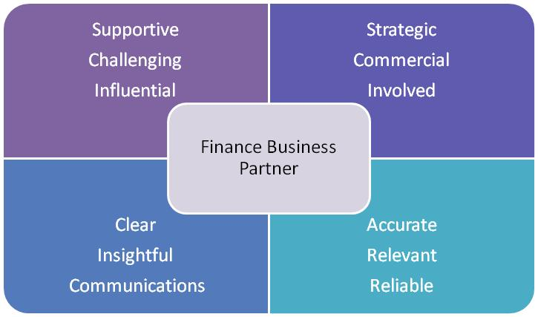

The job demands the following blend of experience/knowledge, skills and behaviours (all are essential, unless otherwise shown and will be assessed by application and/ or interview/assessment):

G1  G2  G3 | Experience, Knowledge & Qualifications  A degree in any discipline, all grades considered  A passion for enhancing people’s lives through public transport and putting the customer at the heart of everything we do  Skills (including any specific safety critical competencies)  Excellent communication and presentation skills  Good oral and written communication skills  The ability to work as part of a team  Excellent analytical and numerical abilities  Accuracy and an eye for detail  Behaviours  Willingness to learn and perform in a fast-changing environment  Ability to work efficiently, effectively and collaboratively as part of a team, contributing to a culture of continuous business improvement  Ability to problem solve issues and to identify opportunities for improvement  Ability to communicate clearly and effectively (both written and oral)
G4 | Other
H | Dimensions of role
H1 | Financial – Direct: |  | 0
H2 | Financial – Other: |  | Depending on relevant business areas
H3 | Staff Responsibilities – Direct: |  | 0
H4 | Staff Responsibilities – Other: |  | 0
H5 | Any Other Statistical Data:
I | Acknowledgement
I1 | Prepared By: | Margaret Martin |  | Date: | 15/07/2020
I2 | Approved By (Head of Department): | _______________ |  | Date: | ______________

K | Job Description Briefing
 | The post holder has been briefed on and understands the requirements of this Job Description and other related documents:
 | Name of post holder: |  | Signature: |  | Date:
 | Name of briefing manager: |  | Signature: |  | Date:
L | Nominated Deputy for Safety requirements
 | If this is a KEY SAFETY POST (D2 in Safety Details above is YES) at least one nominated deputy must be identified. The Job Holder must ensure that the Nominated Deputy(ies) receives a copy of, and is briefed on this Job Description. If there are more nominated deputies, they should sign further copies of this Job Description.
 | The nominated deputy has been briefed on and understands the requirements of this Job Description and other related documents:
 | Name of nominated deputy: |  | Signature: |  | Date:
 | Name of briefing manager: |  | Signature: |  | Date:

